**ASSIGNMENT 3**

**SOFTWARE GROUP PROJECT**

# SOFTWARE ENGINEERING: PROCESS AND TOOLS

**S223 PRT582**

**GROUP NAME - POWER PUFFS (GROUP B)**

**PROJECT – ONLINE MOVIE TICKET BOOKING SYSTEM**

|  |  |  |
| --- | --- | --- |
| **First Name** | **Last Name** | **Student No.** |
| Nithya Romeshika | Yamasinghe | S370170 |
| My Ngoc | Doan | S370857 |
| Oluwaseun | Taiwo | S369805 |
| Ayse Busra | Kocadag | S362263 |

**TABLE OF CONTENTS**

1. ABSTRACT 8

2. INTRODUCTION 9

2.1 BACKGROUND OF THE PROJECT 10

2.2 AIM OF THE PROJECT 11

2.3 PROJECT SCOPE 11

2.4 LIMITATIONS OF THE SOFTWARE 14

2.5 PROJECT REQUIREMENTS 14

2.5.1 FUNCTIONAL REQUIREMENTS 14

2.5.2 EXTERNAL INTERFACE REQUIREMENTS 15

2.5.2.1 USER INTERFACES 15

2.5.2.2 HARDWARE INTERFACES 15

2.5.2.3 SOFTWARE INTERFACES 15

2.5.2.4 COMMUNICATION INTERFACES 15

2.5.3 NON-FUNCTIONAL REQUIREMENTS 16

2.5.3.1 PERFORMANCE REQUIREMENTS 16

2.5.3.2 SAFETY REQUIREMENTS 16

2.5.3.3 SECURITY REQUIREMENTS 16

2.5.3.4 SOFTWARE QUALITY REQUIREMENTS 16

2.6 USER STORIES 17

3. TEST PLANNING 19

3.1 TEST PLAN AND THE AUTOMATION STRATEGY 19

3.1.1 AGILE TESTING QUADRANT I 19

3.1.2 AGILE TESTING QUADRANT II 20

3.1.3 AGILE QUADRANT III PLAN 20

3.1.5 AGILE TESTING QUADRANT IV PLAN 21

3.2 COMPARISON AND THE JUSTIFICATION OF AUTOMATION TOOLS 22

3.3 TEST CASES 27

4. NON-FUNCTIONAL TESTING 64

4.1 USABILTY TESTING 64

4.2 PERFORMANCE TESTING 101

4.2.3 APACHE JMETER – DIFFERENT RAMP UP PERIOD SETTING 115

4.3 SECURITY TESTING 134

5. FUNCTIONAL TESTING 149

5.1 MANUAL TESTING AND RESULTS 149

5.2 AUTOMATED TESTING AND RESULTS 187

6. CONCLUSION 198

7. APPENDIX 202

7.1 YOUTUBE LINK TO THE VIDEO PRESENTATION 202

7.2 RESULTS FROM THE NON-FUNCTIONAL TESTS 202

# ABSTRACT

The Online Movie Ticket Booking System developed using Test-Driven Development (TDD) represents a significant advancement in the realm of digital ticketing solutions. This project was undertaken to address the growing need for a streamlined and user-friendly platform that allows moviegoers to effortlessly reserve tickets while ensuring robust code quality and reliability.

The primary goal of this project was to create a scalable and secure system that caters to the modern-day cinema audience's expectations. Utilizing the principles of Test-Driven Development, the development process began with the formulation of comprehensive test cases. These tests served as a blueprint for the system's functionality, ensuring that each component met the specified requirements and delivered the desired user experience. Major achievements of this project include the successful implementation of a feature-rich online movie ticket booking system. Users can easily browse movies, select theaters, choose showtimes, and reserve seats with confidence.

Moreover, employing TDD in the development process has significantly bolstered the system's reliability and maintainability. Rigorous testing at every stage of development has minimized the risk of critical errors and vulnerabilities, making it a robust and dependable platform for both customers and cinema operators. However, it's important to acknowledge that no system is without limitations. While this project has made substantial strides in online ticket booking, continuous updates and improvements will be necessary to adapt to evolving customer preferences and technological advancements.

In conclusion, the Online Movie Ticket Booking System developed through Test-Driven Development has successfully met the demand for an efficient and user-centric platform, offering a seamless movie ticket booking experience while prioritizing code quality and security. This project represents a significant step forward in enhancing the convenience and reliability of the cinema-going process in the digital age.

# INTRODUCTION

In today's fast-paced digital age, the convenience of online services has transformed many aspects of our lives, and one prime example is the way we book tickets for movies. The Online Movie Ticket Booking System is a revolutionary platform that has redefined the traditional method of purchasing movie tickets. It leverages the power of the internet and technology to provide moviegoers with a seamless and user-friendly experience when reserving seats for their favorite films.

This system allows users to browse through a wide selection of movies, theaters, showtimes, and seating options from the comfort of their homes or on-the-go through mobile devices and computers. Gone are the days of waiting in long queues at box offices or being uncertain about ticket availability. With just a few clicks or taps, users can secure their movie tickets, choosing their preferred seats and showtimes with ease.

## BACKGROUND OF THE PROJECT

The project is an **Online Movie Ticket Booking System,** a web application that can access through the browser. The main purpose of this web application is to reduce the manual work done by people in the cinema, automate the processes, and make them available online so that each person can easily book a movie ticket without going to the cinema to book the tickets. This online system can also eliminate and minimize the errors of the manual human-based process. Also, it will reduce the usage of paper-printed tickets and resources. The system's main audience is the general public. The online movie ticket booking system lets users view their bookings using the application. The system provides search facilities to search the movies, and the system can easily track all the information, including ticket, booking, and show timing, while increasing the efficiency of booking a ticket. The system's admin panel allows one to manage all the information presented in the main user web application and carry out all the operations smoothly and effectively.

Avoiding errors while entering data is one of the main objectives of the application. This allows the application's administration or staff users to concentrate more on other activities than record keeping, so their valuable data can be stored for longer with ease of access and manipulation.

The system is developed using popular technologies like Python and Django Framework, which gives better CDN connectivity and content management. This system uses Django's admin interface, making setting up and running CDNs easy. Besides the main technologies, it has used Bootstrap, JQuery, and Javascript. MySQL is used as the database to persist data of the system.

## 2.2 AIM OF THE PROJECT

The project's main objective is to develop a system that automates the processes in cinema and gives users a modern and easy experience in booking a ticket and selecting a movie to watch from anywhere through the internet. The system is developed for both regular users and administrative ends. Therefore, all the information will be in sync when manipulating data from the web application's user interface or administrator interface.

## 2.3 PROJECT SCOPE

The system consists of four main functionalities: Manage Theatres, Manage Movies, Manage Bookings, and Manage Homes. The system includes three types of user authentication levels, mainly Administration, Staff & Regular Users. The Administration and the Staff authentication levels have more permission than the Regular Users. The functionalities available for Administration and Staff user levels are demonstrated in the following diagram.

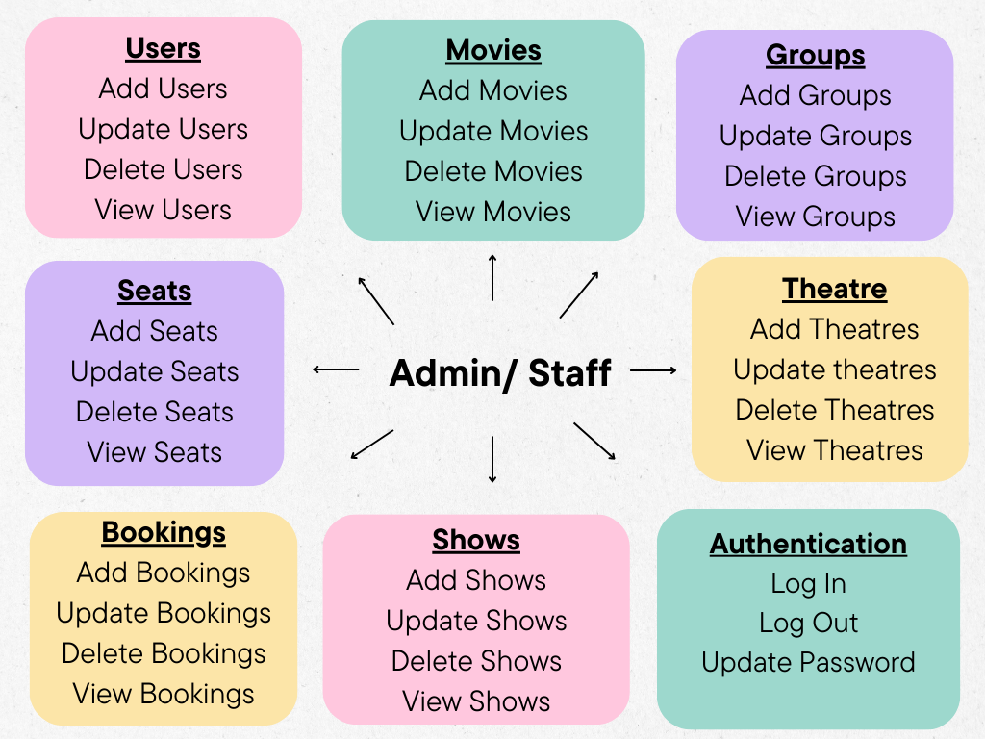

The Regular User Authentication Level Users can log in to the system and check available movies from a list view with the movie's information such as name, cast, director, language, run time and certificate, and available shows for that particular date. Also, they can have a look at the movie trailer as well. Operations like search, booking, and payment are available as well. The following diagram summarizes available functionalities for regular users of the system.

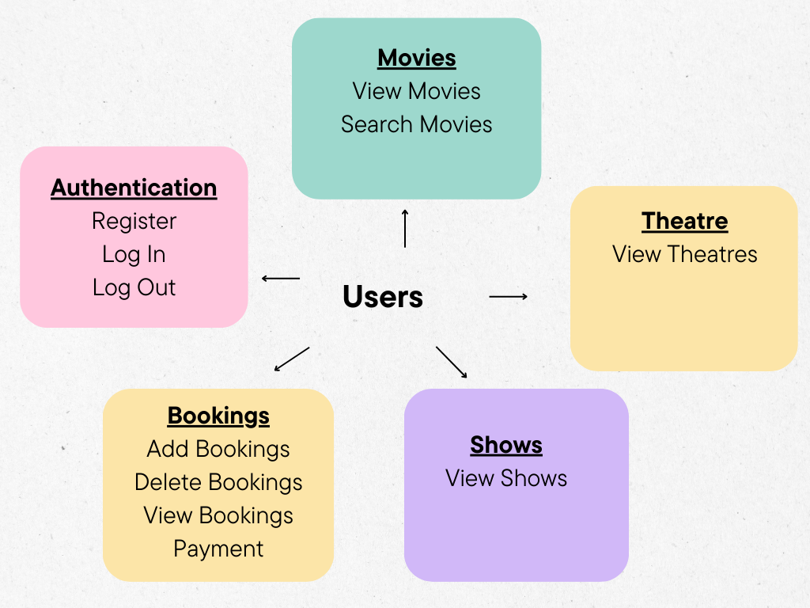

The project aims at business process automation using advancements in technology and IT. The system plans to improve the following in brief.

* The system helps to remove the manual form-filling process.
* Helps to utilize the resources effectively, increasing productivity.
* Generates information that can be used to further analyses.
* Satisfy the user requirements.
* Easy to operate than the manual procedure.
* Excellent user experience and user interface.
* Both client and admin panels are available.
* Secure online payment facility.

## 

## 2.4 LIMITATIONS OF THE SOFTWARE

* There is no registration interface to register admin-level users.
* The system doesn't have an interface to represent movie show times in the upcoming weeks.
* The system doesn't have a secure payment gateway.
* Authentication and authorization mechanisms are not secure as well.
* The UI is not very user-friendly.
* Sensitive information is not encrypted.
* The regular user doesn't have a way to reset their passwords.

## 2.5 PROJECT REQUIREMENTS

The following are the identified requirements of the proposed system after intensive research on the proposed system. The identified requirements are categorized below.

1. Functional Requirements
2. External Interface Requirements
3. Non-Functional Requirements

## 2.5.1 FUNCTIONAL REQUIREMENTS

Functional Requirements are essential to the proposed system's success. The identified functional requirements for the Online Movie Ticket Booking System are as follows. The system consists of three user groups Administrator (Staff), Regular User, and Guest User.

* The system has to store information regarding the new entry of movies, update existing movie records, or delete movie records.
* The system has to store information on the users registered to the system.
* The system has to provide the facility to insert movie theatres, update the information or delete theatre information.
* The system has to store information on the bookings giving the ability to delete or update booking details.
* The system must provide a secure online payment gateway to process the payments.
* The system needs an authentication and authorization mechanism to facilitate different user levels intended to use the final system.
* The system needs to provide a facility to search the movies.
* The system needs to allow the users to update their passwords.
* The system must store information regarding the booked shows and add, update, and delete seats.

## EXTERNAL INTERFACE REQUIREMENTS

## USER INTERFACES

* Front End Software – Developed using HTML with Python Django Framework, Bootstrap3
* Back End Software – Developed using Python, Django, jQuery, JavaScript

## HARDWARE INTERFACES

* Windows
* A Browser that supports running Python Django Web Application

## SOFTWARE INTERFACES

* Operation System – Windows OS because of support and user-friendliness.
* Database – To persist the data, MySQL database has been chosen.
* Python Django – Selected because of rapid development and security and maintenance.

## COMMUNICATION INTERFACES

* The proposed system supports any browser and uses Python Django forms for data collection.

## NON-FUNCTIONAL REQUIREMENTS

## PERFORMANCE REQUIREMENTS

* Implementing the Online Movie Ticket Booking System database includes drawing ER diagram to represent the database's logical structure. This helps organize data as relation, normalize, and develop the relational database.
* Normalization of the database.
* The system should be accessible at any time without large downtimes.
* The system should be able to handle a large number of transactions.

## 

## SAFETY REQUIREMENTS

* If the database is damaged due to some incident or a disk crash persists, the databases will be archived regularly.

## 

## SECURITY REQUIREMENTS

* Selecting a Database from a reputed and reliable database management system.
* Encrypt sensitive data such as passwords.
* Use a secure payment gateway for the payments.
* Data validation and sanitization.
* Authorization and role management.

## SOFTWARE QUALITY REQUIREMENTS

* Usability – The System should satisfy customer requirements, the system could be accessible through different devices such as mobile and desktop, the system should not display erroneous information to the user, and The system should be user-friendly for any user from anywhere.
* Availability – The movies should be available to be booked by customers without any interruption.
* Correctness – The movie's show dates, times, and theatre information should be accurate and concise.
* Maintainability – The System should have regular updates and security patches to avoid unforeseen problems and keep up with technology changes.

## USER STORIES

**ADMIN USER GROUP**

1. As an admin user, I want to be able to add new movie entries to the system, including details such as title, genre, release date, and showtimes.
2. As an admin user, I want the ability to update existing movie records, including changing showtimes or editing movie descriptions.
3. As an admin user, I need the capability to delete movie records that are no longer relevant or being shown in theatres.
4. As an admin user, I want to manage user accounts, including registering new users and updating user information.
5. As an admin user, I need to insert new movie theatres into the system, providing details like location, contact information, and seating capacity.
6. As an admin user, I want to be able to update theater information, such as changing the seating layout or contact details.
7. As an admin user, I should have the authority to delete theatre information if a theatre is no longer in operation.

**NORMAL (REGULAR) USER GROUP**

1. As a normal user, I want to be able to search for movies, filtering by genre, release date, or location to find the most convenient showtimes.
2. As a normal user, I need to update my password for security reasons, ensuring that my account remains safe.
3. As a normal user, I want to view and manage my bookings, including the ability to cancel bookings if my plans change.

**GUEST USER GROUP**

1. As a guest user, I should be able to search for movies and view basic information like titles, showtimes, and locations without registering for an account.
2. As a guest user, I want to see a secure online payment gateway when I decide to book a movie ticket, ensuring the safety of my financial information.
3. As a guest user, I need the option to register for an account to access additional features like booking history and personalized recommendations.

# 3. TEST PLANNING

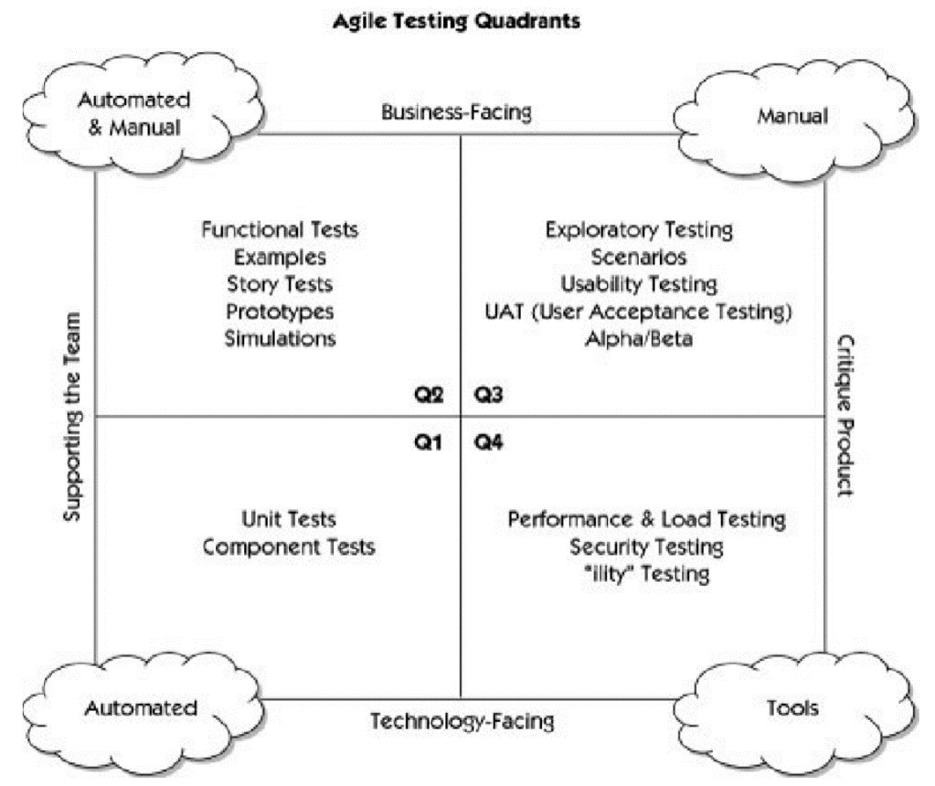

## TEST PLAN AND THE AUTOMATION STRATEGY

## 3.1.1 AGILE TESTING QUADRANT I

|  |  |  |  |  |
| --- | --- | --- | --- | --- |
| **TEST NAME** | **TYPE OF TEST USING** | **TOOLS & TECHNOLOGIES** | **SYSTEM FUNCTIONS TO BE TESTED** | **TIMELINE** |
| Unit Testing | Automated | Unittest (Pyunit)  PyTest | All the units of the system will be tested | Will be performed throughout the development |
| Component Testing | Automated | Unittest (Pyunit)  PyTest | All the components of the system will be tested | Will be performed throughout the development |

The Agile Quadrant I mainly focus on the internal code quality of the systems and technology-facing tests that supports the team.

## AGILE TESTING QUADRANT II

|  |  |  |  |  |
| --- | --- | --- | --- | --- |
| **TEST NAME** | **TYPE OF TEST USING** | **TOOLS & TECHNOLOGIES** | **SYSTEM FUNCTIONS TO BE TESTED** | **TIMELINE** |
| Functional Testing | Manual/  Automated | Story Tests  Prototypes  Mockups  Simulations | * Testing of examples of possible scenarios and workflows * Testing of User experience, such as prototypes * Pair testing | Will be performed throughout the development |

These tests are more business-driven tests that support the team. Agile quadrant II mainly focuses on the requirements.

## AGILE QUADRANT III PLAN

|  |  |  |  |  |
| --- | --- | --- | --- | --- |
| **TEST NAME** | **TYPE OF TEST USING** | **TOOLS & TECHNOLOGIES** | **SYSTEM FUNCTIONS TO BE TESTED** | **TIMELINE** |
| Exploratory Testing  Usability Testing  User Acceptance Testing Collaborative Testing  Alpha Testing  BetaTesting. | Manual | Monitoring Tools  Simulations  Emulations | Gain feedback and improve the overall quality, ensuring it fits the designed purpose. | At the last of the development |

These tests are more business-driven and focus on real-time scenarios. Agile quadrant II mainly focuses on providing feedback to quadrant I and II.

## 

## 3.1.5 AGILE TESTING QUADRANT IV PLAN

|  |  |  |  |  |
| --- | --- | --- | --- | --- |
| **TEST NAME** | **TYPE OF TEST USING** | **TOOLS & TECHNOLOGIES** | **SYSTEM FUNCTIONS TO BE TESTED** | **TIMELINE** |
| Performance Testing | Special Tools/ Automated |  | Gain feedback and improve the overall quality, ensuring it fits the designed purpose | End of the development |
| Load Testing | Special Tools/ Automated | LoadTest/ Load Runner/ | Overall system load will be tested | End of the development |
| Security Testing | Special Tools/ Automated |  | Concerning **authentication**and hacking of the application | End of the development |

These tests are more technology-driven and focus on real-time scenarios. Agile quadrant IV mainly focuses on providing the final product to the client.

## 

## 3.2 COMPARISON AND THE JUSTIFICATION OF AUTOMATION TOOLS

System – Online Movie Ticket Booking System

Technologies – Python, Django, JQuery, Bootstrap, My SQL

Agile Quadrant I

**Test to be Performed -**

1. Unit Testing

We will be performing extensive unit testing for the system to ensure each unit of the system works as expected without any issues or bugs. Here we plan to test each unit with possible inputs and error scenarios and identify if we need to add more validations to forms and the system interfaces. We perform unit testing because it improves the quality of our codebase and reduces the cost of changes if we find them early fixed early in the development process.

1. Component Testing

After the unit testing, we will be testing each component of the system as a whole to ensure the component works as expected because sometimes, even if the unit testing is successfully done when we test them as a component, we might find other bugs, therefore our plan to do the component test based on the main four components of the system.

**Technologies -**

We plan to use Unitetest **(Pyunit)** for the unit and component testing as it is the standard framework for Python unit testing. And it is very easy to set up PyUnit tests.

**Timeline -**

We plan to complete the unit testing of the system within the third week.

**Testing of the System –**

The following are the main items planned for the unit testing.

Administration View –

* Add Movies/ Update Movies/ View Movies/ Delete Movies
* Add Theatre/ Update Theatre/ View Theatre/ Delete Theatre
* Add Groups/ Update Groups/ View Groups/ Delete Groups
* Add Shows/ Update Shows/ View Shows/ Delete Shows
* Add Seats/ Update Seats/ View Seats/ Delete Seats
* Add Users/ Update Users/ View Users/ Delete Users
* Add Booking/ Update Bookings/ View Bookings/ Delete
* Log In/ Log Out/ Update User Password

Regular User View –

* Register/Login/ Log Out
* View Movies/ Search Movies
* View Theatres
* View Shows
* Add Booking/ View Bookings/ Delete Bookings/ Payment

The following are the main items planned for the component testing.

Administration View -

* Movies Management as a component
* Seat Management as a components
* Shows and Theatre Management as a component
* Booking management as a component
* User and Groups Management as a component
* Authentication and Authorization as a component

Regular User View

* Authentication and Authorization as a component
* All the other functionalities will be tested as one component since they are connected.

We will divide these items among the group members and complete the Agile Testing Quadrant I test.

Agile Quadrant II

**Test to be Performed -**

1. Functional Testing
2. Story Testing
3. Prototypes

We will be using Story Testing and Prototypes to complete the functional testing of the system. Our goal is to Test all the possible scenarios and workflows related to the system using story testing, and the prototypes will be used to understand the system's user experience and ensure every requirement of the system is covered as expected.

**Technologies -**

We plan to use freely available online user stories software such as Product Board, Easy Agile, or Jira for user story testing. We can use Figma, Adobe XD, or Mockups for the prototypes.

**Timeline -**

We plan to complete the Agile Testing Quadrant II of the System within the fourth week.

**Testing of the System –**

All the system's main functionalities will be tested in this phase, and identify any missing requirements that need to be addressed.

Agile Quadrant III

**Test to be Performed -**

1. Usability Testing

Planning to perform Usability testing of the system by observing the real users and how they will perform different system tasks, we will mainly focus on how the real users perform the tasks using the system, can they identify the different components and controls of the system and their usage.

1. UAT (User Acceptance Testing)

Performing UAT testing to validate the business flow using end users. And verify the system does what it is supposed to do in the first place.

**Technologies -**

We will use remote usability testing and UAT testing tools like User Brain.

**Timeline -**

We plan to complete the Usability and UAT testing of the system within the fifth week.

**Testing of the System –**

The system will be tested in this phase to gain feedback and improve the overall quality, ensuring it fits the designed purpose.

Agile Quadrant IV

**Test to be Performed -**

1. Performance Testing
2. Security Testing

**Technologies -**

We can use tools like Granulate Code Profiler for Performance Testing and PyT for Security Testing.

**Timeline -**

We plan to complete these tests of the system within the sixth week.

**Testing of the System –**

The complete system will be tested in this phase to identify any performance issues, such as the system being accessible at any time without large downtimes, and the system should be able to handle a large number of transactions. Also, Security testing will be performed to verify the user's sensitive data, including encrypted passwords, and data validation and sanitization.

|  |  |  |  |
| --- | --- | --- | --- |
| **Agile Testing Quadrant** | **Test** | **Tool** | **Timeline** |
| Quadrant I | Unit Testing  Component Testing | Unittest(PyUnit) | Week 03 |
| Quadrant II | Story Testing  Prototypes | Easy Agile/ Jira/ Product Board  Figma/Adobe XD | Week 04 |
| Quadrant III | Usability Testing  UAT Testing | User Brain | Week 05 |
| Quadrant IV | Performance Testing  Security Testing | Granulate Code Profiler  PyT | Week 06 |

## 3.3 TEST CASES

## 

Project Name: Online Movie Booking System Module Name: Add Movies Functionality/ Login Functionality

Created By: Power Puffs Created Date: 03-08-2023

Executed by: Power Puffs Executed Date: 03-08-2023

|  |  |  |  |  |  |  |  |
| --- | --- | --- | --- | --- | --- | --- | --- |
| **Test Case ID** | **Description** | **Test Step** | **Preconditions** | **Test Data** | **Expected Result** | **Actual Result** | **Status** |
| TC_ADD_MOVIES_01 | Verify add movies functionality with valid data set | Navigate to add movies page |  |  | Able to see add movies page | As expected | Pass |
|  |  | Enter valid movie name | Valid movie name | Name - Barbie | Movie name can be entered | As Expected | Pass |
|  |  | Enter valid movie cast | Valid movie cast | Cast - Margret Robbie | Movie cast can be entered | As Expected | Pass |
|  |  | Enter valid movie director name | Valid movie director name | Director – Greta Grewig | Movie director name can be entered | As Expected | Pass |
|  |  | Select valid movie language | Valid movie language | Language - English | Movie language can be selected | As Expected | Pass |
|  |  | Enter valid movie run length | Valid movie run length | Run Length – 90 minutes | Movies run length can be entered | As Expected | Pass |
|  |  | Select valid movie certificate | Valid movie certificate | Certificate - RA | Movie certificate can be selected | As Expected | Pass |
|  |  | Enter movie popularity index | Valid popularity index | Popularity Index - 8.6 | Movie popularity index can be entered | As Expected | Pass |
|  |  | Enter movie trailer link | Valid trailer link | Trailer Link - <https://www.youtube.com/watch?v=pBk4NYhWNMM> | Trailer can be entered | As Expected | Pass |
|  |  | Upload movie poster | Valid movie poster | Image – barbie.jpg | Image can be upload | As Expected | Pass |
|  |  | Click on save button |  |  | Movie added | Movie added successfully | Pass |
| TC_ADD_MOVIES_02 | Verify add movies functionality without selecting movie language | Navigate to add movies page |  |  | Able to see add movies page | As expected | Pass |
|  |  | Enter valid movie name | Valid movie name | Name - Barbie | Movie name can be entered | As Expected | Pass |
|  |  | Enter valid movie cast | Valid movie cast | Cast - Margret Robbie | Movie cast can be entered | As Expected | Pass |
|  |  | Enter valid movie director name | Valid movie director name | Director – Greta Grewig | Movie director name can be entered | As Expected | Pass |
|  |  | Select valid movie language | Movie language not selected | Language – Empty/ Null | Movie language can be selected | As Expected | Pass |
|  |  | Enter valid movie run length | Valid movie run length | Run Length – 90 minutes | Movies run length can be entered | As Expected | Pass |
|  |  | Select valid movie certificate | Valid movie certificate | Certificate - RA | Movie certificate can be selected | As Expected | Pass |
|  |  | Enter movie popularity index | Valid popularity index | Popularity Index - 8.6 | Movie popularity index can be entered | As Expected | Pass |
|  |  | Enter movie trailer link | Valid trailer link | Trailer Link - <https://www.youtube.com/watch?v=pBk4NYhWNMM> | Trailer can be entered | As Expected | Pass |
|  |  | Upload movie poster | Valid movie poster | Image – barbie.jpg | Image can be upload | As Expected | Pass |
|  |  | Click on save button |  |  | Movie added | Movie adding unsuccessful | Fail |
| TC_ADD_MOVIES_03 | Verify add movies functionality without selecting movie poster | Navigate to add movies page |  |  | Able to see add movies page | As expected | Pass |
|  |  | Enter valid movie name | Valid movie name | Name - Barbie | Movie name can be entered | As Expected | Pass |
|  |  | Enter valid movie cast | Valid movie cast | Cast - Margret Robbie | Movie cast can be entered | As Expected | Pass |
|  |  | Enter valid movie director name | Valid movie director name | Director – Greta Grewig | Movie director name can be entered | As Expected | Pass |
|  |  | Select valid movie language | Valid movie language | Language - English | Movie language can be selected | As Expected | Pass |
|  |  | Enter valid movie run length | Valid movie run length | Run Length – 90 minutes | Movies run length can be entered | As Expected | Pass |
|  |  | Select valid movie certificate | Valid movie certificate | Certificate - RA | Movie certificate can be selected | As Expected | Pass |
|  |  | Enter movie popularity index | Valid popularity index | Popularity Index - 8.6 | Movie popularity index can be entered | As Expected | Pass |
|  |  | Enter movie trailer link | Valid trailer link | Trailer Link - <https://www.youtube.com/watch?v=pBk4NYhWNMM> | Trailer can be entered | As Expected | Pass |
|  |  | Upload movie poster | Movie poster not uploaded | Image – Null | Image can be upload | As Expected | Pass |
|  |  | Click on save button |  |  | Movie added | Movie adding unsuccessful | Fail |
| TC_ADD_MOVIES_04 | Verify add movies functionality without selecting movie certificate | Navigate to add movies page |  |  | Able to see add movies page | As expected | Pass |
|  |  | Enter valid movie name | Valid movie name | Name - Barbie | Movie name can be entered | As Expected | Pass |
|  |  | Enter valid movie cast | Valid movie cast | Cast - Margret Robbie | Movie cast can be entered | As Expected | Pass |
|  |  | Enter valid movie director name | Valid movie director name | Director – Greta Grewig | Movie director name can be entered | As Expected | Pass |
|  |  | Select valid movie language | Valid movie language | Language - English | Movie language can be selected | As Expected | Pass |
|  |  | Enter valid movie run length | Valid movie run length | Run Length – 90 minutes | Movies run length can be entered | As Expected | Pass |
|  |  | Select valid movie certificate | Movie certificate not selected | Certificate – Empty/ Null | Movie certificate can be selected | As Expected | Pass |
|  |  | Enter movie popularity index | Valid popularity index | Popularity Index - 8.6 | Movie popularity index can be entered | As Expected | Pass |
|  |  | Enter movie trailer link | Valid trailer link | Trailer Link - <https://www.youtube.com/watch?v=pBk4NYhWNMM> | Trailer can be entered | As Expected | Pass |
|  |  | Upload movie poster | Valid movie poster | Image – barbie.jpg | Image can be upload | As Expected | Pass |
|  |  | Click on save button |  |  | Movie added | Movie adding unsuccessful | Fail |
| TC_ADD_MOVIES_05 | Verify add movies functionality without adding invalid trailer link. | Navigate to add movies page |  |  | Able to see add movies page | As expected | Pass |
|  |  | Enter valid movie name | Valid movie name | Name - Barbie | Movie name can be entered | As Expected | Pass |
|  |  | Enter valid movie cast | Valid movie cast | Cast - Margret Robbie | Movie cast can be entered | As Expected | Pass |
|  |  | Enter valid movie director name | Valid movie director name | Director – Greta Grewig | Movie director name can be entered | As Expected | Pass |
|  |  | Select valid movie language | Valid movie language | Language - English | Movie language can be selected | As Expected | Pass |
|  |  | Enter valid movie run length | Valid movie run length | Run Length – 90 minutes | Movies run length can be entered | As Expected | Pass |
|  |  | Select valid movie certificate | Valid movie certificate | Certificate - RA | Movie certificate can be selected | As Expected | Pass |
|  |  | Enter movie popularity index | Valid popularity index | Popularity Index - 8.6 | Movie popularity index can be entered | As Expected | Pass |
|  |  | Enter movie trailer link | Invalid trailer link | Trailer Link - [watch?v=pBk4NYhWNMM](https://www.youtube.com/watch?v=pBk4NYhWNMM) | Trailer can be entered | As Expected | Pass |
|  |  | Upload movie poster | Valid movie poster | Image – barbie.jpg | Image can be upload | As Expected | Pass |
|  |  | Click on save button |  |  | Movie added | Movie adding unsuccessful | Fail |
| TC_UPDATE_MOVIES_01 | Verify updating movie name. | Navigate to update movies page. |  |  | Able to see view movies page. | As Expected | Pass |
|  |  | Select a movie to update. | Valid movie selected. | Selected movie - Barbie | Movie selected | As Expected | Pass |
|  |  | Modify the movie name. | Valid movie name | Name – Barbie and Ken | Movie name entered | As Expected | Pass |
|  |  | Click on the update button. |  |  | Movie name updated successfully. | Movie name updated successfully | Pass |
| TC_UPDATE_MOVIES_02 | Verify updating movie cast | Navigate to update movies page. |  |  | Able to see view movies page. | As Expected | Pass |
|  |  | Select a movie to update. | Valid movie selected. | Selected movie - Barbie | Movie selected | As Expected | Pass |
|  |  | Modify the movie cast. | Valid movie cast | Cast – Margert Robbie, Ryan Gosling | Movie cast entered | As Expected | Pass |
|  |  | Click on the update button. |  |  | Movie cast updated successfully. | As Expected | Pass |
| TC_UPDATE_MOVIES_04 | Verify updating movie language | Navigate to update movies page. |  |  | Able to see view movies page. | As Expected | Pass |
|  |  | Select a movie to update. | Valid movie selected. | Selected movie - Barbie | Movie selected | As Expected | Pass |
|  |  | Change the movie language. | Valid movie language | Language – French | Movie language entered | As Expected | Pass |
|  |  | Click on the update button. |  |  | Movie language updated successfully. | As Expected | Pass |
| TC_UPDATE_MOVIES_05 | Verify updating movie director name | Navigate to update movies page. |  |  | Able to see view movies page. | As Expected | Pass |
|  |  | Select a movie to update. | Valid movie selected. | Selected movie - Barbie | Movie selected | As Expected | Pass |
|  |  | Change the movie director. | Valid movie director | Director – john Art | Movie director entered | As Expected | Pass |
|  |  | Click on the update button. |  |  | Movie language updated successfully. | As Expected | Pass |
| TC_UPDATE_MOVIES_06 | Verify updating movie run length | Navigate to update movies page. |  |  | Able to see view movies page. | As Expected | Pass |
|  |  | Select a movie to update. | Valid movie selected. | Selected movie - Barbie | Movie selected | As Expected | Pass |
|  |  | Modify the run length. | Valid movie run length | Run Length – 120 minutes | Movie run length entered | As Expected | Pass |
|  |  | Click on the update button. |  |  | Movie language updated successfully. | As Expected | Pass |
| TC_LOGIN_01 | Verify login functionality with valid username and password | Navigate to login page |  |  | Able to see login page | As Expected | Pass |
|  |  | Enter valid username | Valid username | Username: [abc@gmail.com](mailto:abc@gmail.com) | Credentials can be entered | As Expected | Pass |
|  |  | Enter valid password | Valid password | Password: 123ABC!@# | Credentials can be entered | As Expected | Pass |
|  |  | Click on login button |  |  | User logged | User logged successfully | Pass |
| TC_LOGIN_02 | Verify login functionality with valid username and invalid password | Navigate to login page |  |  | Able to see login page | As Expected | Pass |
|  |  | Enter valid username | Valid username | Username: [abc@gmail.com](mailto:abc@gmail.com) | Credentials can be entered | As Expected | Pass |
|  |  | Enter valid password | Invalid password | Password: ABC!@# | Credentials can be entered | As Expected | Pass |
|  |  | Click on login button |  |  | User logged | Unsuccessful login | Fail |
| TC_LOGIN_03 | Verify login functionality with invalid username and valid password | Navigate to login page |  |  | Able to see login page |  |  |
|  |  | Enter valid username | Invalid username | Username: [abc1@gmail.com](mailto:abc1@gmail.com) | Credentials can be entered | As Expected | Pass |
|  |  | Enter valid password | Valid password | Password: 123ABC!@# | Credentials can be entered | As Expected | Pass |
|  |  | Click on login button |  |  | User logged | Unsuccessful login | Fail |
| TC_LOGIN_04 | Verify login functionality with invalid username and invalid password | Navigate to login page |  |  | Able to see login page |  |  |
|  |  | Enter valid username | Invalid username | Username: [abc3@gmail.com](mailto:abc3@gmail.com) | Credentials can be entered | As Expected | Pass |
|  |  | Enter valid password | Invalid Password | Password: 4556A | Credentials can be entered | As Expected | Pass |
|  |  | Click on login button |  |  | User logged | Unsuccessful login | Fail |

Project Name: Online Movie Booking System Module Name: Theatre app Functionality

Created By: Power Puffs Created Date: 03-08-2023

Executed by: Power Puffs Executed Date: 03-08-2023

|  |  |  |  |  |  |  |  |
| --- | --- | --- | --- | --- | --- | --- | --- |
| **Test Case ID** | **Description** | **Test Step** | **Preconditions** | **Test Data** | **Expected Result** | **Actual Result** | **Status** |
| TC_ADD_THEATRE_01 | Verify add theatre functionality with valid data set | Navigate to add theatre page |  |  | Able to see add theatre page | As expected | Pass |
|  |  | Enter valid theatre name | Valid theatre name | Name: Theatre Dh1 | Theatre name can be entered | As Expected | Pass |
|  |  | Select valid City | Valid theatre city | City: Delhi | Theatre city can be selected | As Expected | Pass |
|  |  | Enter valid theatre address | Valid theatre address | Address: 123 Abcd Street | Theatre address can be entered | As Expected | Pass |
|  |  | Enter number of screen | Valid number of screen | Number of screen: 5 | Number of screen can be entered | As Expected | Pass |
|  |  | Select Admin id | Valid admin id | Admin id: Admin1 | Admin id can be selected | As Expected | Pass |
|  |  | Click on save button |  |  | Theater added | Theater added successfully | Pass |
| TC_ADD_THEATRE_02 | Verify add theatre functionality with invalid theatre name | Navigate to add theatre page |  |  | Able to see add theatre page | As expected | Pass |
|  |  | Enter valid theatre name | Not enter theater name | Name: Empty/ Null | Theatre name can be entered | Unexpected | Fail |
|  |  | Select valid City | Valid theatre city | City: Delhi | Theatre city can be selected | As Expected | Pass |
|  |  | Enter valid theatre address | Valid theatre address | Address: 123 Abcd Street | Theatre address can be entered | As Expected | Pass |
|  |  | Enter number of screen | Valid number of screen | Number of screen: 5 | Number of screen can be entered | As Expected | Pass |
|  |  | Select Admin id | Valid admin id | Admin id: Admin1 | Admin id can be selected | As Expected | Pass |
|  |  | Click on save button |  |  | Theatre cannot added | Theatre adding unsuccessfully | Fail |
| TC_ADD_THEATRE_03 | Verify add theatre functionality without selecting theatre city | Navigate to add theatre page |  |  | Able to see add theatre page | As expected | Pass |
|  |  | Enter valid theatre name | Valid theatre name | Name: Theatre Dh1 | Theatre name can be entered | As Expected | Pass |
|  |  | Select valid City | Not select theatre city | City: Empty/ Null | Theatre city can be selected | Unexpected | Fail |
|  |  | Enter valid theatre address | Valid theatre address | Address: 123 Abcd Street | Theatre address can be entered | As Expected | Pass |
|  |  | Enter number of screen | Valid number of screen | Number of screen: 5 | Number of screen can be entered | As Expected | Pass |
|  |  | Select Admin id | Valid admin id | Admin id: Admin1 | Admin id can be selected | As Expected | Pass |
|  |  | Click on save button |  |  | Theatre cannot added | Theatre adding unsuccessfully | Fail |
| TC_ADD_THEATRE_04 | Verify add theatre functionality with invalid theatre address | Navigate to add theatre page |  |  | Able to see add theatre page | As expected | Pass |
|  |  | Enter valid theatre name | Valid theatre name | Name: Theatre Dh1 | Theatre name can be entered | As Expected | Pass |
|  |  | Select valid City | Valid theatre city | City: Delhi | Theatre city can be selected | As Expected | Pass |
|  |  | Enter valid theatre address | Not enter theatre address | Address: Empty/Null | Theatre address can be entered | Unexpected | Fail |
|  |  | Enter number of screen | Valid number of screen | Number of screen: 5 | Number of screen can be entered | As Expected | Pass |
|  |  | Select Admin id | Valid admin id | Admin id: Admin1 | Admin id can be selected | As Expected | Pass |
|  |  | Click on save button |  |  | Theater cannot added | Theatre adding unsuccessfully | Fail |
| TC_ADD_THEATRE_05 | Verify add theatre functionality with invalid number of screen | Navigate to add theatre page |  |  | Able to see add theatre page | As expected | Pass |
|  |  | Enter valid theatre name | Valid theatre name | Name: Theatre Dh1 | Theatre name can be entered | As Expected | Pass |
|  |  | Select valid City | Valid theatre city | City: Delhi | Theatre city can be selected | As Expected | Pass |
|  |  | Enter valid theatre address | Valid theatre address | Address: 123 Abcd Street | Theatre address can be entered | As Expected | Pass |
|  |  | Enter number of screen | Invalid number of screen | Number of screen: -1 | Number of screen can be entered | As Expected | Pass |
|  |  | Select Admin id | Valid admin id | Admin id: Admin1 | Admin id can be selected | As Expected | Pass |
|  |  | Click on save button |  |  | Theater cannot added | Theatre adding unsuccessfully | Fail |
| TC_ADD_THEATRE_06 | Verify add theatre functionality without selecting admin id | Navigate to add theatre page |  |  | Able to see add theatre page | As expected | Pass |
|  |  | Enter valid theatre name | Valid theatre name | Name: Theatre Dh1 | Theatre name can be entered | As Expected | Pass |
|  |  | Select valid City | Valid theatre city | City: Delhi | Theatre city can be selected | As Expected | Pass |
|  |  | Enter valid theatre address | Valid theatre address | Address: 123 Abcd Street | Theatre address can be entered | As Expected | Pass |
|  |  | Enter number of screen | Valid number of screen | Number of screen: 5 | Number of screen can be entered | As Expected | Pass |
|  |  | Select Admin id | Not select admin id | Admin id: Empty/null | Admin id can be selected | Unexpected | Pass |
|  |  | Click on save button |  |  | Theater cannot added | Theatre adding unsuccessfully | Fail |
| TC_ADD_SHOW_01 | Verify add show functionality with valid data set | Navigate to add show page |  |  | Able to see add show page | As expected | Pass |
|  |  | Select valid movie name | Valid movie name | Name: Barbie | Movie name can be selected | As Expected | Pass |
|  |  | Select valid theatre | Valid theatre name | Name: Theatre Dh1 | Theatre name can be selected | As Expected | Pass |
|  |  | Enter screen | Valid theatre’s screen | Screen: 2 | Screen can be entered | As Expected | Pass |
|  |  | Enter valid date | Valid show’s date | Date: 05/11/2024 | Show date can be entered | As Expected | Pass |
|  |  | Enter valid time | Valid show’s time | Time: 12:00 | Show time can be entered | As Expected | Pass |
|  |  | Click on save button |  |  | Show added | Show added successfully | Pass |
| TC_ADD_SHOW_02 | Verify add show functionality with invalid movie name | Navigate to add show page |  |  | Able to see add show page | As expected | Pass |
|  |  | Select valid movie name | Not select movie name | Name: Empty/Null | Movie name can be selected | Unexptected | Fail |
|  |  | Select valid theatre | Valid theatre name | Name: Theatre Dh1 | Theatre name can be selected | As Expected | Pass |
|  |  | Enter screen | Valid theatre’s screen | Screen: 2 | Screen can be entered | As Expected | Pass |
|  |  | Enter valid date | Valid show’s date | Date: 05/11/2024 | Show date can be entered | As Expected | Pass |
|  |  | Enter valid time | Valid show’s time | Time: 12:00 | Show time can be entered | As Expected | Pass |
|  |  | Click on save button |  |  | Show cannot added | Show adding unsuccessfully | Fail |
| TC_ADD_SHOW_03 | Verify add show functionality with invalid theatre | Navigate to add show page |  |  | Able to see add show page | As expected | Pass |
|  |  | Select valid movie name | Valid movie name | Name: Barbie | Movie name can be selected | As Expected | Pass |
|  |  | Select valid theatre | Not select theatre | Theatre: Empty/Null | Theatre name can be selected | Unexpected | Fail |
|  |  | Enter screen | Valid theatre’s screen | Screen: 2 | Screen can be entered | As Expected | Pass |
|  |  | Enter valid date | Valid show’s date | Date: 05/11/2024 | Show date can be entered | As Expected | Pass |
|  |  | Enter valid time | Valid show’s time | Time: 12:00 | Show time can be entered | As Expected | Pass |
|  |  | Click on save button |  |  | Show connot added | Show adding unsuccessfully | Fail |
| TC_ADD_SHOW_04 | Verify add show functionality with invalid screen | Navigate to add show page |  |  | Able to see add show page | As expected | Pass |
|  |  | Select valid movie name | Valid movie name | Name: Barbie | Movie name can be selected | As Expected | Pass |
|  |  | Select valid theatre | Valid theatre name | Name: Theatre Dh1 | Theatre name can be selected | As Expected | Pass |
|  |  | Enter screen | Enter invalid screen | Screen: -1 | Screen can be entered | As Expected | Pass |
|  |  | Enter valid date | Valid show’s date | Date: 05/11/2024 | Show date can be entered | As Expected | Pass |
|  |  | Enter valid time | Valid show’s time | Time: 12:00 | Show time can be entered | As Expected | Pass |
|  |  | Click on save button |  |  | Show cannot added | Show adding unsuccessfully | Fail |
| TC_ADD_SHOW_05 | Verify add show functionality with invalid date | Navigate to add show page |  |  | Able to see add show page | As expected | Pass |
|  |  | Select valid movie name | Valid movie name | Name: Barbie | Movie name can be selected | As Expected | Pass |
|  |  | Select valid theatre | Valid theatre name | Name: Theatre Dh1 | Theatre name can be selected | As Expected | Pass |
|  |  | Enter screen | Valid theatre’s screen | Screen: 2 | Screen can be entered | As Expected | Pass |
|  |  | Enter valid date | Enter invalid show’s date | Date: 34/11/2024 | Show date can be entered | As Expected | Pass |
|  |  | Enter valid time | Valid show’s time | Time: 12:00 | Show time can be entered | As Expected | Pass |
|  |  | Click on save button |  |  | Show cannot added | Show adding unsuccessfully | Fail |
| TC_ADD_SHOW_06 | Verify add show functionality with invalid time | Navigate to add show page |  |  | Able to see add show page | As expected | Pass |
|  |  | Select valid movie name | Valid movie name | Name: Barbie | Movie name can be selected | As Expected | Pass |
|  |  | Select valid theatre | Valid theatre name | Name: Theatre Dh1 | Theatre name can be selected | As Expected | Pass |
|  |  | Enter screen | Valid theatre’s screen | Screen: 2 | Screen can be entered | As Expected | Pass |
|  |  | Enter valid date | Valid show’s date | Date: 05/11/2024 | Show date can be entered | As Expected | Pass |
|  |  | Enter valid time | Enter invalid show’s time | Time: 26:00 | Show time can be entered | As Expected | Pass |
|  |  | Click on save button |  |  | Show cannot added | Show adding unsuccessfully | Fail |
| TC_EDIT_THEATRE_01 | Verify edit theatre functionality with valid data set | Navigate to edit theatre page |  |  | Able to see edit theatre page | As expected | Pass |
|  |  | Enter valid theatre name | Valid theatre name | Name: Theatre SuperStar | Theatre name can be entered | As Expected | Pass |
|  |  | Select valid City | Valid theatre city | City: Delhi | Theatre city can be selected | As Expected | Pass |
|  |  | Enter valid theatre address | Valid theatre address | Address: 123 Abcd Street | Theatre address can be entered | As Expected | Pass |
|  |  | Enter number of screen | Valid number of screen | Number of screen: 5 | Number of screen can be entered | As Expected | Pass |
|  |  | Select Admin id | Valid admin id | Admin id: Admin1 | Admin id can be selected | As Expected | Pass |
|  |  | Click on save button |  |  | Theater edited | Theater edited successfully | Pass |
| TC_EDIT_THEATRE_02 | Verify edit theatre functionality with invalid theatre name | Navigate to edit theatre page |  |  | Able to see edit theatre page | As expected | Pass |
|  |  | Enter valid theatre name | Not enter theater name | Name: Empty/ Null | Theatre name can be entered | Unexpected | Fail |
|  |  | Select valid City | Valid theatre city | City: Delhi | Theatre city can be selected | As Expected | Pass |
|  |  | Enter valid theatre address | Valid theatre address | Address: 123 Abcd Street | Theatre address can be entered | As Expected | Pass |
|  |  | Enter number of screen | Valid number of screen | Number of screen: 5 | Number of screen can be entered | As Expected | Pass |
|  |  | Select Admin id | Valid admin id | Admin id: Admin1 | Admin id can be selected | As Expected | Pass |
|  |  | Click on save button |  |  | Theatre cannot edited | Theatre editing unsuccessfully | Fail |
| TC_EDIT_THEATRE_03 | Verify edit theatre functionality without selecting theatre city | Navigate to edit theatre page |  |  | Able to see edit theatre page | As expected | Pass |
|  |  | Enter valid theatre name | Valid theatre name | Name: Theatre Dh1 | Theatre name can be entered | As Expected | Pass |
|  |  | Select valid City | Not select theatre city | City: Empty/ Null | Theatre city can be selected | Unexpected | Fail |
|  |  | Enter valid theatre address | Valid theatre address | Address: 123 Abcd Street | Theatre address can be entered | As Expected | Pass |
|  |  | Enter number of screen | Valid number of screen | Number of screen: 5 | Number of screen can be entered | As Expected | Pass |
|  |  | Select Admin id | Valid admin id | Admin id: Admin1 | Admin id can be selected | As Expected | Pass |
|  |  | Click on save button |  |  | Theatre cannot edited | Theatre editing unsuccessfully | Fail |
| TC_EDIT_THEATRE_04 | Verify edit theatre functionality with invalid theatre address | Navigate to edit theatre page |  |  | Able to see edit theatre page | As expected | Pass |
|  |  | Enter valid theatre name | Valid theatre name | Name: Theatre Dh1 | Theatre name can be entered | As Expected | Pass |
|  |  | Select valid City | Valid theatre city | City: Delhi | Theatre city can be selected | As Expected | Pass |
|  |  | Enter valid theatre address | Not enter theatre address | Address: Empty/Null | Theatre address can be entered | Unexpected | Fail |
|  |  | Enter number of screen | Valid number of screen | Number of screen: 5 | Number of screen can be entered | As Expected | Pass |
|  |  | Select Admin id | Valid admin id | Admin id: Admin1 | Admin id can be selected | As Expected | Pass |
|  |  | Click on save button |  |  | Theater cannot edited | Theatre editing unsuccessfully | Fail |
| TC_EDIT_THEATRE_05 | Verify edit theatre functionality with invalid number of screen | Navigate to edit theatre page |  |  | Able to see edit theatre page | As expected | Pass |
|  |  | Enter valid theatre name | Valid theatre name | Name: Theatre Dh1 | Theatre name can be entered | As Expected | Pass |
|  |  | Select valid City | Valid theatre city | City: Delhi | Theatre city can be selected | As Expected | Pass |
|  |  | Enter valid theatre address | Valid theatre address | Address: 123 Abcd Street | Theatre address can be entered | As Expected | Pass |
|  |  | Enter number of screen | Invalid number of screen | Number of screen: -1 | Number of screen can be entered | As Expected | Pass |
|  |  | Select Admin id | Valid admin id | Admin id: Admin1 | Admin id can be selected | As Expected | Pass |
|  |  | Click on save button |  |  | Theater cannot edited | Theatre editing unsuccessfully | Fail |
| TC_EDIT_THEATRE_06 | Verify edit theatre functionality without selecting admin id | Navigate to edit theatre page |  |  | Able to see edit theatre page | As expected | Pass |
|  |  | Enter valid theatre name | Valid theatre name | Name: Theatre Dh1 | Theatre name can be entered | As Expected | Pass |
|  |  | Select valid City | Valid theatre city | City: Delhi | Theatre city can be selected | As Expected | Pass |
|  |  | Enter valid theatre address | Valid theatre address | Address: 123 Abcd Street | Theatre address can be entered | As Expected | Pass |
|  |  | Enter number of screen | Valid number of screen | Number of screen: 5 | Number of screen can be entered | As Expected | Pass |
|  |  | Select Admin id | Not select admin id | Admin id: Empty/null | Admin id can be selected | Unexpected | Pass |
|  |  | Click on save button |  |  | Theater cannot edit | Theatre edit unsuccessfully | Fail |
| TC_EDIT_SHOW_01 | Verify edit show functionality with valid data set | Navigate to edit show page |  |  | Able to see edit show page | As expected | Pass |
|  |  | Select valid movie name | Valid movie name | Name: Barbie | Movie name can be selected | As Expected | Pass |
|  |  | Select valid theatre | Valid theatre name | Name: Theatre Dh1 | Theatre name can be selected | As Expected | Pass |
|  |  | Enter screen | Valid theatre’s screen | Screen: 3 | Screen can be entered | As Expected | Pass |
|  |  | Enter valid date | Valid show’s date | Date: 12/11/2024 | Show date can be entered | As Expected | Pass |
|  |  | Enter valid time | Valid show’s time | Time: 16:00 | Show time can be entered | As Expected | Pass |
|  |  | Click on save button |  |  | Show edited | Show edited successfully | Pass |
| TC_EDIT_SHOW_02 | Verify edit show functionality with invalid movie name | Navigate to edit show page |  |  | Able to see edit show page | As expected | Pass |
|  |  | Select valid movie name | Not select movie name | Name: Empty/Null | Movie name can be selected | Unexptected | Fail |
|  |  | Select valid theatre | Valid theatre name | Name: Theatre Dh1 | Theatre name can be selected | As Expected | Pass |
|  |  | Enter screen | Valid theatre’s screen | Screen: 2 | Screen can be entered | As Expected | Pass |
|  |  | Enter valid date | Valid show’s date | Date: 05/11/2024 | Show date can be entered | As Expected | Pass |
|  |  | Enter valid time | Valid show’s time | Time: 12:00 | Show time can be entered | As Expected | Pass |
|  |  | Click on save button |  |  | Show cannot edited | Show editing unsuccessfully | Fail |
| TC_EDIT_SHOW_03 | Verify edit show functionality with invalid theatre | Navigate to edit show page |  |  | Able to see edit show page | As expected | Pass |
|  |  | Select valid movie name | Valid movie name | Name: Barbie | Movie name can be selected | As Expected | Pass |
|  |  | Select valid theatre | Not select theatre | Theatre: Empty/Null | Theatre name can be selected | Unexpected | Fail |
|  |  | Enter screen | Valid theatre’s screen | Screen: 2 | Screen can be entered | As Expected | Pass |
|  |  | Enter valid date | Valid show’s date | Date: 05/11/2024 | Show date can be entered | As Expected | Pass |
|  |  | Enter valid time | Valid show’s time | Time: 12:00 | Show time can be entered | As Expected | Pass |
|  |  | Click on save button |  |  | Show connot edited | Show editing unsuccessfully | Fail |
| TC_EDIT_SHOW_04 | Verify edit show functionality with invalid screen | Navigate to edit show page |  |  | Able to see edit show page | As expected | Pass |
|  |  | Select valid movie name | Valid movie name | Name: Barbie | Movie name can be selected | As Expected | Pass |
|  |  | Select valid theatre | Valid theatre name | Name: Theatre Dh1 | Theatre name can be selected | As Expected | Pass |
|  |  | Enter screen | Enter invalid screen | Screen: -1 | Screen can be entered | As Expected | Pass |
|  |  | Enter valid date | Valid show’s date | Date: 05/11/2024 | Show date can be entered | As Expected | Pass |
|  |  | Enter valid time | Valid show’s time | Time: 12:00 | Show time can be entered | As Expected | Pass |
|  |  | Click on save button |  |  | Show cannot edited | Show editing unsuccessfully | Fail |
| TC_EDIT_SHOW_05 | Verify edit show functionality with invalid date | Navigate to edit show page |  |  | Able to see edit show page | As expected | Pass |
|  |  | Select valid movie name | Valid movie name | Name: Barbie | Movie name can be selected | As Expected | Pass |
|  |  | Select valid theatre | Valid theatre name | Name: Theatre Dh1 | Theatre name can be selected | As Expected | Pass |
|  |  | Enter screen | Valid theatre’s screen | Screen: 2 | Screen can be entered | As Expected | Pass |
|  |  | Enter valid date | Enter invalid show’s date | Date: 34/11/2024 | Show date can be entered | As Expected | Pass |
|  |  | Enter valid time | Valid show’s time | Time: 12:00 | Show time can be entered | As Expected | Pass |
|  |  | Click on save button |  |  | Show cannot edited | Show editing unsuccessfully | Fail |
| TC_EDIT_SHOW_06 | Verify edit show functionality with invalid time | Navigate to edit show page |  |  | Able to see edit show page | As expected | Pass |
|  |  | Select valid movie name | Valid movie name | Name: Barbie | Movie name can be selected | As Expected | Pass |
|  |  | Select valid theatre | Valid theatre name | Name: Theatre Dh1 | Theatre name can be selected | As Expected | Pass |
|  |  | Enter screen | Valid theatre’s screen | Screen: 2 | Screen can be entered | As Expected | Pass |
|  |  | Enter valid date | Valid show’s date | Date: 05/11/2024 | Show date can be entered | As Expected | Pass |
|  |  | Enter valid time | Enter invalid show’s time | Time: 26:00 | Show time can be entered | As Expected | Pass |
|  |  | Click on save button |  |  | Show cannot edited | Show editing unsuccessfully | Fail |
| TC_INFO_THEATRE_01 | Verify showing theatre’s information functionality with valid data set | Navigate to theatre’s information page when click on theatre’s name |  |  | Able to see theather’s information page when click on theatre’s name | As expected | Pass |
|  |  | This page show:  -Name  -City  -Address  -Number of screen  -Contact number  -Show’s information with movie name and time | -Valid Theatre name  -Valid City  -Valid Address  -Valid Number of screen  -Valid Admin ID  -Valid Movie  -Valid Show time | Click on theatre name “Theatre Dh1” | This page show:  -Correct name  -Correct city  -Correct address  -Correct number of screen  -Correct contact number  -Correct show’s information with movie name and time | As expected | Pass |
| TC_INFO_THEATRE_02 | Verify showing theatre’s information functionality with invalid data set | Navigate to theatre’s information page when click on theatre’s name |  |  | Able to see theatre’s information page when click on theatre’s name | As expected | Pass |
|  |  | This page show:  -Name  -City  -Address  -Number of screen  -Contact number  -Show’s information with movie name and time | At least one element is invalid:  -Theatre name  -City  -Address  -Number of screen  -Admin ID  -Movie  -Show time | Click on theatre name “Theater Dh1” | This page show:  -Correct name  -Correct city  -Correct address  -Correct number of screen  -Correct contact number  -Correct show’s information with movie name and time | Unexpected | Fail |
| TC_INFO_SHOW_01 | Verify showing the show information functionality with valid data set | Navigate to selecting seat page when click on show’s time |  |  | Able to see selecting seat page when click on show’s time | As expected | Pass |
|  |  | This page show:  - Movie name  -Theatre  -Address  -City  -Date  -Time  -Screen map | -Valid Movie  -Valid Theatre  -Valid Screen  -Valid Date  -Valid Time | Click on the show’s time “12:00” of Barbie movie | This page show:  -Correct movie name  -Correct theatre  -Correct address  -Correct city  -Correct date  -Correct time  -Correct Screen map | As expected | Pass |
| TC_INFO_SHOW_02 | Verify showing the show information functionality with invalid data set | Navigate to selecting seat page when click on show’s time |  |  | Able to see selecting seat page when click on show’s time | As expected | Pass |
|  |  | This page show:  - Movie name  -Theatre  -Address  -City  -Date  -Time  -Screen map | At least one element is invalid:  -Movie  -Theatre  -Screen  -Date  -Time | Click on the show’s time “12:00” of Barbie movie | This page show:  -Correct movie name  -Correct theatre  -Correct address  -Correct city  -Correct date  -Correct time  -Correct Screen map | Unexpected | Fail |

# NON-FUNCTIONAL TESTING

## USABILTY TESTING

For an online movie ticket booking system that caters to both admin users and regular users, conducting thorough usability testing is essential to ensure that the platform is user-friendly, efficient, and meets the needs of its diverse user base. Usability testing helps identify usability issues, gather user feedback, and refine the system for optimal user experience. Here's a justification for the tools and types of usability testing that can be conducted for this project:

**USABILTY TESTING TOOLS**

1. Usability Testing Software - Using specialized usability testing tools like UsabilityHub, UserTesting, or Maze can facilitate the creation of user tasks, feedback collection, and analysis of usability metrics. These platforms often provide features for remote testing, screen recording, and heatmaps, making it easier to gather comprehensive data.
2. Survey and Feedback Tools - Tools like Google Forms or SurveyMonkey can be used to collect user feedback after usability testing sessions. This helps capture qualitative insights and opinions from users, which can complement quantitative data.
3. Screen Recording Software - Tools like OBS Studio or Camtasia can be used to record usability testing sessions. These recordings help the design team review user interactions, identify pain points, and understand how users navigate the system.
4. Remote Collaboration Tools: - Collaboration tools like Slack or Microsoft Teams can facilitate communication between the testing team, designers, and stakeholders, especially if the testing team and other stakeholders are in different locations.

**TYPES OF USABILITY TESTING**

1. Cognitive Walkthrough involves having usability experts step through the system while imagining themselves as users, identifying potential usability issues based on the user's thought process.
2. Task-Based Testing - Create scenarios and tasks that users typically perform, such as searching for a movie, selecting seats, and booking. Observe how easily users complete these tasks, where they encounter difficulties, and how they navigate through the interface.
3. A/B Testing - Present users with two different versions of a particular feature or interface element to determine which performs better in user engagement and task completion.
4. Think-Aloud Testing - Ask users to vocalize their thoughts as they interact with the system. This provides insights into their decision-making process, frustrations, and areas of confusion.
5. User Surveys and Questionnaires - Collect user feedback through surveys and questionnaires after usability testing sessions. Ask users about their overall experience, satisfaction levels, and specific issues they encountered.
6. Remote Usability Testing - Conduct usability testing sessions remotely, allowing participants to access the system from their devices and environments. This provides insights into how the system performs in real-world conditions.
7. Accessibility Testing - Ensure that the system is usable by individuals with disabilities by incorporating accessibility testing methods, such as screen reader testing and keyboard navigation testing.

By combining these different tools and types of usability testing, you can comprehensively understand how admin and regular users interact with the online movie ticket booking system. This information will guide you in making informed design decisions, addressing usability issues, and enhancing the overall user experience.

**MEMBER 01 - S370170 - NITHYA ROMESHIKA YAMASINGHE**

**4.1.1 FIVE SECOND TESTING**

For the Usability Testing Five Second Test was selected. This approach is suitable for obtaining quick and valuable feedback, which is particularly beneficial during the development process. It allows you to identify major usability issues early on and make iterative improvements. Given the fast-paced nature of software development, this type of testing can save time and resources.

The choice of tools and types of usability testing you have conducted for your project appear to be well-rounded and aligned with common usability testing practices.

**FUNCTIONALITIES TESTED USING FIVE SECOND TESTING**

Add Movies - Testing the process of adding movies is crucial as it's a core functionality of your movie ticket booking system. Ensuring that this task is intuitive and error-free is essential for user satisfaction.

Update Movies - Similarly, the ability to update movie information is vital. Users should find it easy to edit details such as showtimes or descriptions.

View Movies and Movie List Page - Testing how users interact with movie listings and individual movie pages ensures that users can access relevant information efficiently. This aligns with the core purpose of your system.

Delete Movies - Assessing the process of deleting movies is important for usability and data management. It helps prevent accidental deletions and ensures the process is straightforward.

Admin Dashboard and Admin Login from an Admin Perspective - Testing these functionalities from the perspective of an admin user is crucial because administrators will frequently use these features for managing the system. It ensures that admin-specific tasks are user-friendly and secure.

Home Page, Login, Register, and Search Movies - Testing these fundamental aspects of the system addresses the user journey from initial interaction to movie selection. These areas are the entry points for users, and usability issues here can deter users from exploring further. Efficient search functionality is particularly important for user convenience.

**REASON TO SELECT THE FIVE SECOND TESTING APPROACH**

Five-second testing is a usability evaluation approach that offers a swift and insightful glimpse into users' initial reactions to a design or webpage. In the span of just five seconds, participants are exposed to the design and subsequently queried about what they recall and their immediate impressions. This method provides several advantages, including rapid feedback that facilitates quick design refinements and decision-making. It helps pinpoint the most memorable visual elements, assess the effectiveness of branding and messaging, and identify aspects of a design that engage users positively. By focusing on users' initial experiences, five-second testing ensures that designs are user-centric, aids in early issue detection, and supports iterative design processes. It is cost-effective, particularly useful for scenarios with limited user attention spans, and enables efficient comparison testing between design variations. Overall, five-second testing is a valuable tool for enhancing user interfaces and website designs.

**ANALYSIS AND SUGGESTIONS TO IMPROVE THE TEST RESULT**

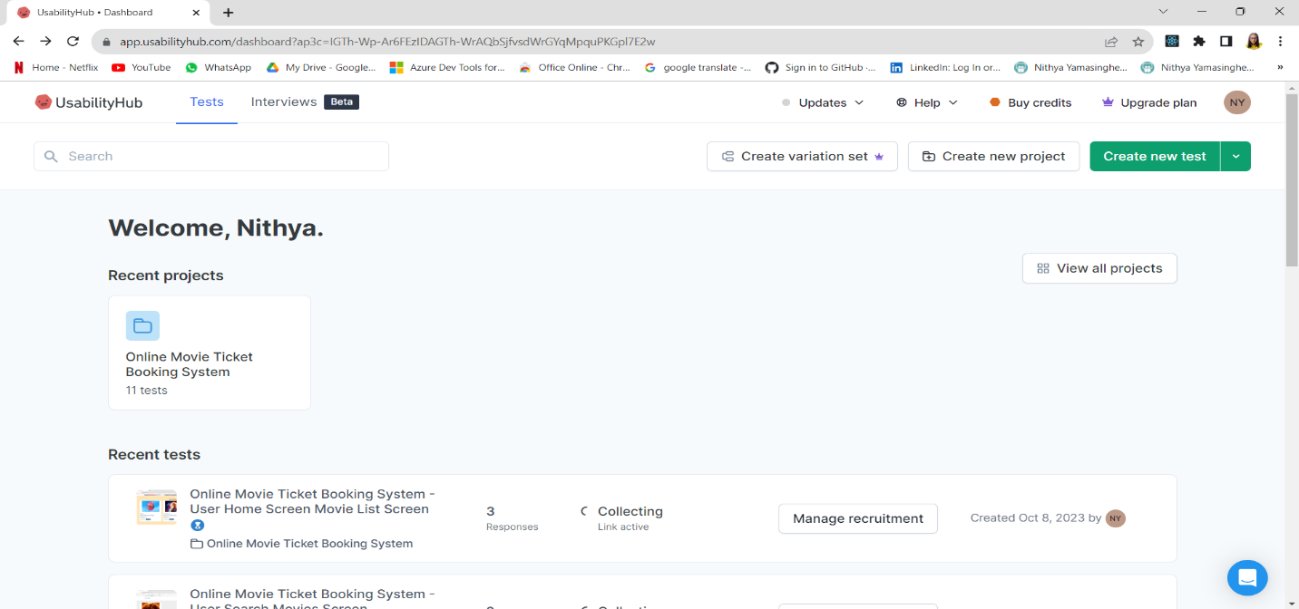

Conducted 11 five seconds screen tests for 11 screens with 10 to 12 participants total.

**REGULAR USERS**

1. **FIVE SECOND TESTING FOR USER HOME SCREEN**

Link for the test - <https://app.usabilityhub.com/do/5748be728628/e649>

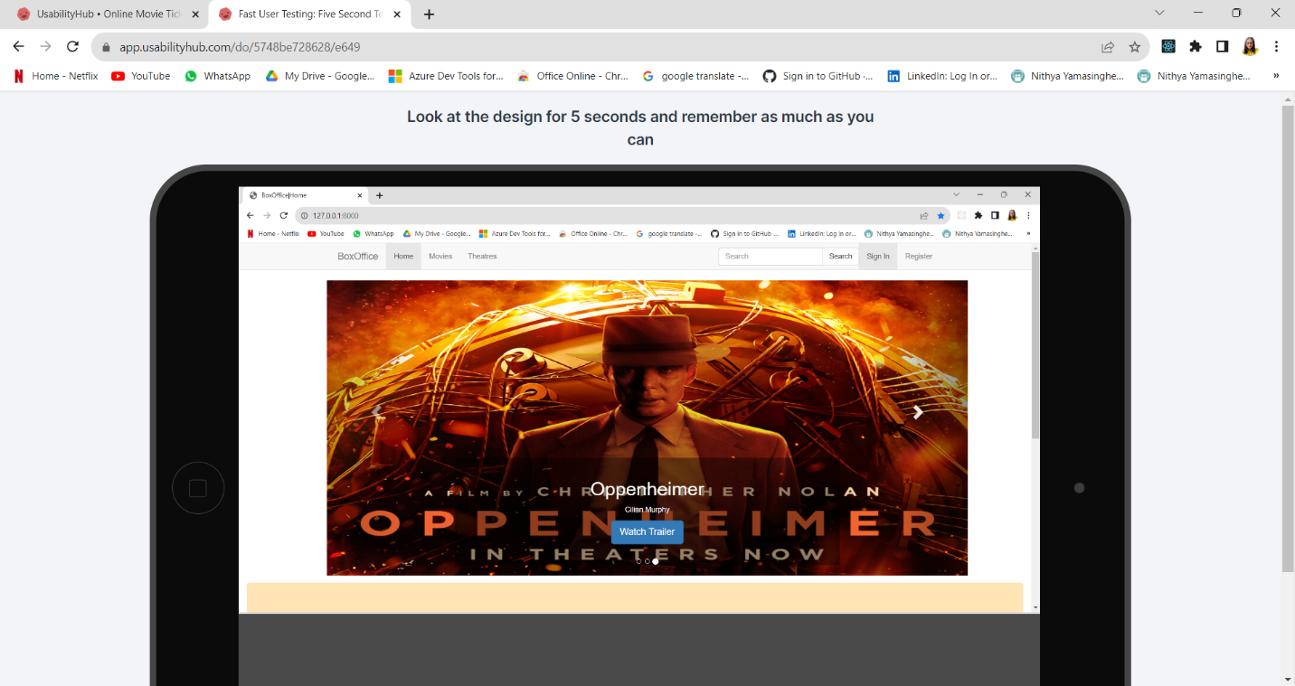

**RESULTS**

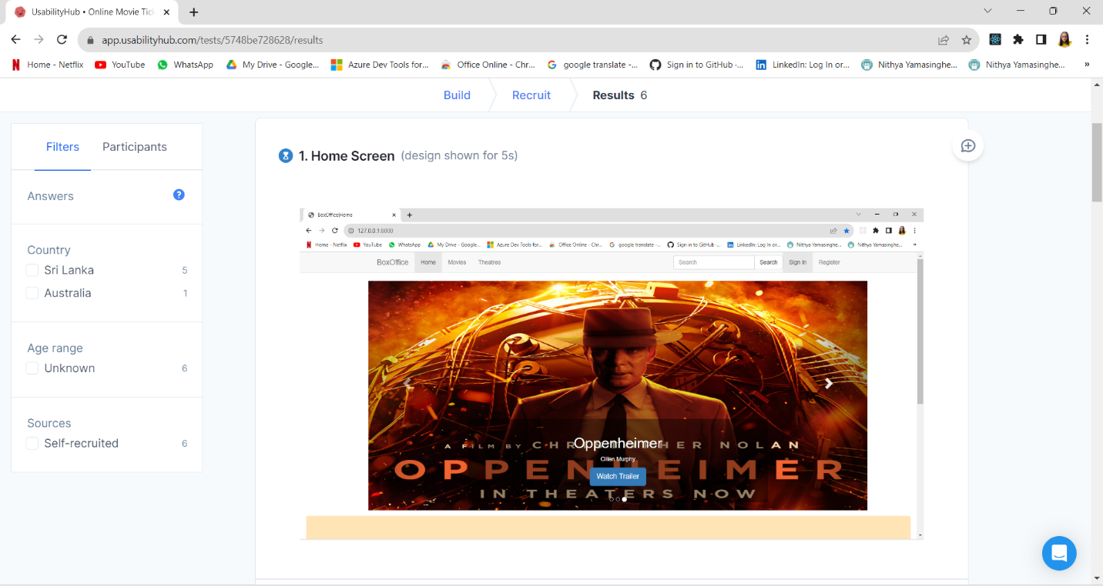

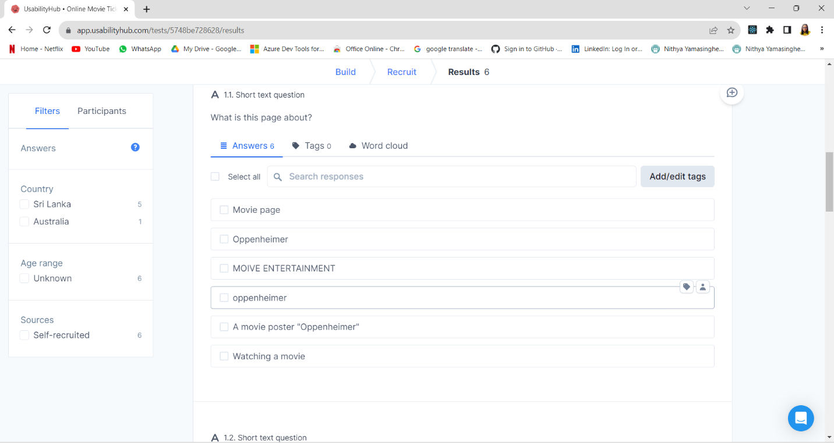

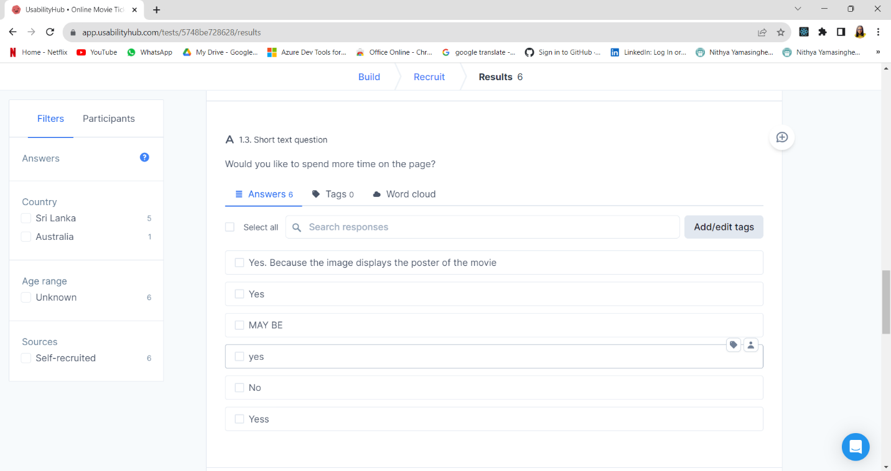

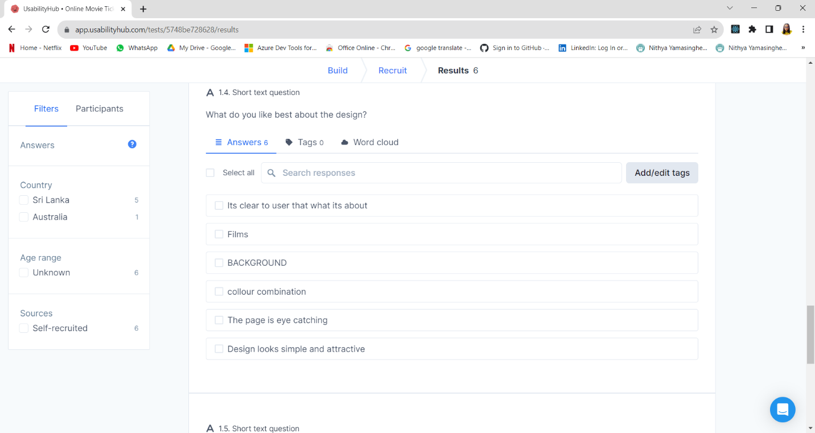

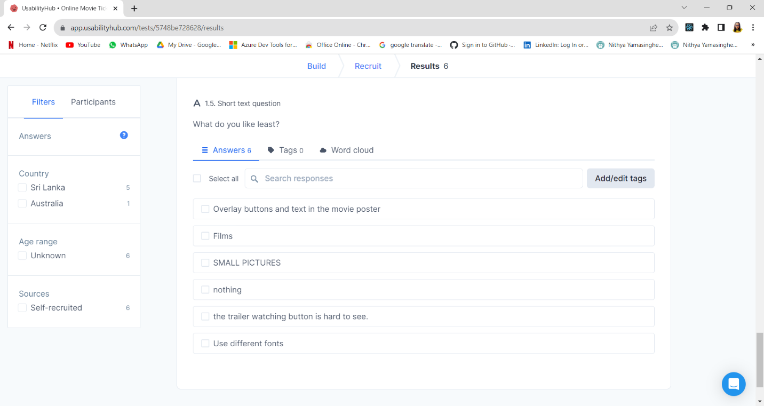

The results of the five-second test for the "Home Screen" provide valuable insights into users' initial impressions and interactions with the design.

First and foremost, participants seemed to grasp the primary purpose of the page, with responses indicating that it's about a "Movie page," specifically highlighting "Oppenheimer." This suggests that the content's purpose is effectively conveyed to users.

In terms of design, users had varying impressions, ranging from finding it "Normal" to "Good," "Attractive," and "Interesting." Positive comments noted the eye-catching movie poster and the simplicity and attractiveness of the design. This indicates that the visual elements are generally engaging and appealing to users.

Interestingly, most participants expressed a desire to spend more time on the page, citing reasons such as the displayed movie poster and its appeal. However, there was one user who indicated they wouldn't like to spend more time, suggesting that there may be a need for further engagement elements or content diversity to cater to different user preferences.

Participants appreciated the clarity of the design, the color combination, and the fact that it's clear to users what the page is about. These are positive attributes that enhance the user experience.

On the flip side, users identified some areas for improvement. They mentioned issues such as overlay buttons and text on the movie poster, small pictures, and the difficulty of seeing the trailer watching button. Additionally, there was a suggestion to use different fonts, possibly indicating a need for improved readability and typography choices.

To enhance the "Home Screen," it's advisable to address the identified issues with overlay buttons, text legibility, and button visibility, especially for the trailer watching feature. Additionally, considering diversifying content or interaction options to cater to various user preferences could further improve engagement. Overall, this feedback suggests that while the page is generally appealing, minor refinements in usability and readability can enhance the user experience

1. **FIVE SECOND TEST FOR USER HOME MOVIE LIST SCREEN**

Link for the test - <https://app.usabilityhub.com/do/98fe51902ea3/e389>

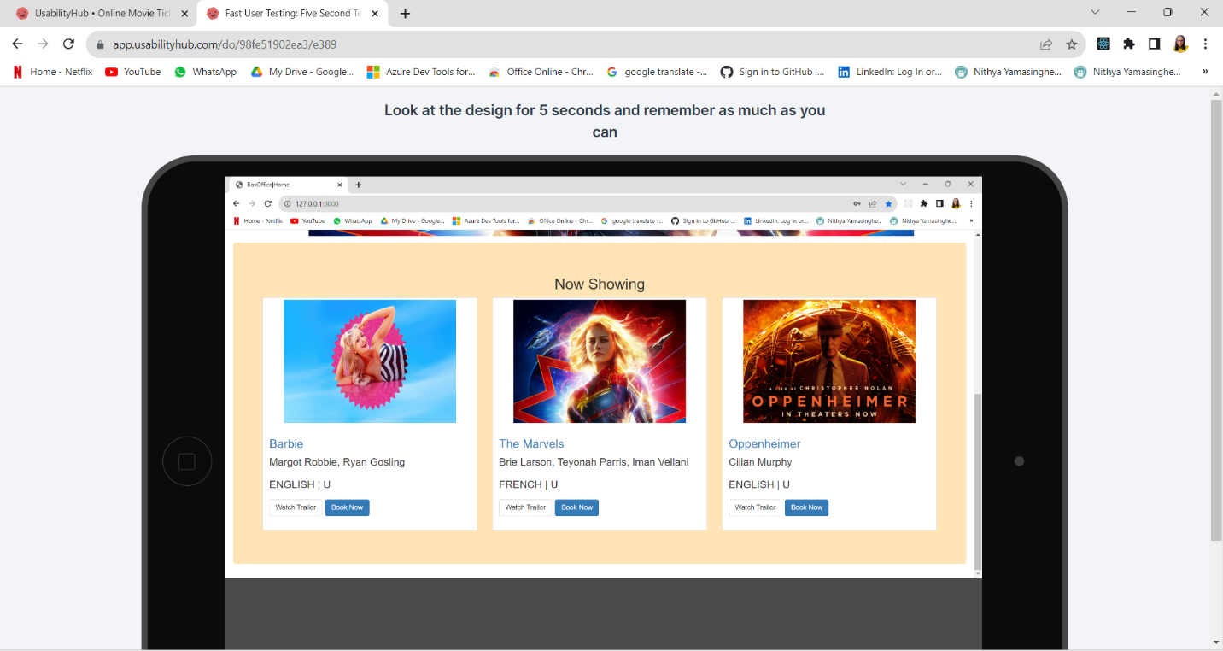

**RESULTS**

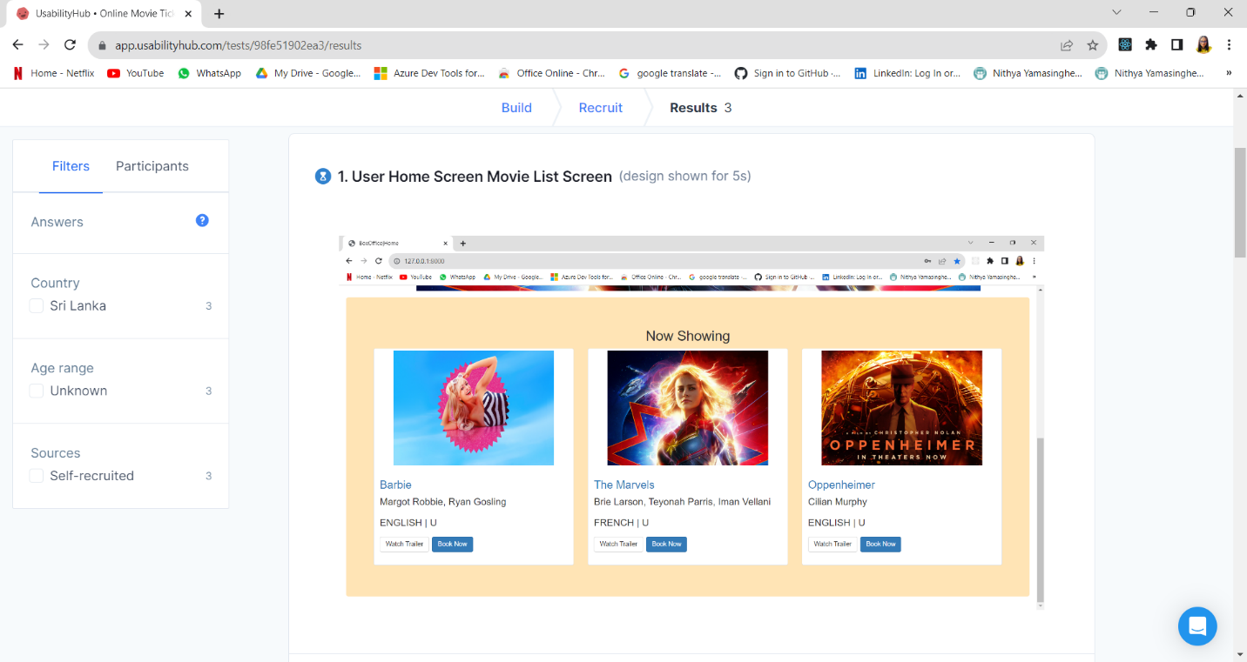

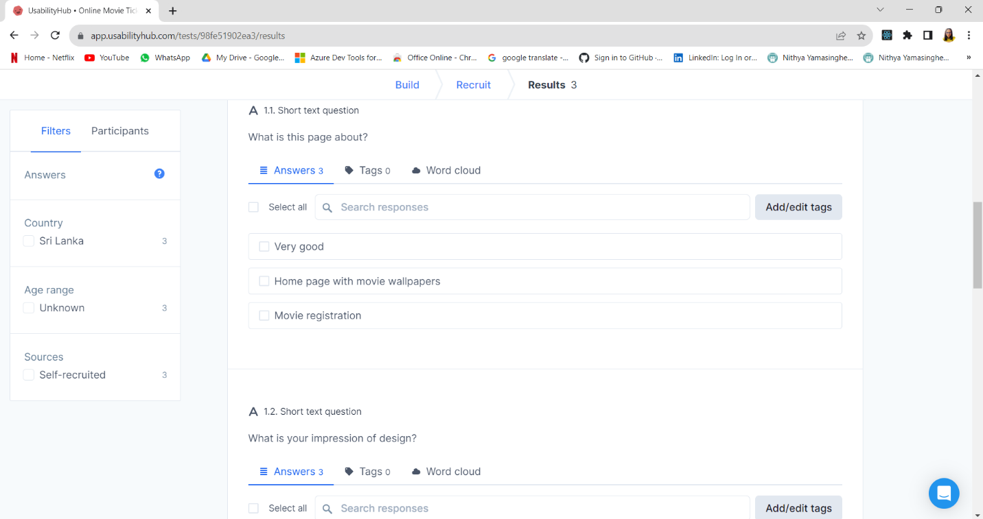

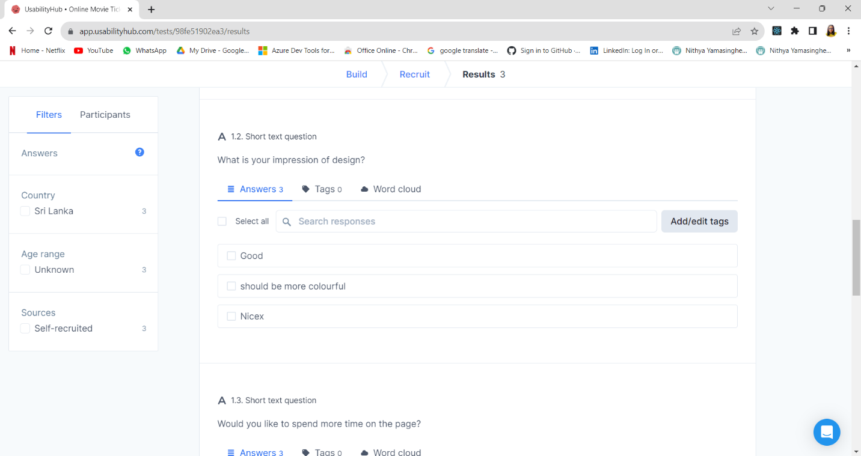



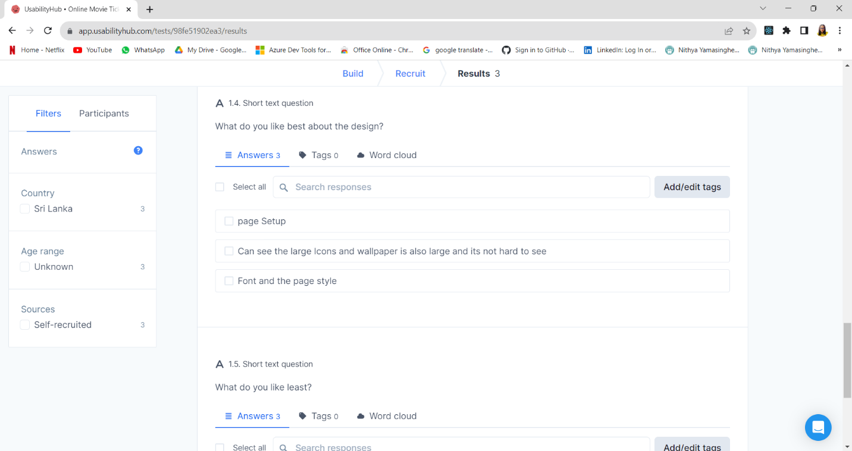

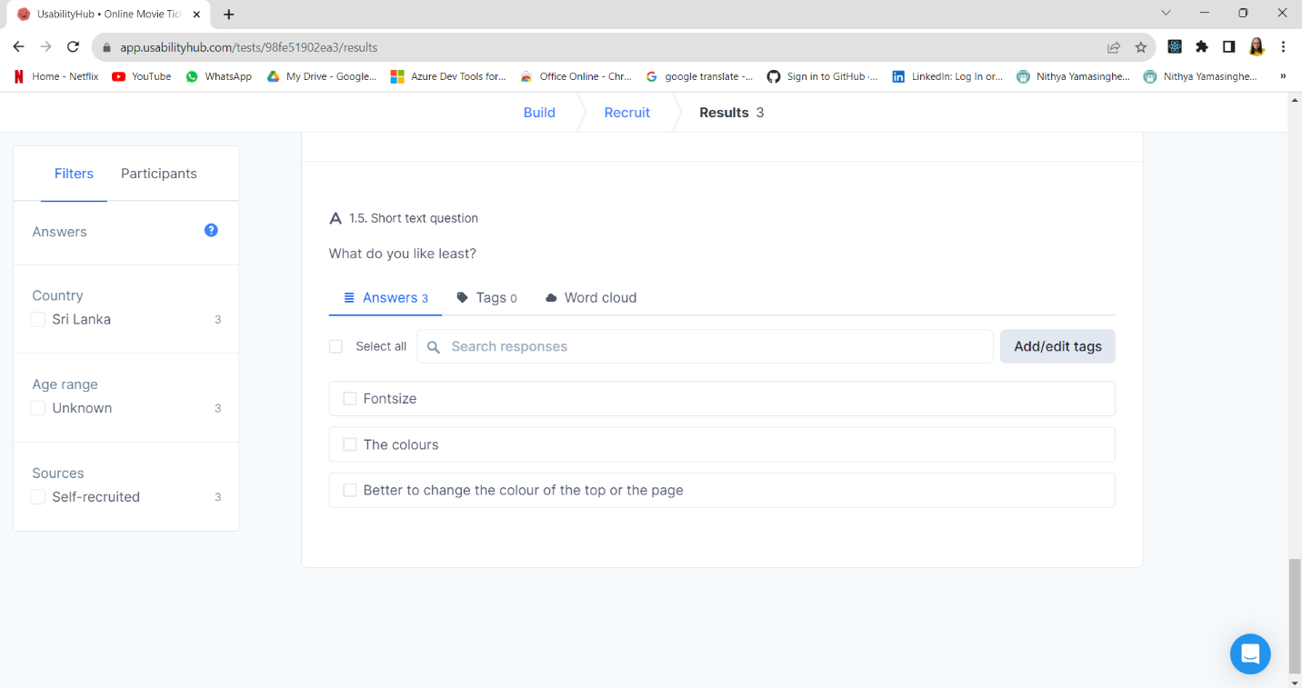

The results of the five-second test for the "Movie List" screen offer valuable insights into users' initial impressions and interactions with the design.

Users generally provided positive feedback regarding the page's purpose, with responses indicating a clear understanding of what the page is about, such as being a "Home page with movie wallpapers" or for "Movie registration." This indicates that the content's purpose and relevance are well-communicated.

In terms of design, participants had mixed opinions. While some users found the design "Good" and appreciated features like large icons and wallpapers, others suggested that the page could be made "more colorful." This suggests an opportunity to balance the aesthetic appeal with user preferences.

The unanimous response to wanting to spend more time on the page suggests that users found the content engaging or intriguing enough to warrant further exploration.

Participants highlighted positive aspects of the design, such as the page setup, visibility of large icons and wallpapers, and font and page style. These elements seem to have resonated well with users.

On the downside, users mentioned issues with font size and colors. Specifically, there were concerns about font size being difficult to read, and suggestions to change the page's color scheme, particularly the top of the page. These comments imply that there's room for improvement in terms of readability and visual aesthetics.

To improve the "Movie List" screen, consider addressing the font size and color scheme to enhance readability and make the page more visually appealing. Additionally, it's important to maintain a balance between aesthetics and usability, as some users expressed a desire for a more colorful design. Gathering further user feedback and conducting usability testing with a larger audience can provide deeper insights and guide refinements to create an even more engaging and user-friendly movie list screen.

**ADMIN USERS**

1. **FIVE SECOND TESTING FOR ADMIN ADD MOVIE SCREEN**

Link for the test - <https://app.usabilityhub.com/do/c8a8604c81da/d9c7>

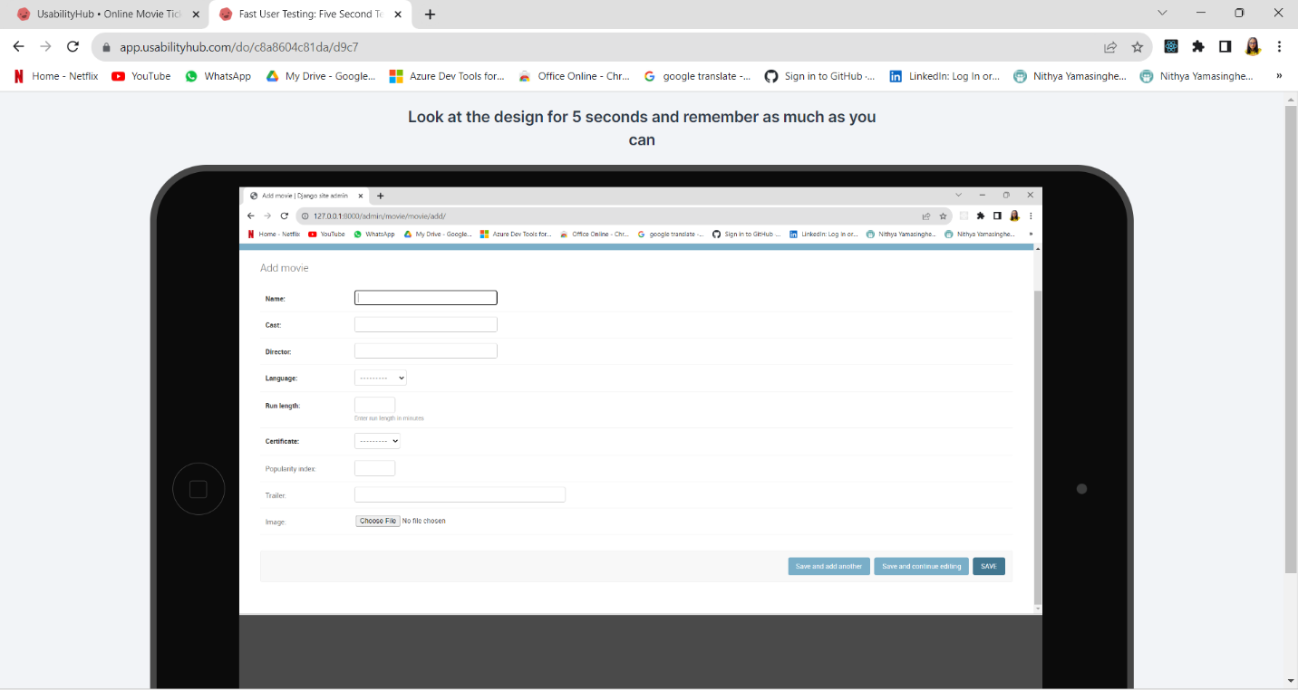

**RESULTS**

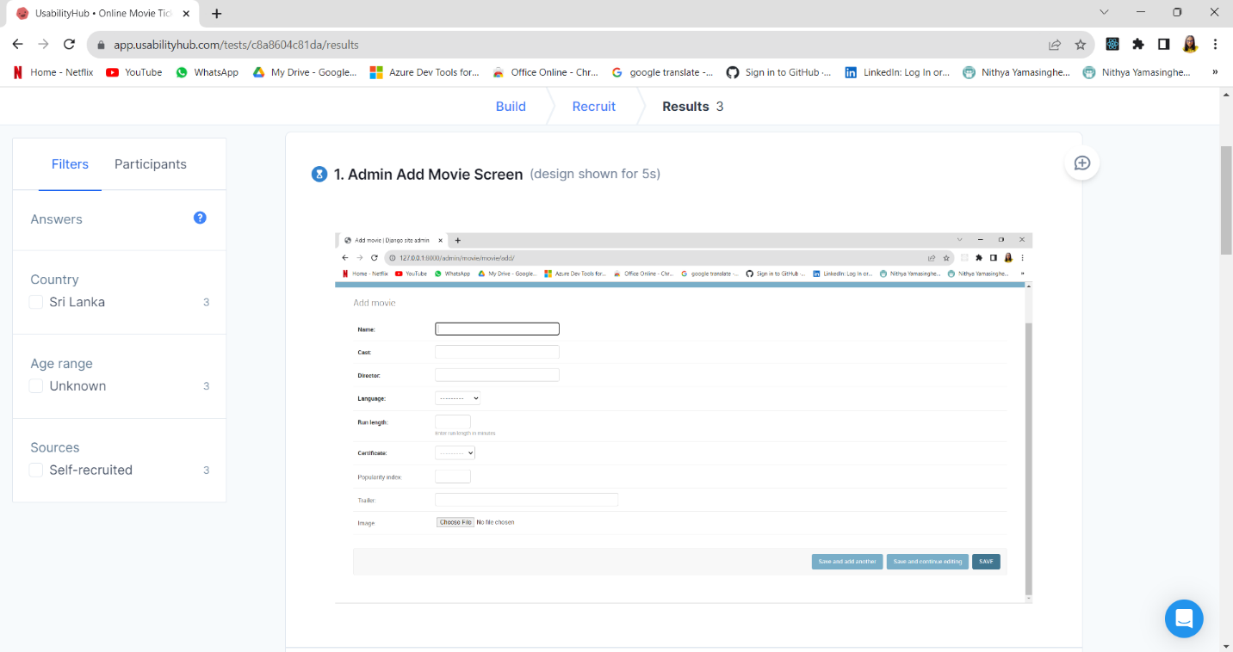

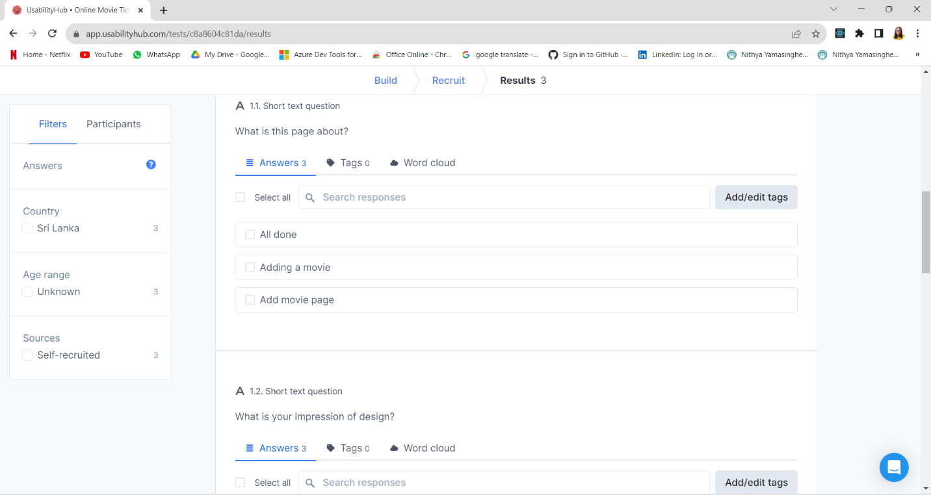

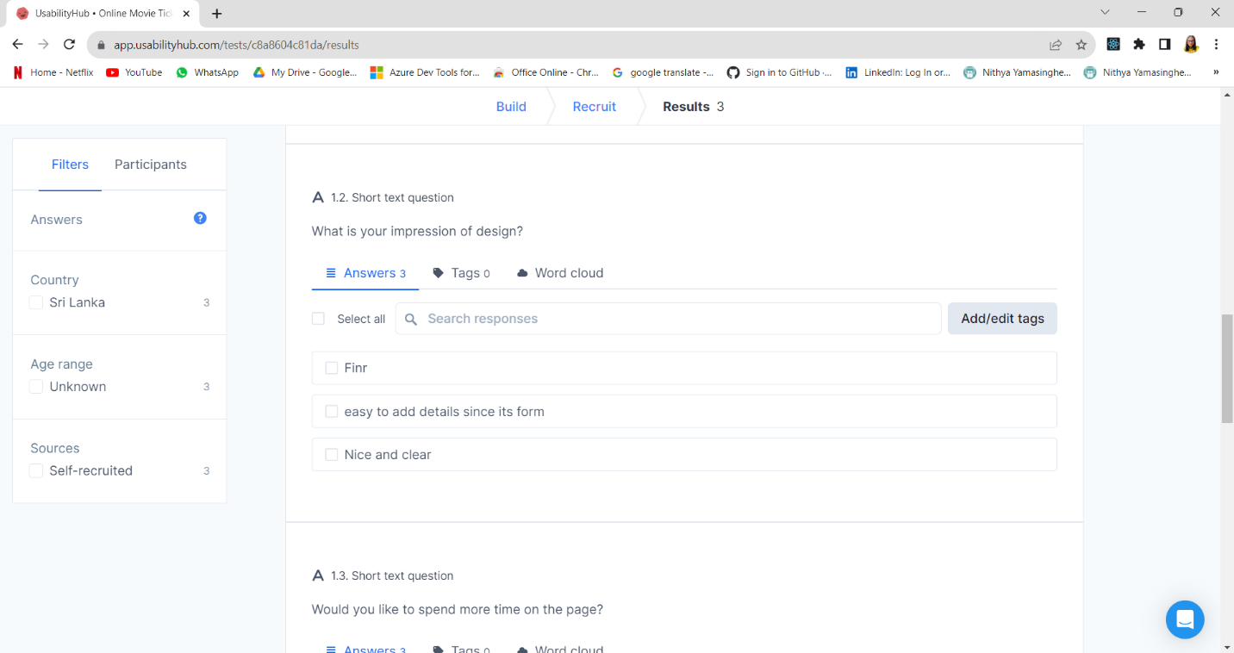

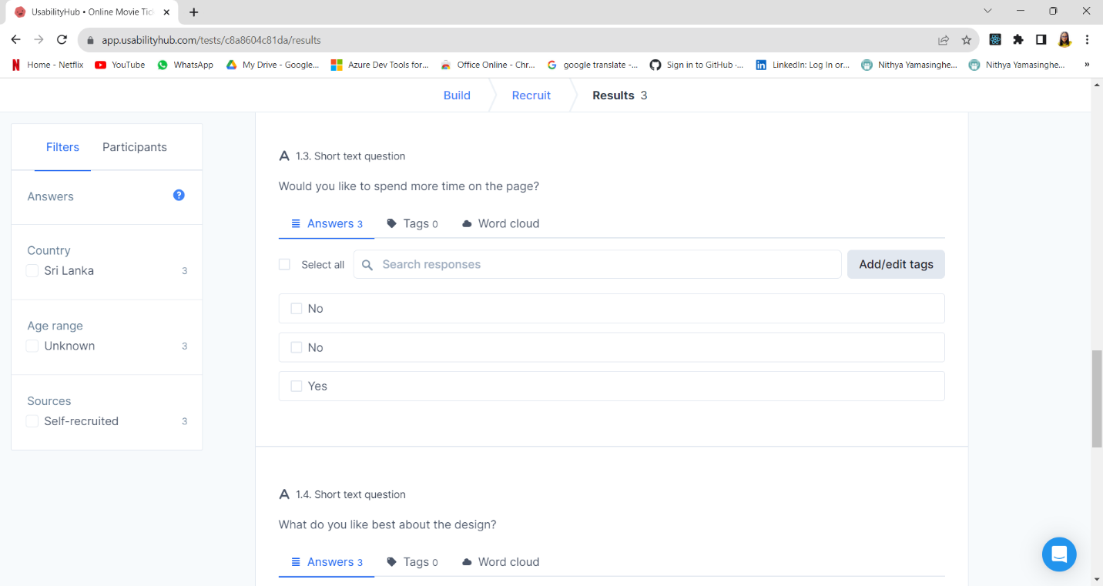

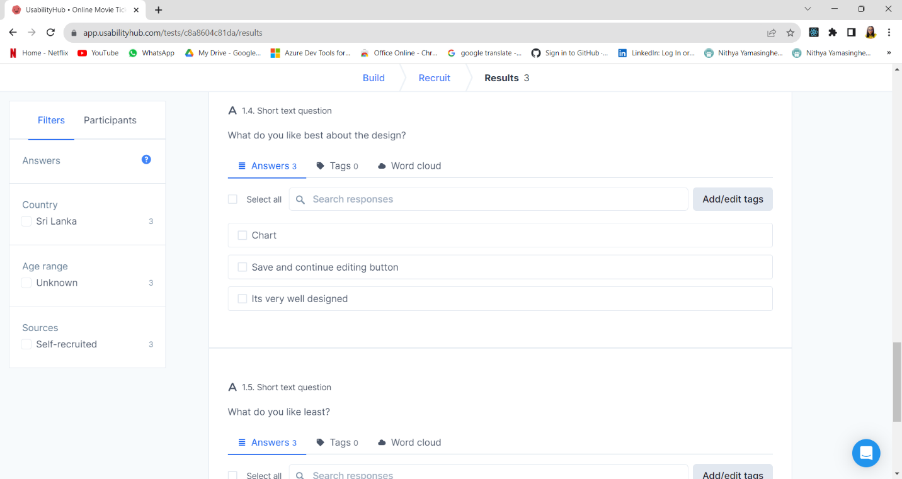

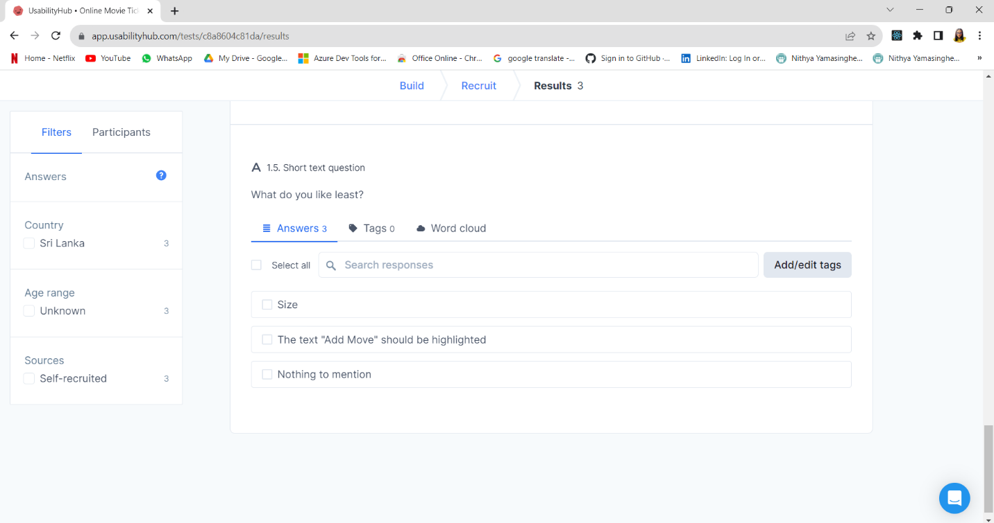

The five-second test responses for the "Add Movie" screen provide valuable insights into users' initial impressions and interactions with the design.

Firstly, it's evident that users found the page relatively easy to navigate, with comments indicating that adding details was straightforward, thanks to the form-based approach. This is a positive sign, suggesting that the core functionality is intuitive.

Users also appreciated the clarity and design of the "Save and continue editing" button, highlighting its effectiveness in guiding their actions. However, one user mentioned that the text "Add Move" should be highlighted, indicating a minor issue with clarity that could be addressed.

Interestingly, when asked if they would like to spend more time on the page, there were mixed responses. While two users stated that they wouldn't like to spend more time, one user expressed a desire to do so. This discrepancy might suggest that the page could benefit from providing more engaging or informative content to capture user interest.

In conclusion, the initial feedback from the five-second test is generally positive, indicating that the core functionality of adding a movie is user-friendly. To improve the design further, consider highlighting the "Add Movie" text for better clarity and explore opportunities to enhance user engagement, possibly by adding more context or information about the movie being added. Additionally, it's essential to gather additional feedback and conduct usability testing with a larger group of users to validate these initial findings and make informed design refinements.

**4.1.2 PERSONA AND SCENARIO TESTING**

|  |  |
| --- | --- |
| profile.png  **Emily Doe**  **Registered User** | **Profile Background**  Movie enthusiast who frequently watches movies in theatres.  **Goals and Tasks**   * Browse and search for movies currently playing in local theatres. * View movie details such as synopsis, cast, and showtimes. * Select seats and book tickets for desired movie showtimes. * Make online payments securely for the booked tickets. * Receive booking confirmation and digital tickets. |
| **Anxieties and Motivations**   * Anxious about technical glitches that might hinder the ticket booking process. * Motivated by the convenience of booking tickets online and avoiding long queues. * Motivated by the prospect of enjoying a seamless movie-watching experience.   **Frustrations and Concerns**   * Frustrated by slow-loading pages or errors during the ticket booking process. * Concerned about the availability of good seats, especially for highly anticipated movies. * Frustrated if the payment process is complicated or there are issues with payment gateways. * Concerned about not receiving the booking confirmation or tickets on time.   **Needs and Expectations**   * Expects an intuitive and user-friendly interface for browsing movies and booking tickets. * Expects real-time seat availability updates and the ability to choose preferred seats. * Needs a secure and smooth payment process with multiple payment options. * Expects timely email or SMS notifications with booking details and QR code tickets. | **Scenario**  Emily is excited about watching the highly anticipated movie released this weekend. She opens the online movie ticket booking platform on her laptop and starts browsing the list of movies currently playing. She selects the movie she's interested in and checks the showtimes. Seeing that the evening show has limited seats left, she quickly selects her preferred seats and proceeds to the payment page. She chooses to pay using her saved card details and completes the booking. Within seconds, she receives a booking confirmation email along with digital tickets attached. Emily was relieved that the process was smooth and secured her seats for the movie. |

|  |  |
| --- | --- |
| profile.png  **Alex John**  **Admin User** | **Profile Background**  Theatre manager or staff responsible for managing movie listings and theatre operations.  **Goals and Tasks**   * Add and update movie listings, including details like title, synopsis, showtimes, and available seats. * Manage and monitor seat reservations and bookings for each movie showtime. * Handle cancellations, refunds, and rescheduling of movie showtimes if necessary. * Generate reports on ticket sales, occupancy rates, and popular movies. |
| **Anxieties and Motivations**   * Anxious about inaccurate movie listings or showtime information leading to customer complaints. * Motivated by the efficient management of theatre operations and providing a seamless experience. * Motivated to ensure optimal occupancy rates and successful movie screenings.   **Frustrations and Concerns**   * Frustrated by a complex and non-intuitive admin interface that makes movie management difficult. * Concerned about overbooking or double-booking of seats due to system errors. * Frustrated if there's a lack of timely support for technical issues from the platform's support team. * Concerned about data security and Privacy of customer information.   **Needs and Expectations**   * Needs a user-friendly admin dashboard for easy movie and showtime management. Expects real-time updates on seat reservations and bookings to prevent overbooking. * Needs a reliable technical support system to address any issues that arise quickly. | **Scenario**  Alex, the theatre manager, logs into the admin portal of the online movie ticket booking system. He notices that one of the upcoming blockbuster movies has changed its release date. He quickly updates the movie listing with the new showtimes and ensures that the seat availability is accurate. He also receives a notification about a technical glitch some users experienced during bookings. He contacts the platform's support team and gets a prompt response with a solution. With everything in order, he generates a report on the ticket sales for the month and is pleased with the occupancy rate. |

|  |  |
| --- | --- |
| profile.png  **Guest Linda**  **Guest User** | **Profile Background**  Individuals who are not registered but want to explore movie options.  **Goals and Tasks**   * Browse available movies and their showtimes. * Get an overview of the theatre's location and facilities. * Understand the ticket prices for different categories (e.g., adult, child, senior). * Decide whether to register for an account to simplify future bookings. |
| **Anxieties and Motivations**   * Anxious about the complexity of the booking process if they decide to register. * Motivated by the convenience of exploring movie options without committing to registration. * Motivated by the hassle-free process if they decide to book tickets as a guest.   **Frustrations and Concerns**   * Frustrated by limited access to certain features compared to registered users. * Concerned about not receiving personalized recommendations or loyalty rewards. * Frustrated if the guest booking process is not clearly explained or is confusing. * Concerned about potential hidden fees or charges during the booking process.   **Needs and Expectations**   * Expects a straightforward and transparent guest browsing experience. * Needs clear information about ticket prices, showtimes, and theatre details. * Expects a simple and accessible option to register for an account if desired. * Expects to be able to access customer support easily in case of any questions or concerns. | **Scenario**  Linda is new to online movie ticket booking platforms. She visits the website to explore movies for the weekend. She clicks on a movie poster that catches his interest and is directed to the movie's page. Linda quickly checks the showtimes and ticket prices. She notices a "Book Now" button and clicks it. Linda feels relieved that booking was easy and looks forward to her movie night. |

|  |  |
| --- | --- |
| profile.png  **Mary Anna**  **Registered User** | **Profile Background**  A busy professional who enjoys watching movies to unwind during weekends.  **Goals and Tasks**   * Quickly browse through the list of movies playing in nearby theatres. * Check showtimes and select convenient timings that fit his schedule. * Prefer premium seating options for a more comfortable experience. * Book tickets efficiently and securely. * Share her movie plans with friends on social media. |
| **Anxieties and Motivations**   * Anxious about missing out on tickets for popular movies due to limited availability. * Motivated by the prospect of a relaxing movie experience after a hectic workweek. * Motivated to find a user-friendly platform that makes the process efficient.   **Frustrations and Concerns**   * Frustrated by slow loading times that could deter him from using the platform. * Concerned about the clarity of seat availability and the accuracy of showtime information. * Frustrated if the booking process becomes time-consuming or complex. * Concerned about the security of her payment information.   **Needs and Expectations**   * Expects a responsive and fast-loading interface to make selections quickly. * Needs real-time updates on seat availability and showtimes to make informed decisions. * Expects a seamless and secure payment process with multiple payment options. * Expects the option to save her preferences for future bookings. | **Scenario**  A busy professional, Mary decides to unwind by watching a movie this weekend. She opens his smartphone's online movie ticket booking app during a short break. She searches for the latest movies and their showtimes. Finding a movie she's interested in, she selects the Saturday matinee show. She prefers premium seating for a comfortable experience and easily selects the seats he wants. She proceeds to the payment page and uses a digital wallet for convenience. The process is smooth, and she receives a confirmation SMS with her digital ticket. She shares her plans with her friends on social media, looking forward to a relaxing weekend. |

**MEMBER 02 - S370857 -MY NGOC DOAN**

**4.1.3 FIRST CLICK TESTING**

For the theatre app of the Movie booking system, there are two different interfaces for the admin user and the regular user. Usability tests ensure that digital interfaces are intuitive, efficient, and effective for their users. To do the usability testing for the Theatre app section of this system, I decided to use the first click test for both admin and general experiences.

For admin users, there are two main functions that need to be tested: Add Theatre function and Add Show function. For general users, there are also two main functions to test Select a theatre from a list and choose the show time to book a movie ticket.

There are some reasons for me to choose the first click test. First, it provides a quick and efficient way to assess the usability of a digital user interface. Focusing on the first interactions, it captures the crucial moments when users form their first impressions and make important navigational decisions. It can also show how well-designed the interface was constructed, it can show where the user feels unsure, confused, or misunderstood which can lead to different decisions.

**ANALYSIS AND SUGGESTIONS TO IMPROVE THE TEST RESULT**

1. **Test for Admin users**

**1). First Click Testing for “Add Theatre function interface”:** 15 participants

Suppose you are the admin of the theatre brand, now you have to add a new movie theatre in your city to your website. Click on the place you "Enter the theatre name”.

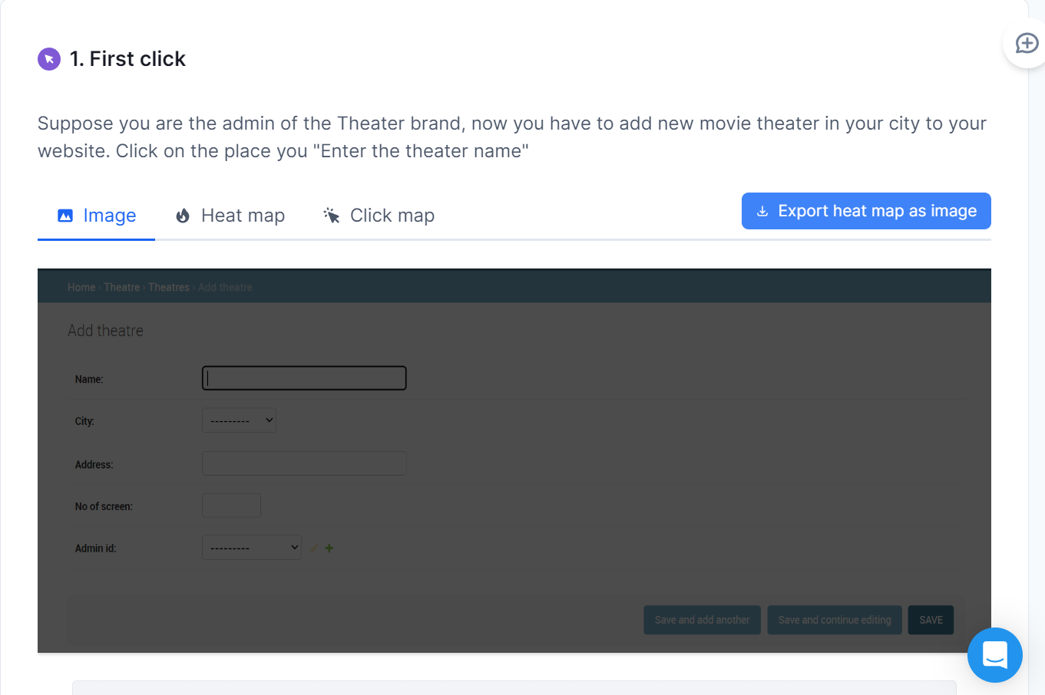

**RESULT**

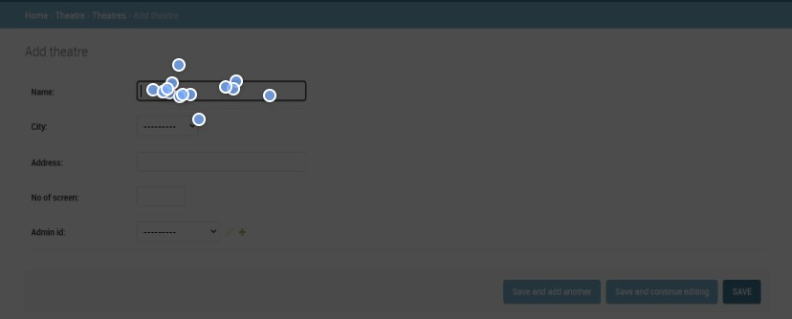

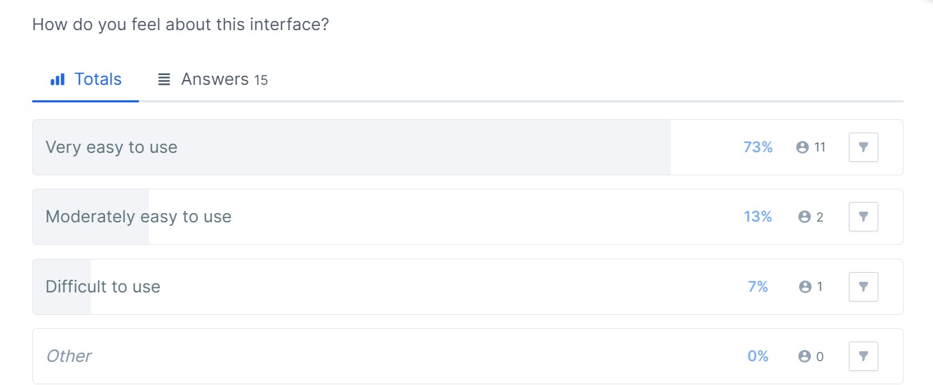

|  |  |  |
| --- | --- | --- |
| **Click position** | **Number** | **Percentage** |
| Expected Position | 13 | 86.67% |
| Close to Expected Position | 2 | 13.33% |
| Unexpected Position | 0 | 0 |

This test is specifically targeting the admin user experience. The result for this test was that the successful rate is high, there is no unexpected click position, and only 2 clicks are close to the expected position with 13.33%. The number indicates a strong level of usability for admin users and this page’s interface is well-designed and intuitive for admin users. This statement can also be proved by 73% of participants feel this interface is very easy to use.

Although there are minimal areas for improvement, there are 7% chose this interface as “Difficult to use”, and 13% chosee it as “Moderately easy to use”, I suggest gathering feedback from admin users about their overall experience and any specific suggestions they may have for further improvements.

**2). First Click Testing for “Add Show function interface”:** 15 participants

Suppose you are the admin of the theatre, now you have to add a show time for a movie. Click the place to "Enter Date”.

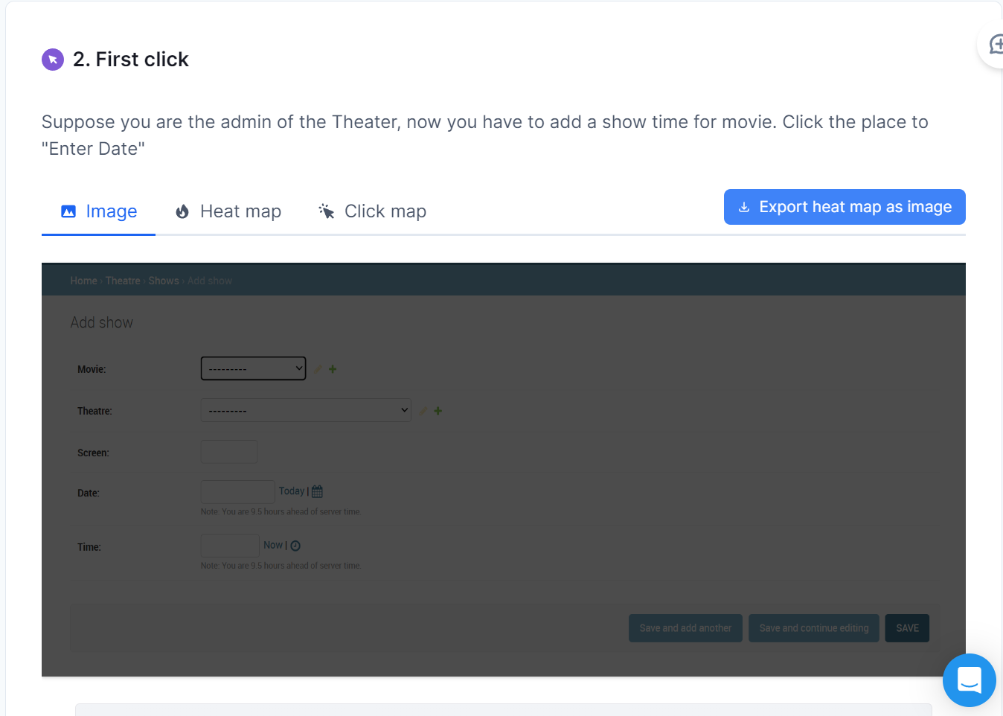

**RESULT**

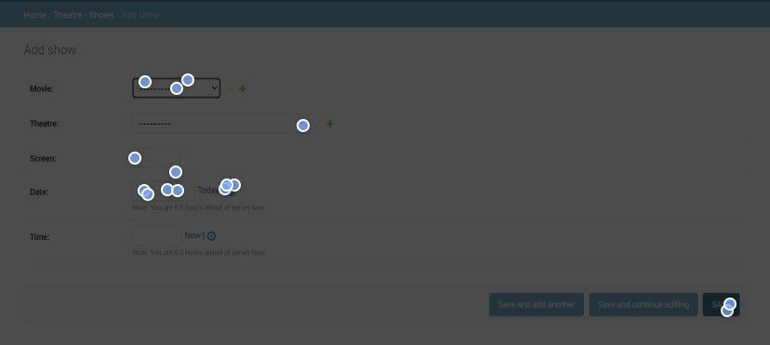

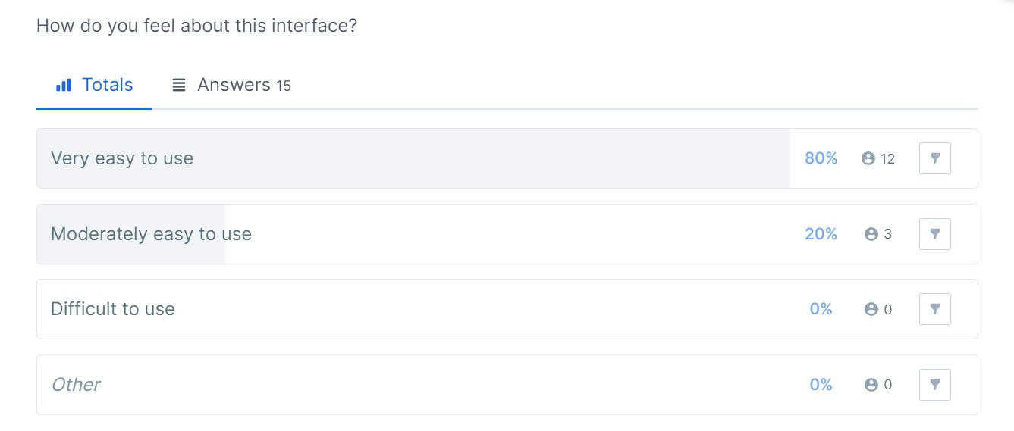

|  |  |  |
| --- | --- | --- |
| **Click position** | **Number** | **Percentage** |
| Expected Position | 7 | 46.67% |
| Close to Expected Position | 1 | 6.66% |
| Unexpected Position | 7 | 46.67% |

The high result for this test belongs to “Unexpected Click”, with 7 over 12 participants (46.67%). I suggest the low success rate could be the misunderstanding between the survey questions and the participants; instead of clicking on “Enter Date”, the other sections, even the “Save” Button, were also clicked. Moreover, 80% of participants felt this interface is "Very easy to use", contributing to the thinking that they were misunderstanding. So, this test is not reliable. I suggest that there must be another test for the admin users with the "Add Show Function", which would have no misunderstanding questions.

However, with that number we got, we need to gather feedback from the admin users to decide if this interface has any problem or any difficulty leading to the wrong click decisions. After finding out the actual problem in the “Add show” page’s interface, we will find the reason for the problem and a better way to improve this page.

1. **Test for regular users**

**3). First Click Testing for “Choose Theatre Interface”:** 15 participants

Click to choose "theatre Dh1" in Delhi

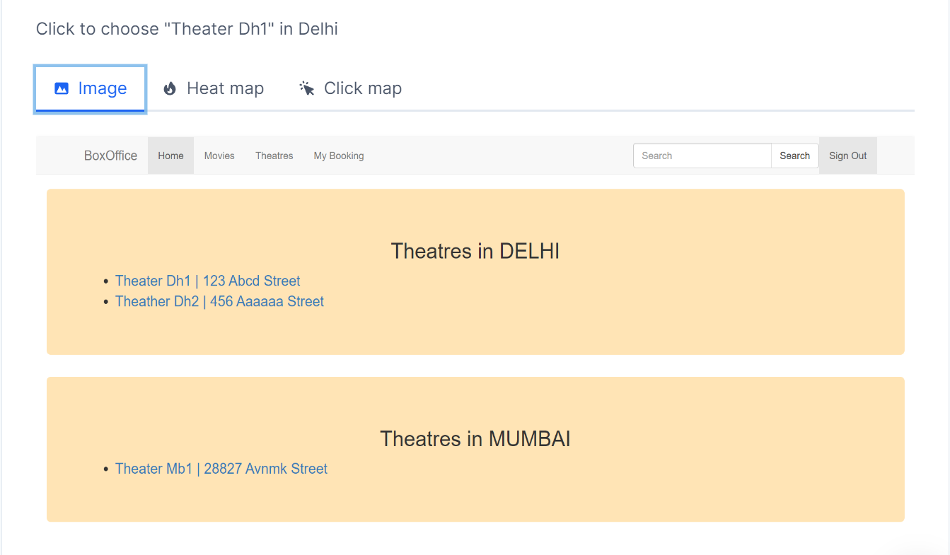

**RESULT**

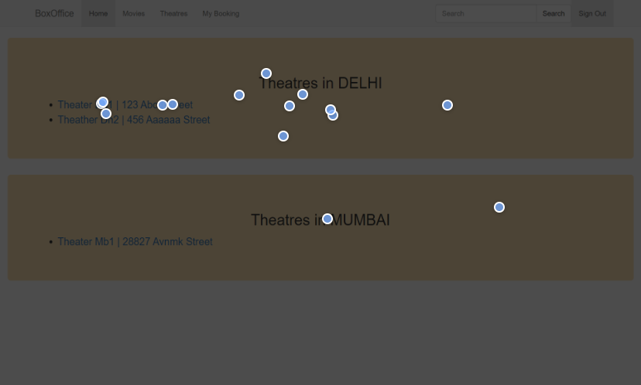

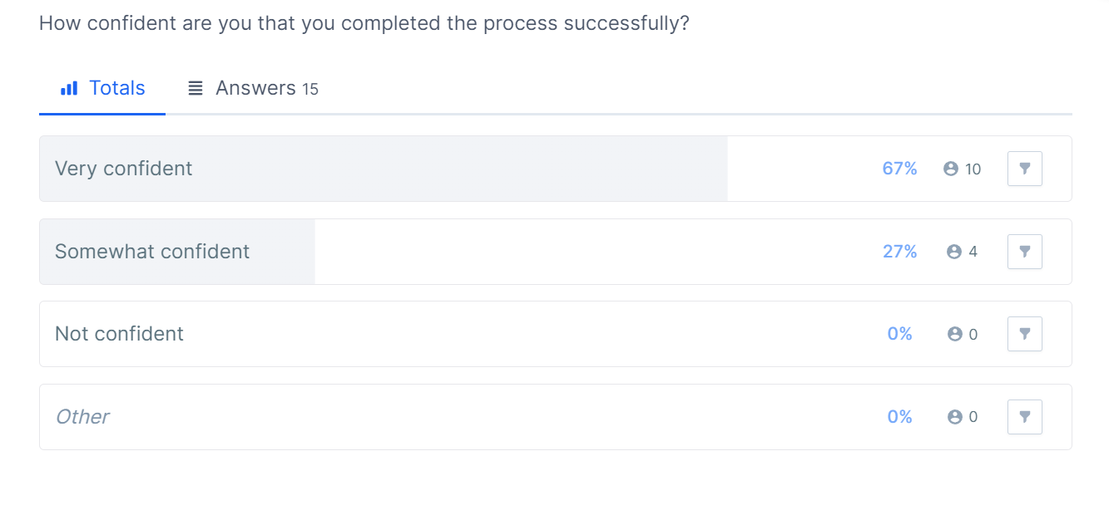

|  |  |  |
| --- | --- | --- |
| **Click position** | **Number** | **Percentage** |
| Expected Position | 5 | 33.33% |
| Close to Expected Position | 4 | 26.67% |
| Unexpected Position | 6 | 40% |

From the information in the two tables above, we can see that 10/15 people feel very confident about their answers, but we only got 5 correct click positions. Although the success rate, which is counted as both the “expected click position” and “Close to expected click position”, is 9 out of 15 participants. We can say that this “Choose Theatre” page confuses the customer when they try to choose the right theatre. The 40% of unexpected click positions mean we need improvements for this page.

I can suggest some reasons for this problem. Firstly, the visual hierarchy: there is only a hyperlink in the list of theatres to lead to a selected theatre’s page. There is no actual button such as “select” or “view”,... Therefore, the user might not know where to click properly. Besides, the size and colour are also a major factor. It is not attractive enough to the user. They might think this page only shows the list of the theatres in each city, but they don’t know they can see more information by clicking on the name of each theatre. Lastly, the position between two theatres in the same city is too close, it’s too easy to click on the wrong theatres.

To improve this test result, I suggest creating a button for each theatre’s name with an attractive colour and a suitable position. The placements of each button shouldn’t be too close to each other. Further testing and refinement should be ongoing to ensure continued usability and user satisfaction.

4). **First Click Testing for “Choose Movie Show Interface”:** 15 participants

Click to choose Barbie Movie at 4:00 PM

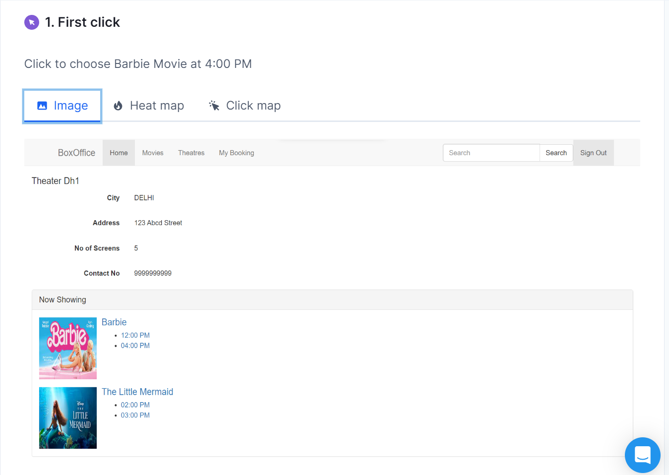

**RESULT**

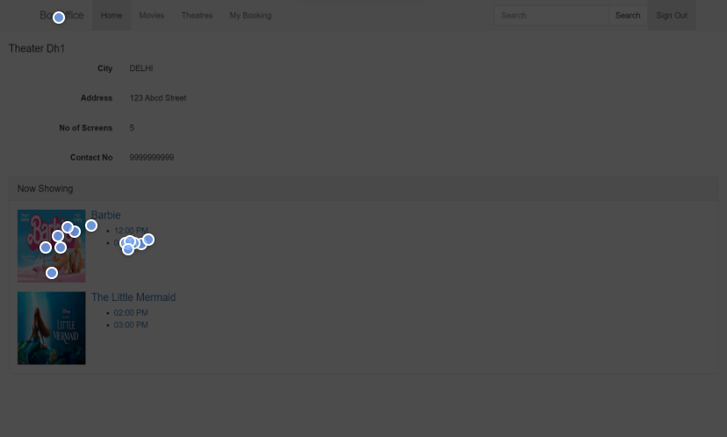

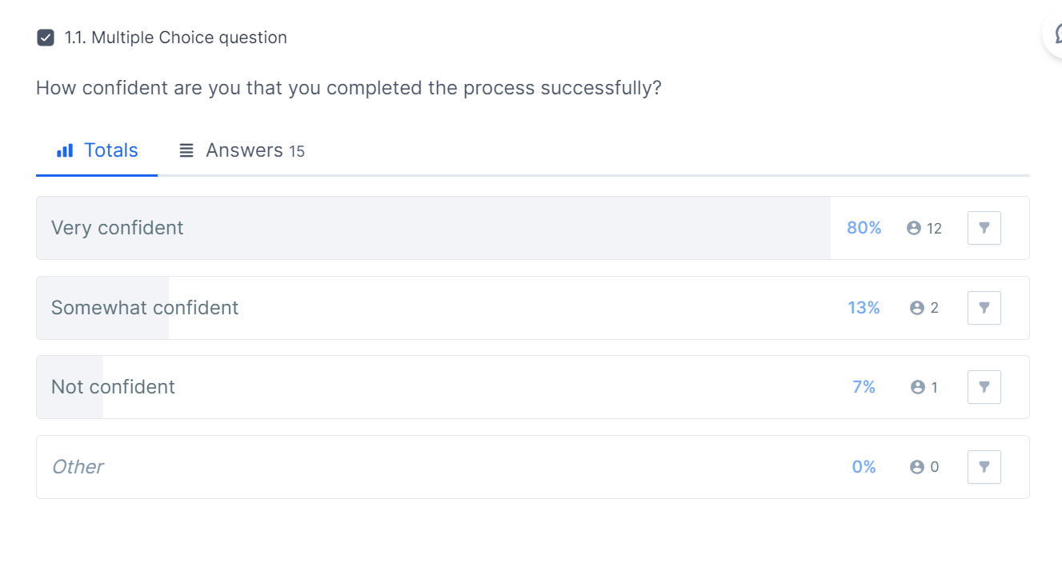

|  |  |  |
| --- | --- | --- |
| **Click position** | **Number** | **Percentage** |
| Expected Position | 7 | 46.67% |
| Close to Expected Position | 7 | 46.67% |
| Unexpected Position | 1 | 6.66% |

In this test, the success rate is much satisfied with 14 out of 15 participants choosing “Expected Position” and “Close to Expected Position” (93.34%). There is only 1 person who clicks into an unexpected position and feels not confident about the answer, so this page doesn’t need a lot of improvement.

Take a closer look at both two tables above, only 7 over 15 participants (46.67%) clicked on the picture instead of clicking on the time in the show list. I guess the user thinks they have to click to choose the movie first, to see more information about the movie, then choose the time after that. But on this website, the movie information is in a different section.

For that reason, to improve the result of this test, I suggest we write the instructions more clearly such as “Choose booking time” above the list of show times. Another suggestion is that we should create a button for each “time”, it’s easier for the user to think that they can click on the time not only to view the time. The placements of each button shouldn’t be too close to each other. Further testing and refinement should be an ongoing process to ensure continued usability and user satisfaction.

## PERFORMANCE TESTING

1). Page Speed Testing

Page speed testing is a crucial aspect of performance testing, especially for web applications and websites. The primary purpose of conducting page speed tests is to ensure that your online platform loads quickly and efficiently. This is essential for enhancing user experience as users tend to abandon slow-loading websites. Moreover, it has a direct impact on SEO rankings, making it a key consideration for web visibility. Tools like Google's PageSpeed Insights provide realistic insights into real-world performance, allowing you to identify issues that may affect user satisfaction. By prioritizing page speed testing, you can ensure that your project offers a smooth and responsive user experience while improving its visibility in search engine results.

2). Python timeit

Python's timeit module is an invaluable tool for performance testing at the code level. It serves the purpose of microbenchmarking, enabling you to measure the execution time of specific code snippets. This tool is particularly useful when you need to profile and optimize particular functions or sections of your codebase. By using Python timeit, you gain granular insights into your code's performance, pinpointing potential bottlenecks that could impact overall system efficiency. This level of detail helps you make targeted improvements where they are most needed, ensuring that your project's Python code operates optimally, performs efficiently, and responds swiftly to user interactions.

3). Apache JMeter

Apache JMeter, when integrated with Python, becomes a powerful performance testing tool for assessing the performance of web applications and services. Its primary purpose is to simulate varying levels of user traffic to evaluate how your system performs under different loads and scenarios. Python JMeter excels in load testing, allowing you to stress-test your application, understand its scalability, and identify potential issues under heavy user loads. Its integration with Python aligns well with your project's Python-based development, making it an ideal choice for seamlessly incorporating performance testing into your development workflow. By using Python JMeter, you can ensure that your web application or service can handle expected traffic and maintain its performance standards even during peak usage, ultimately delivering a reliable user experience.

**MEMBER 01 - S370170 - NITHYA ROMESHIKA YAMASINGHE**

* + 1. **PAGE SPEED (PERFORMANCE TESTING USING LIGHT HOUSE)**

Conducted a comprehensive performance test using PageSpeed Lighthouse, a powerful tool available in Google DevTools, to assess the performance of a locally hosted website. This testing methodology offers a detailed and real-time evaluation of various aspects of web page performance, including load times, accessibility, SEO, and more.

The process involved accessing the website through a local development environment, mimicking the conditions of a real-world user accessing the site from their browser. PageSpeed Lighthouse then analyzed the website's performance based on a set of predefined metrics and best practices.

During the test, PageSpeed Lighthouse assessed several critical factors. First and foremost, it evaluated page load times, ensuring that the website loads swiftly and efficiently, which is essential for providing a positive user experience. Additionally, the tool examined accessibility features, making sure that the website is inclusive and adheres to accessibility standards. It also scrutinized the website's SEO performance, assessing its visibility and ranking potential in search engine results.

Moreover, PageSpeed Lighthouse provided detailed insights into areas that needed improvement, such as optimizing images, leveraging browser caching, and reducing server response times. It offered actionable recommendations to enhance the website's overall performance, suggesting ways to minimize render-blocking resources, prioritize visible content, and address other performance bottlenecks.

By using PageSpeed Lighthouse for local website testing, I gained valuable data and recommendations that allowed me to fine-tune the website's performance and address any potential issues proactively. This approach ensures that the website will deliver an optimal user experience when it goes live on the web, loading quickly and efficiently while meeting accessibility and SEO standards.

**ANALYSIS AND SUGGESTIONS TO IMPROVE THE TEST RESULT**

**1). PAGE SPEED TEST FOR THE USER HOME SCREEN**

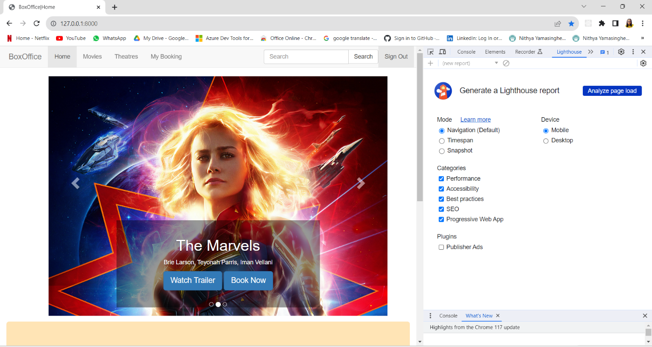

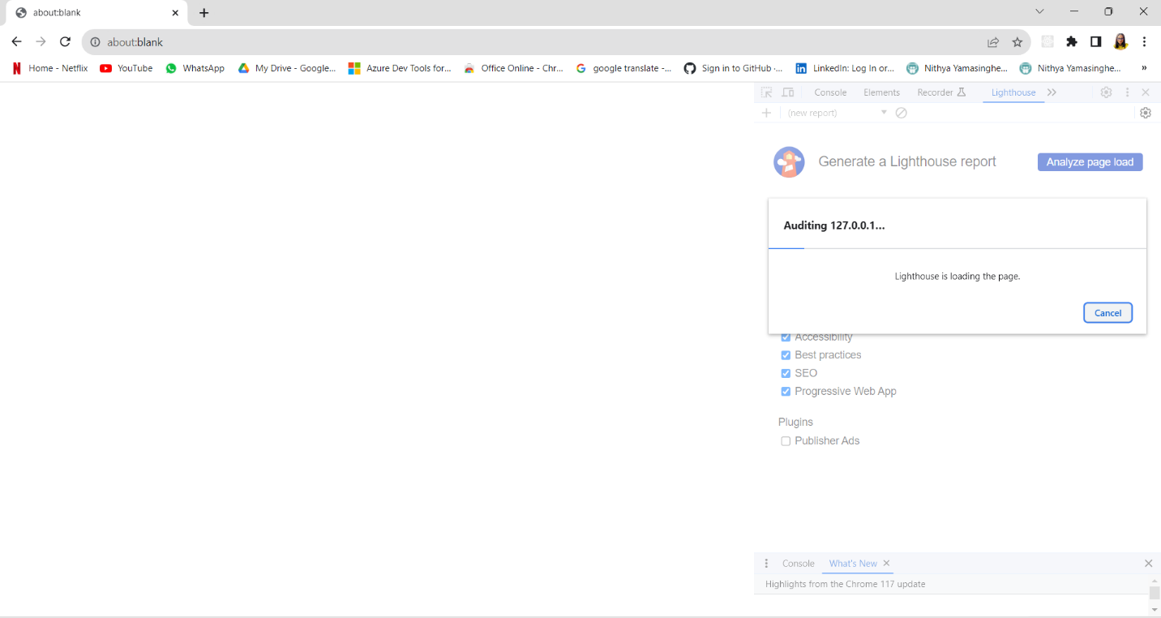

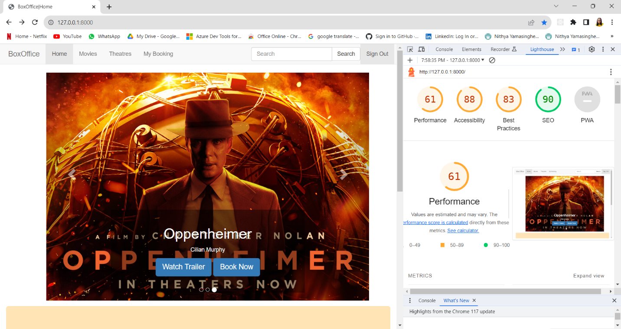

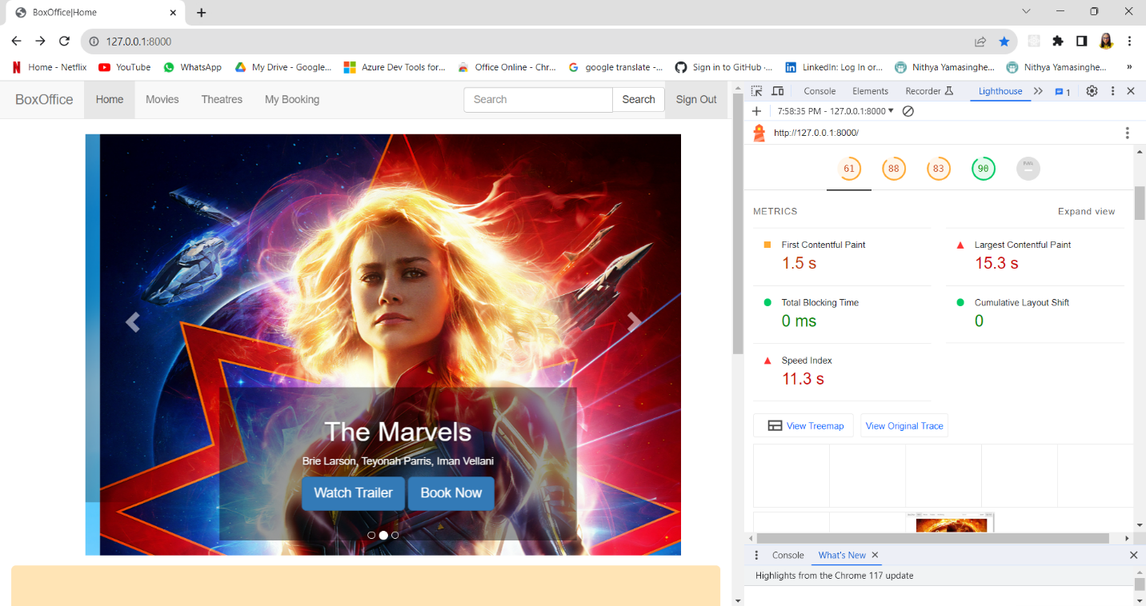

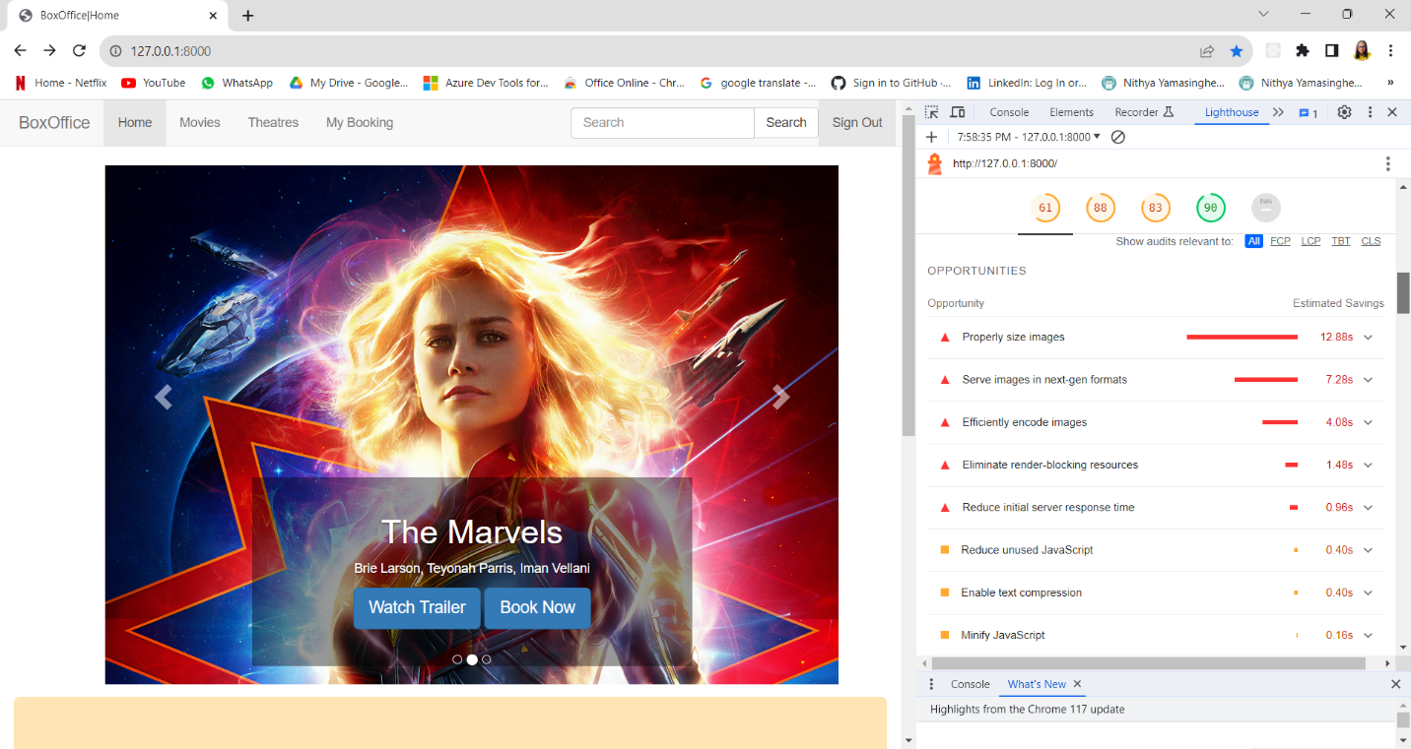

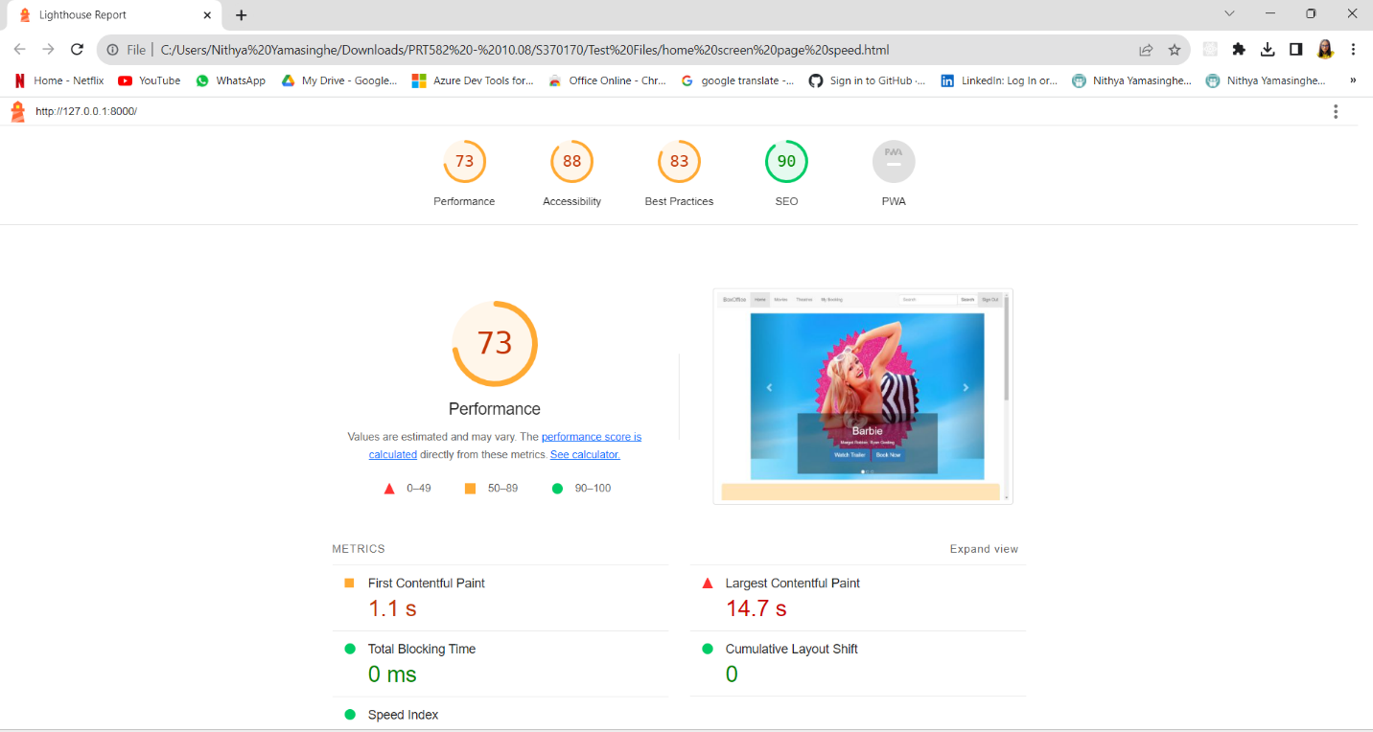

Performance (73/100): The performance score of 73/100 indicates that while some aspects of the page load relatively quickly, there are significant issues to address. The First Contentful Paint and Speed Index suggest a decent start in rendering content. However, the Largest Contentful Paint score of 14.7 seconds is a concern, indicating a substantial delay in loading the most significant content on the page. To improve performance, recommendations include resizing images appropriately, using next-gen image formats, efficient image encoding, and eliminating render-blocking resources.

Accessibility (88/100): The accessibility audit revealed opportunities for improvement. It identified issues related to ARIA (Accessible Rich Internet Applications) roles, where required children were missing for elements with ARIA roles, and ARIA input fields lacked accessible names. Furthermore, contrast issues were highlighted, indicating that background and foreground colors did not have sufficient contrast ratios. Additionally, the absence of a lang attribute for internationalization and localization was noted.

Best Practices (83/100): The best practices audit identified several areas of concern. It found that the page displayed images with incorrect aspect ratios, lacked an HTML doctype (which triggers quirks mode), and required improvements in user experience. The audit also detected JavaScript libraries in use and recommended the inclusion of source maps for large first-party JavaScript for better debugging.

SEO (90/100): The SEO checks indicated that there were areas for improvement in optimizing the page for search engines. Specifically, the page lacked a meta description, which is essential for search engine result display. Additionally, it suggested formatting the HTML in a way that enhances the understanding of the page's content by search engine crawlers.

PWA (Progressive Web App): Regarding Progressive Web App checks, several issues were identified. The page was not considered installable because the web app manifest or service worker did not meet installability requirements. Furthermore, the page was not optimized for PWA as it did not register a service worker that controls the page and start_url, lacked configuration for a custom splash screen, and did not set a theme color for the address bar. The manifest also lacked a maskable icon.

In conclusion, the analysis conducted, highlighted various areas for improvement. These include optimizing performance to reduce page load times, addressing accessibility issues, adhering to best practices for HTML and JavaScript, improving SEO by adding a meta description, and optimizing the web app for a better user experience by addressing PWA-related concerns.

**2). PAGE SPEED TEST FOR THE ADMIN ADD MOVIES SCREEN**

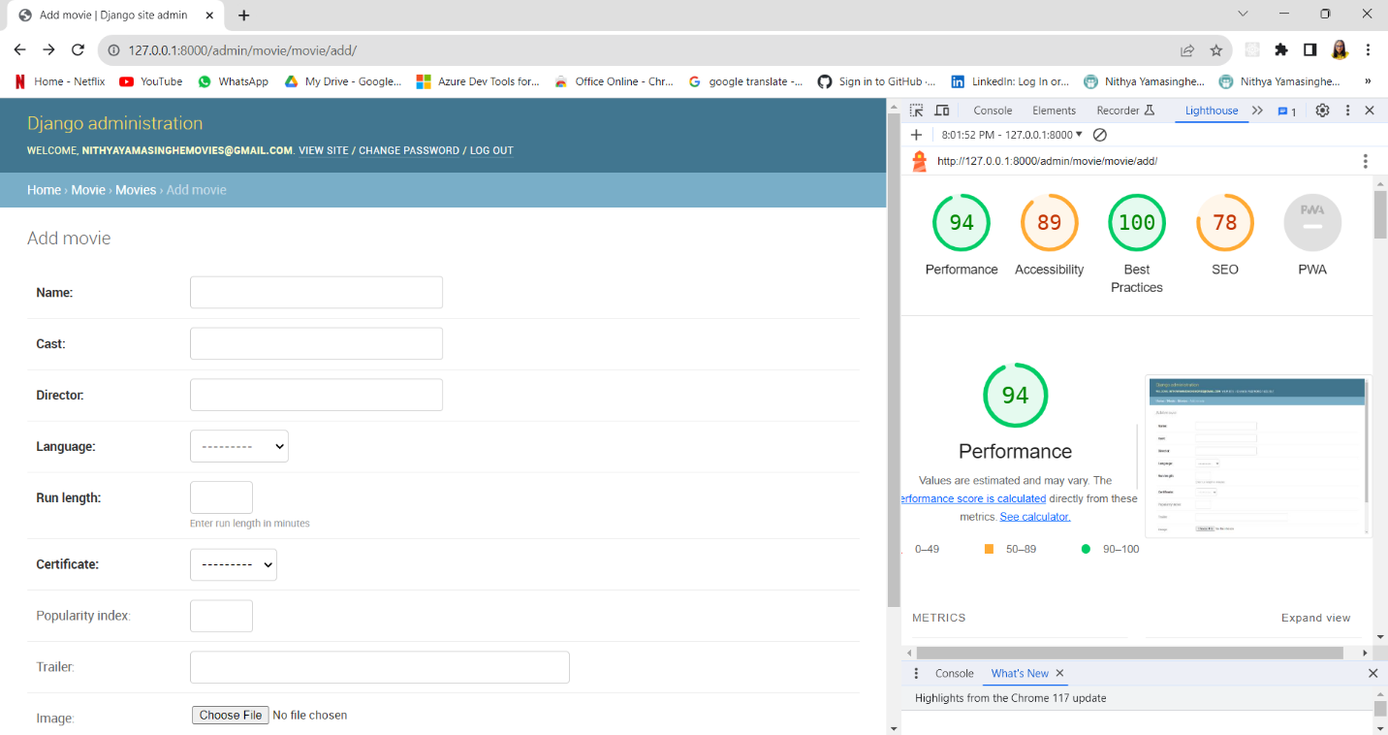

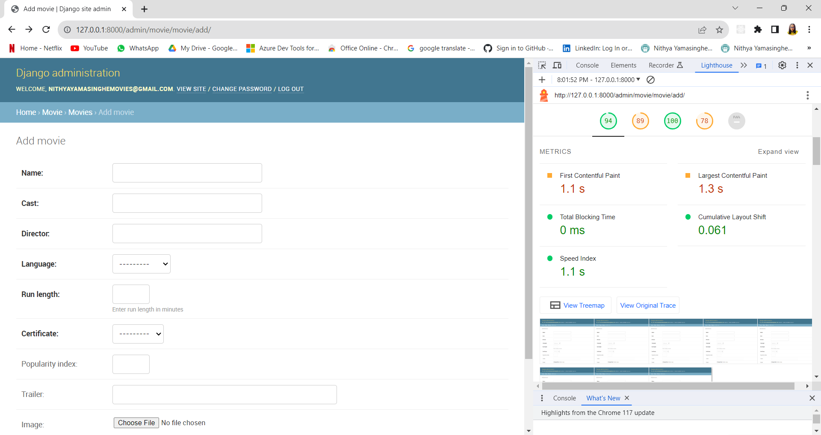

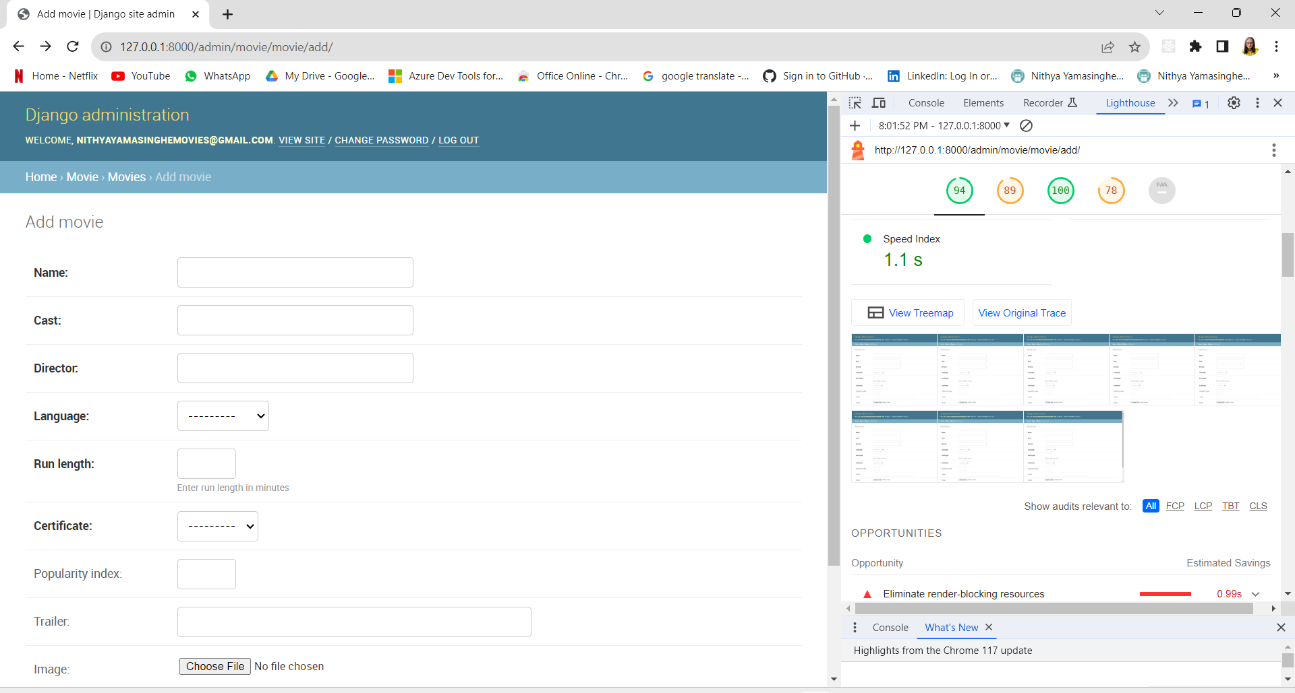

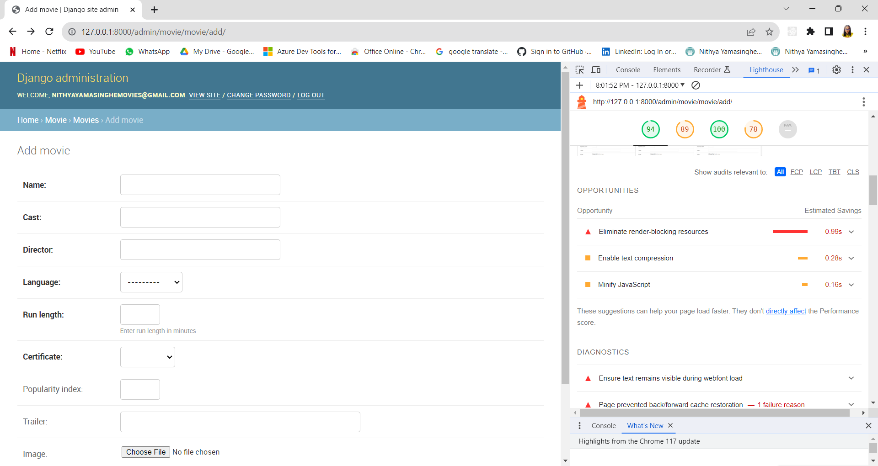

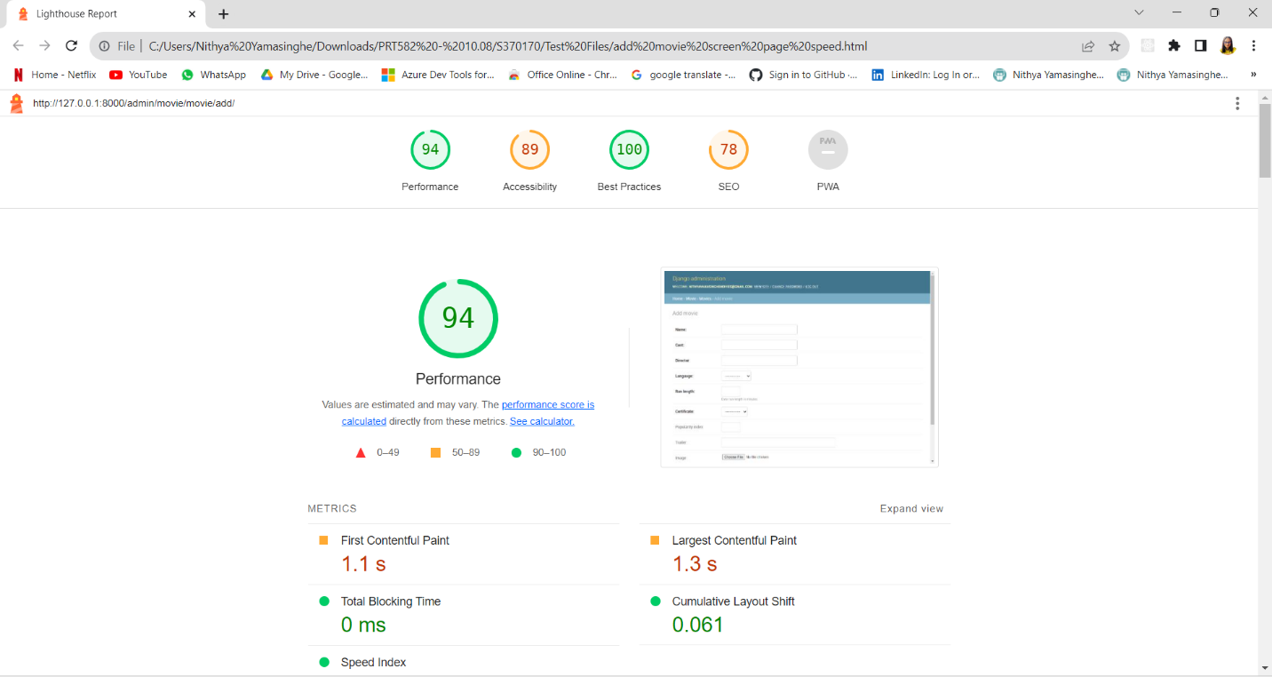

The page received a performance score of 94 out of 100. This score is determined based on various metrics, including the time it takes for the first content to appear on the page (1.1 seconds), the time it takes for the largest content to load (1.3 seconds), and other factors like total blocking time and cumulative layout shift. These metrics indicate that the page has relatively good performance, but there is room for improvement, particularly in reducing render-blocking resources, enabling text compression, and minifying JavaScript to make the page load even faster.

The accessibility score for the page is 89 out of 100, which suggests that there are opportunities to enhance the accessibility of the web app. While automated testing has highlighted some issues, manual testing is encouraged to identify and address additional accessibility concerns.

In terms of best practices, the page scored a perfect 100 out of 100 in trust and safety by ensuring that the Content Security Policy (CSP) effectively guards against cross-site scripting (XSS) attacks.

For SEO (Search Engine Optimization), the page received a score of 78 out of 100. It was noted that the page lacks a meta description and should improve the formatting of its HTML to make it more understandable to search engine crawlers. Additionally, the page is currently blocked from indexing, which means it may not appear in search engine results. This issue needs to be addressed to enhance its discoverability.

Regarding Progressive Web App (PWA) checks, there are several issues. The web app manifest and service worker do not meet the install ability requirements, and there are problems with setting up a custom splash screen and theme color for the address bar. These issues need attention to make the web app more installable and user-friendly.

In summary, the analysis highlighted that while the page performs well in some aspects, there are opportunities for improvement in performance optimization, accessibility, SEO, and PWA implementation. Addressing these issues can lead to a more effective and user-friendly web application

## PYTHON TIMEIT

The `movie_tests.py` module serves as a collection of test cases designed to assess the performance of specific operations within a Django application's Movie model. this module primarily focuses on measuring the efficiency of two key operations: the search method and the retrieval of all movie details while ordering them by language. These tests aim to provide valuable insights into the application's performance characteristics.

The first test, `test_search_performance`, evaluates the performance of the search method within the Movie model. It measures the time taken to execute this method for a specified query, repeating the search process a total of 1000 times. The results of these iterations are recorded to gauge the efficiency of the search functionality.

The second test, `test_get_all_movie_details_performance`, assesses the performance of retrieving all movie details from the Movie model and ordering them by language. Like the first test, this operation is executed 1000 times to ensure a comprehensive evaluation of performance. The results are then logged to the console to provide insights into the efficiency of this data retrieval process.

These tests, integrated with Django's testing framework, enable developers to monitor and optimize the performance of critical operations within the application, ensuring that it remains responsive and efficient as it scales. The utilization of Python's `timeit` module allows for precise measurement and reporting of execution times, facilitating data-driven performance improvements.

**ANALYSIS AND SUGGESTIONS TO IMPROVE THE TEST RESULT**

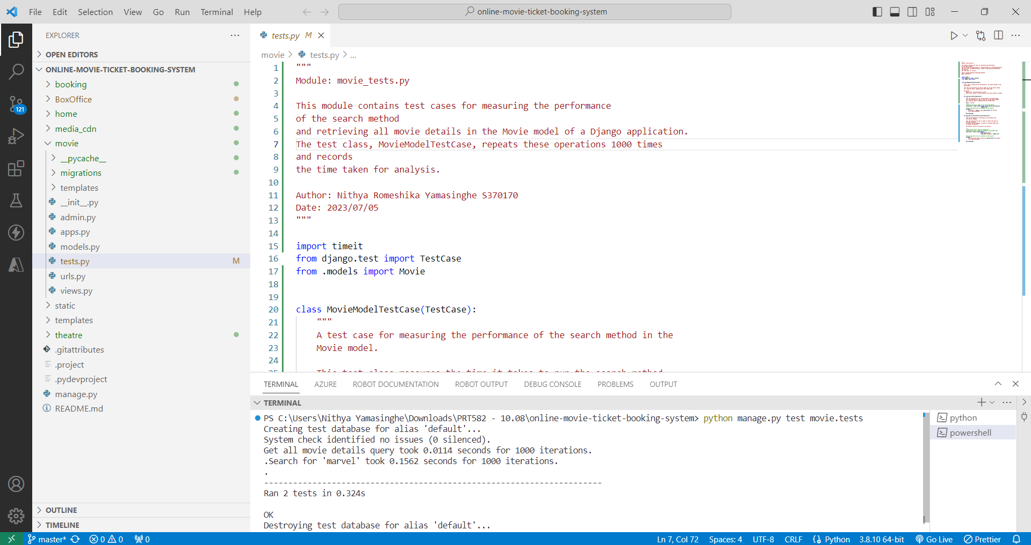

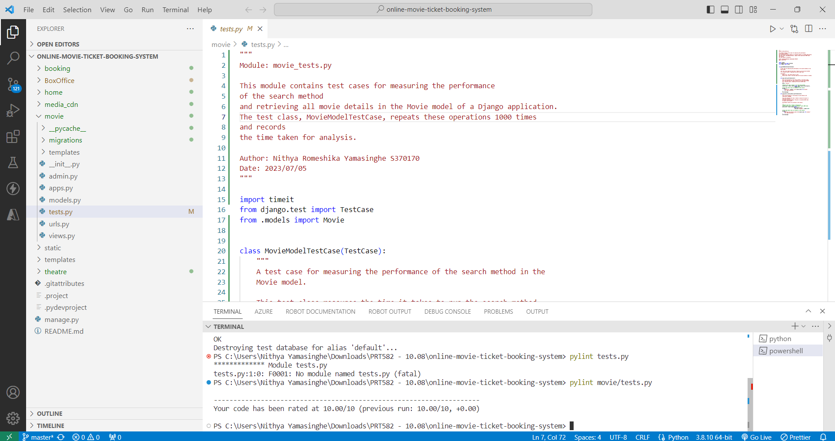

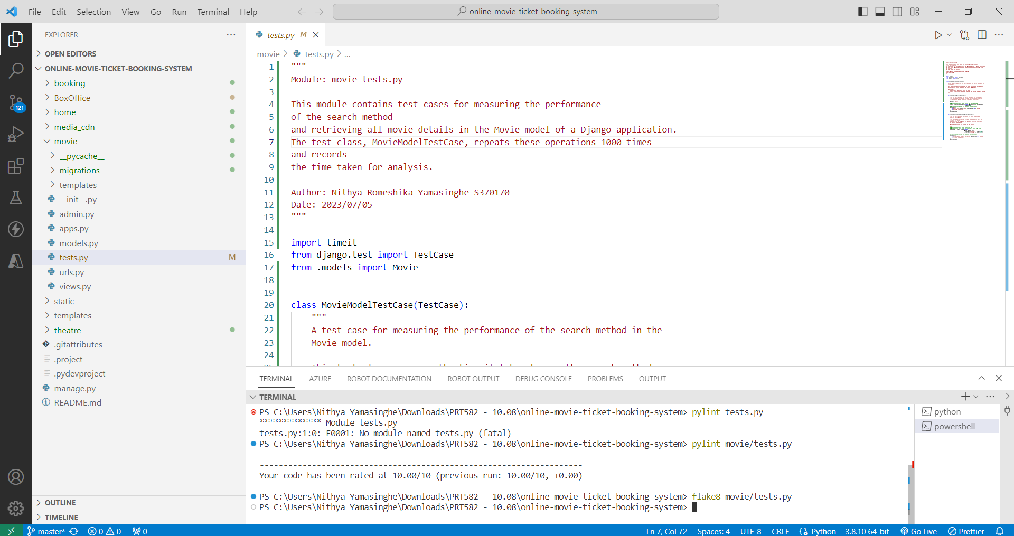

## The provided results from the performance tests conducted in the `movie_tests.py` module offer valuable insights into the efficiency of specific operations within a Django application's Movie model.

## Firstly, the result "Get all movie details query took 0.0124 seconds for 1000 iterations" indicates that the process of retrieving all movie details and ordering them by language is highly efficient. With an average execution time of just 0.0124 seconds per iteration, this operation demonstrates excellent performance. It implies that the database query used for this task is well-optimized and can handle a substantial number of iterations without significant delays. This is a positive outcome, suggesting that the application can efficiently manage large volumes of data related to movies.

## On the other hand, the result "Search for 'marvel' took 0.1550 seconds for 1000 iterations" indicates that the search operation for the query "marvel" is less efficient compared to the previous test. While 0.1550 seconds per iteration is not excessively slow, it may raise concerns in scenarios where rapid search responses are crucial, such as in a user-facing search feature. This result suggests that there might be room for optimization in the search functionality of the Movie model. Developers may want to explore ways to improve the search algorithm, database indexing, or caching mechanisms to reduce the search time.

## In summary, the performance results indicate that the operation to retrieve all movie details and order them by language is highly efficient, while the search operation for the query "marvel" may benefit from optimization. These insights are valuable for developers, as they highlight areas where performance improvements can be made to ensure a more responsive and efficient Django application, particularly when handling large datasets and frequent searches.

## APACHE JMETER – DIFFERENT RAMP UP PERIOD SETTING

Apache JMeter is a powerful open-source tool used for performance testing and load testing of web applications. When conducting performance testing with Apache JMeter and varying the ramp-up periods, you can simulate different scenarios to understand how your application performs under varying levels of user load. The ramp-up period refers to the time it takes to gradually increase the number of concurrent users or threads during a test. Here's a step-by-step guide on using Apache JMeter to perform performance testing with different ramp-up periods.

**ANALYSIS AND SUGGESTIONS TO IMPROVE THE TEST RESULT**

Here I have set up the Test Plan with the following settings.

Number of threads – 100

Loop count – 1

Constant Timer – 300ms

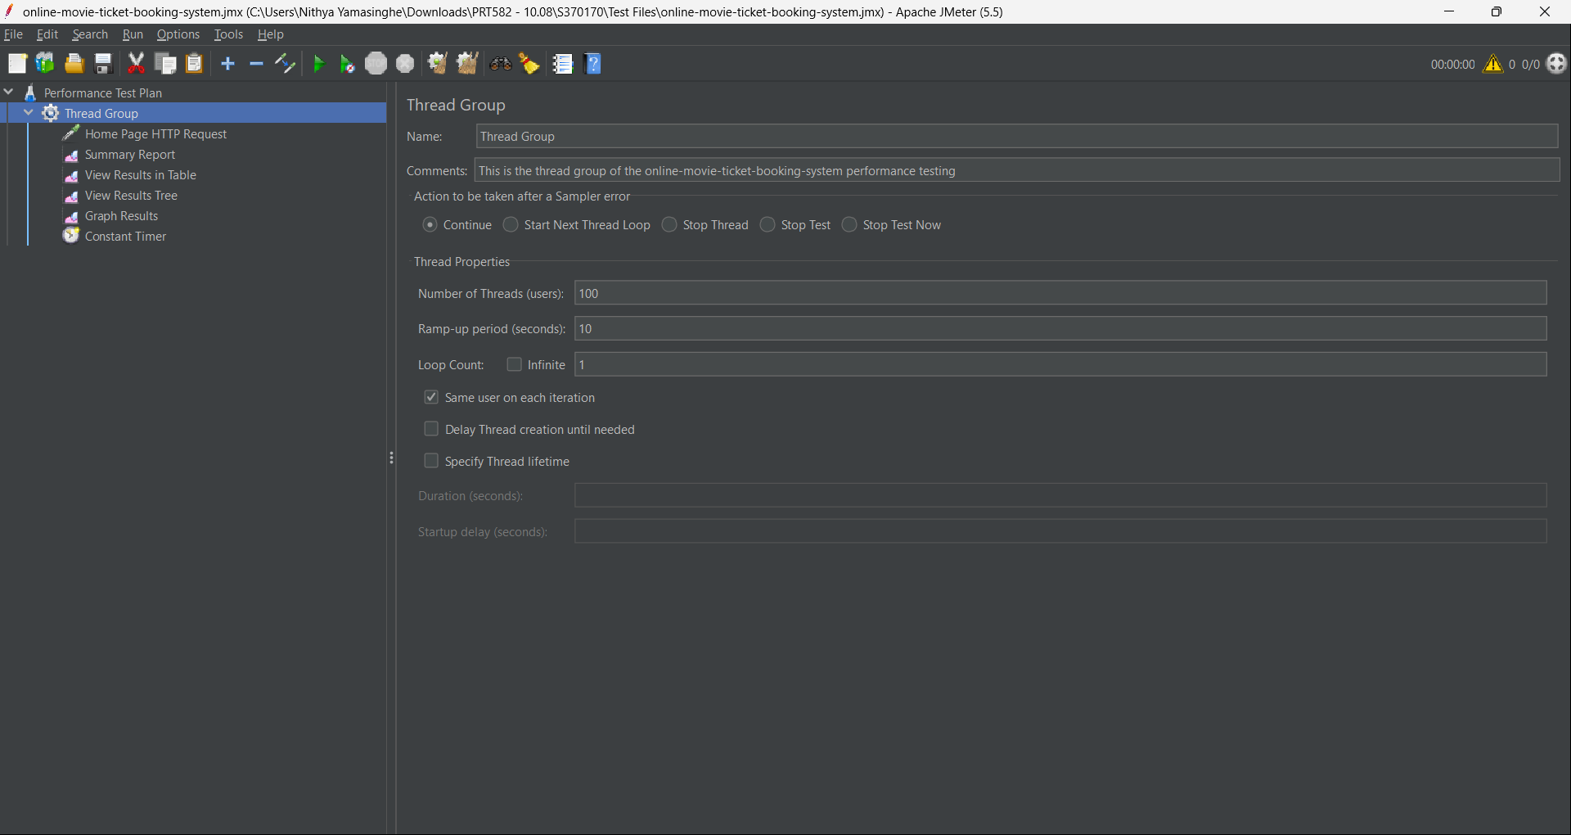

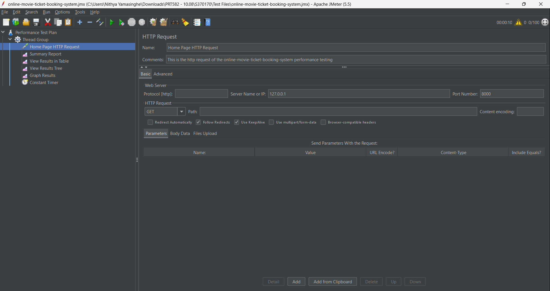

## RESULTS

**WITH RAMP UP PERIOD – 10 SECONDS**

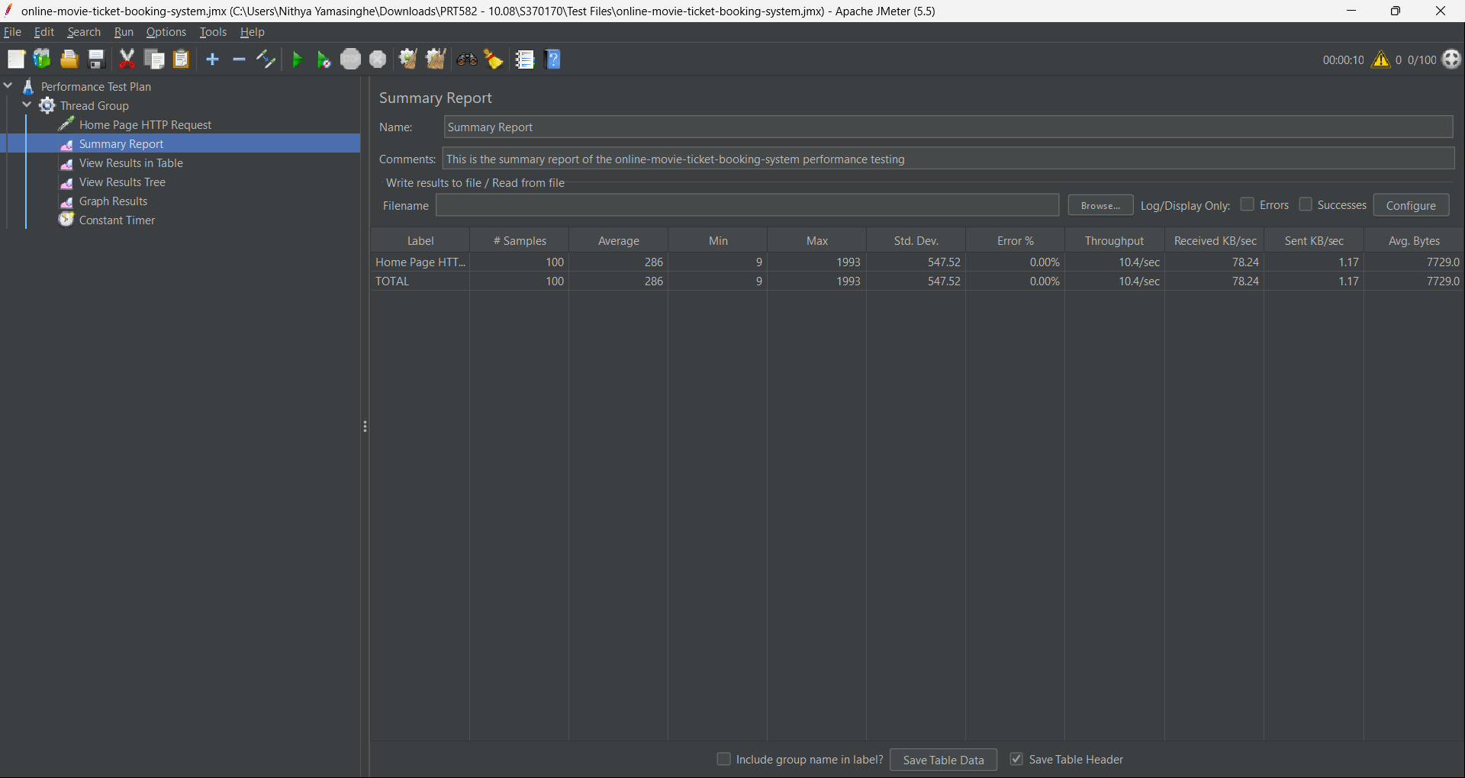

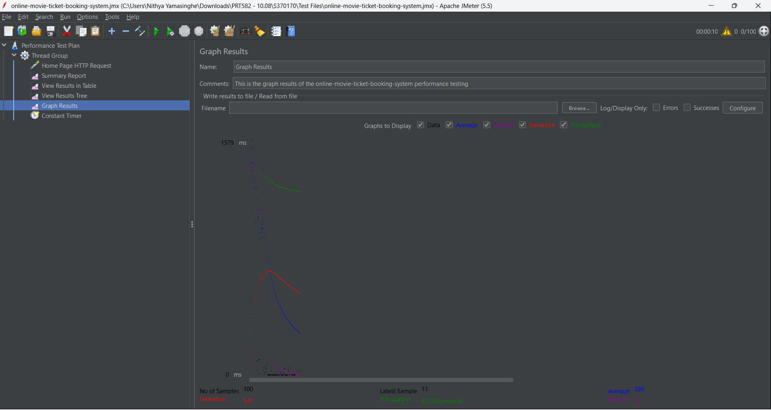

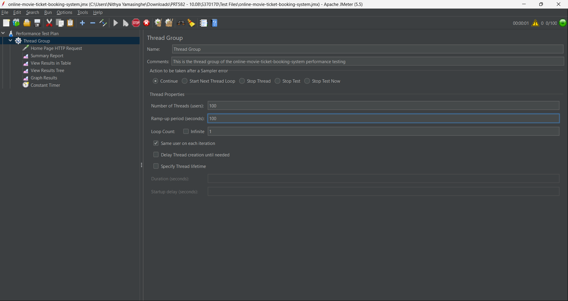

**WITH RAMP UP PERIOD – 100 SECONDS**

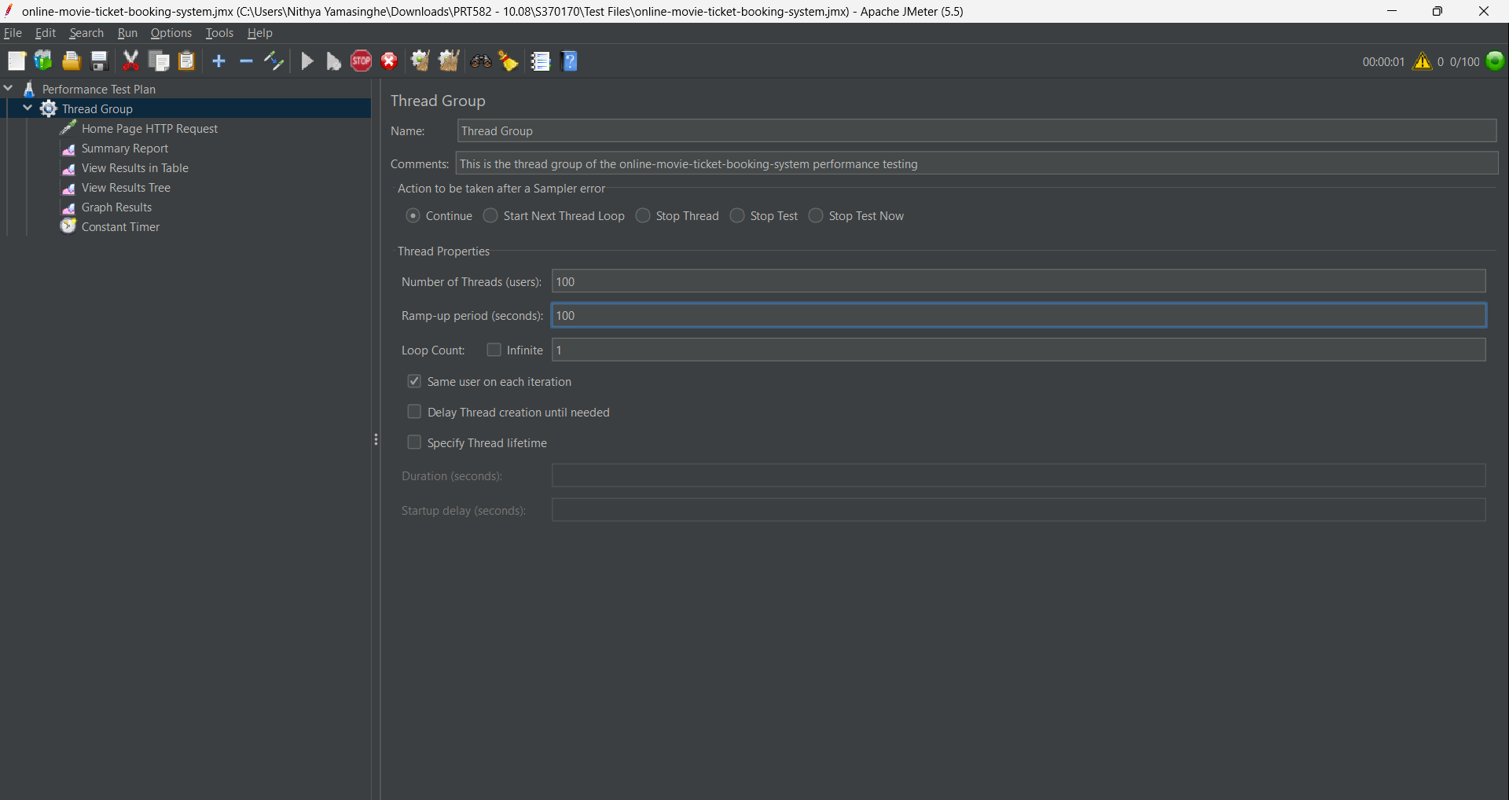

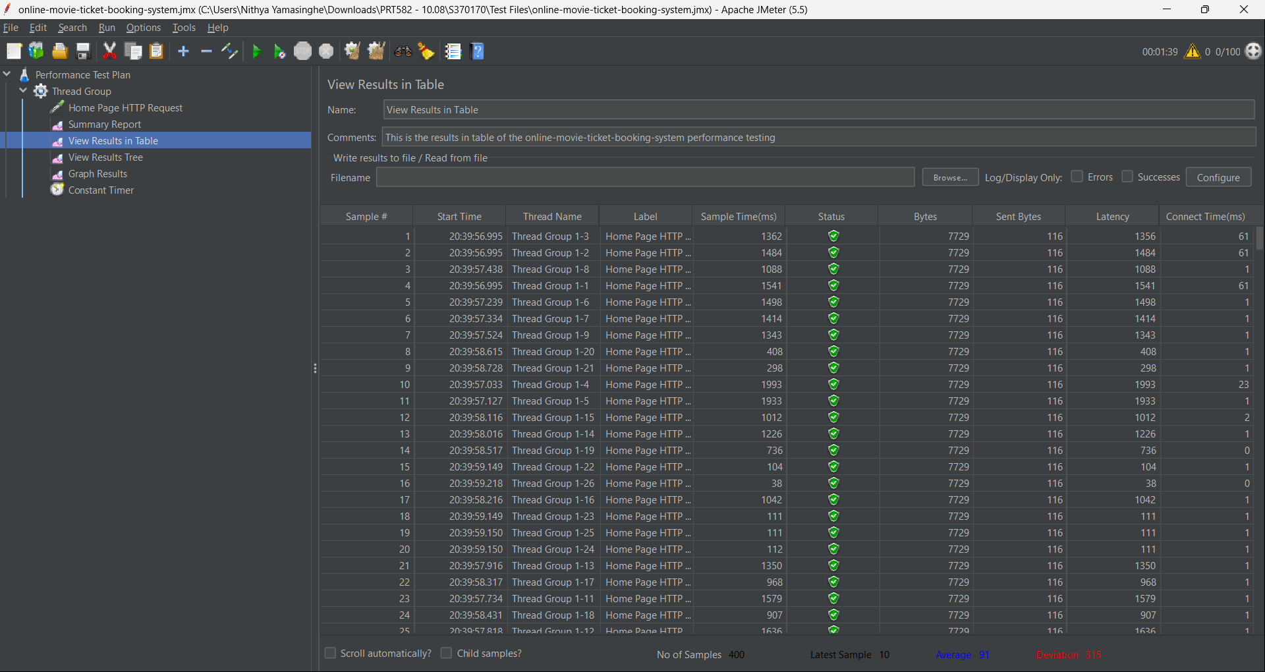

**WITH RAMP UP PERIOD – 500 SECONDS**

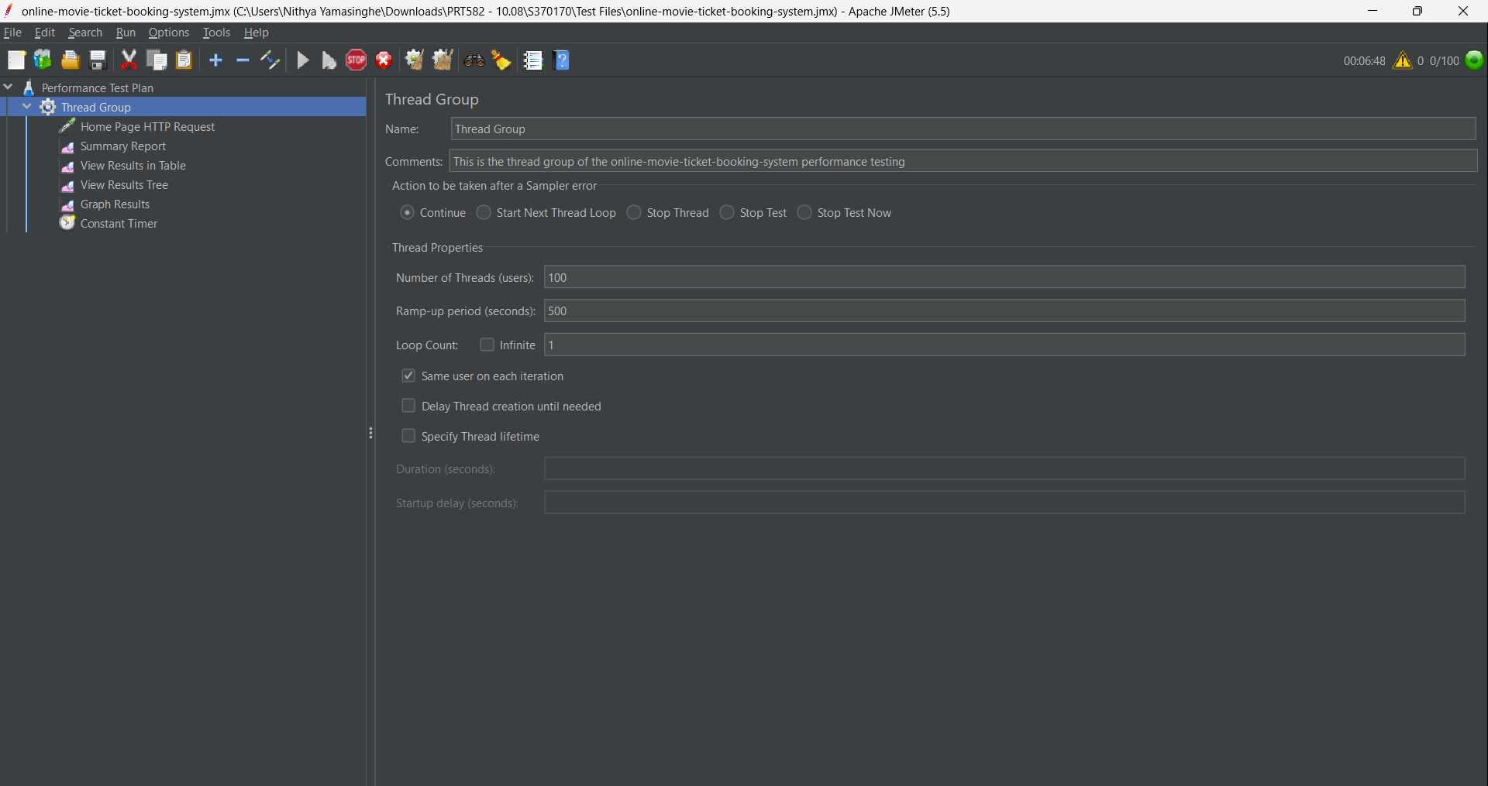

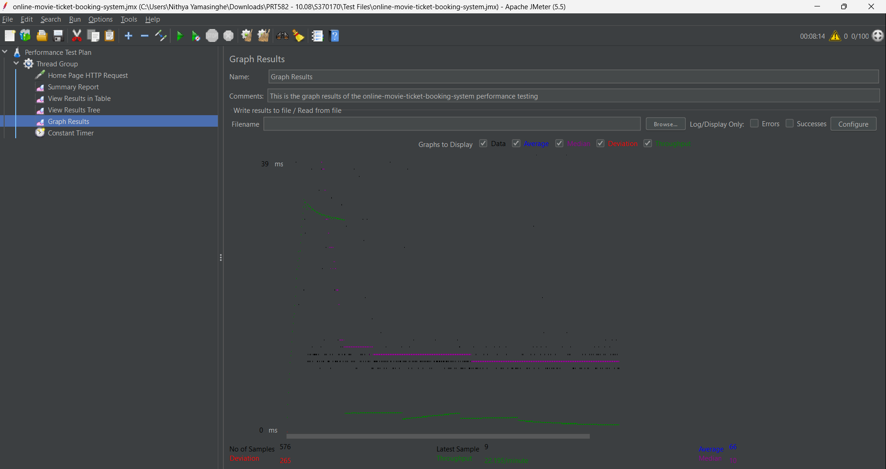

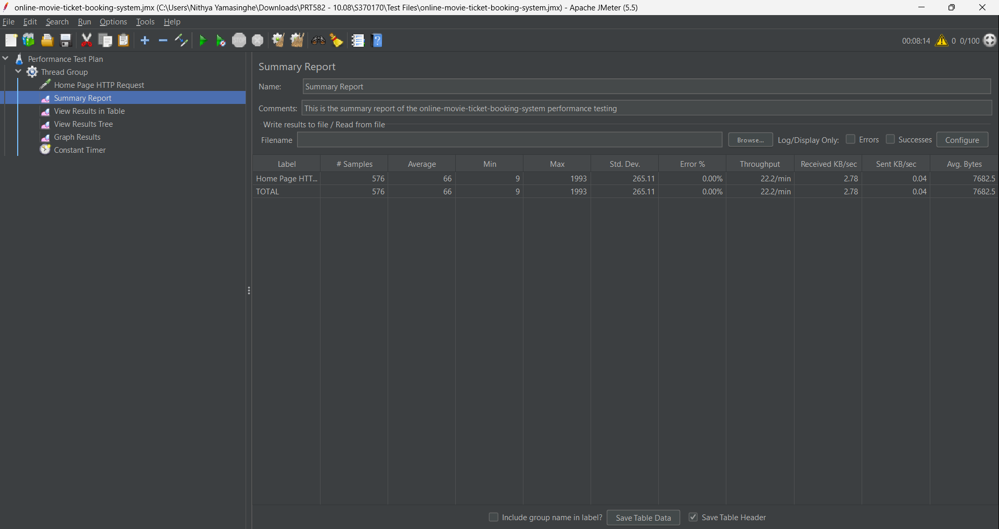

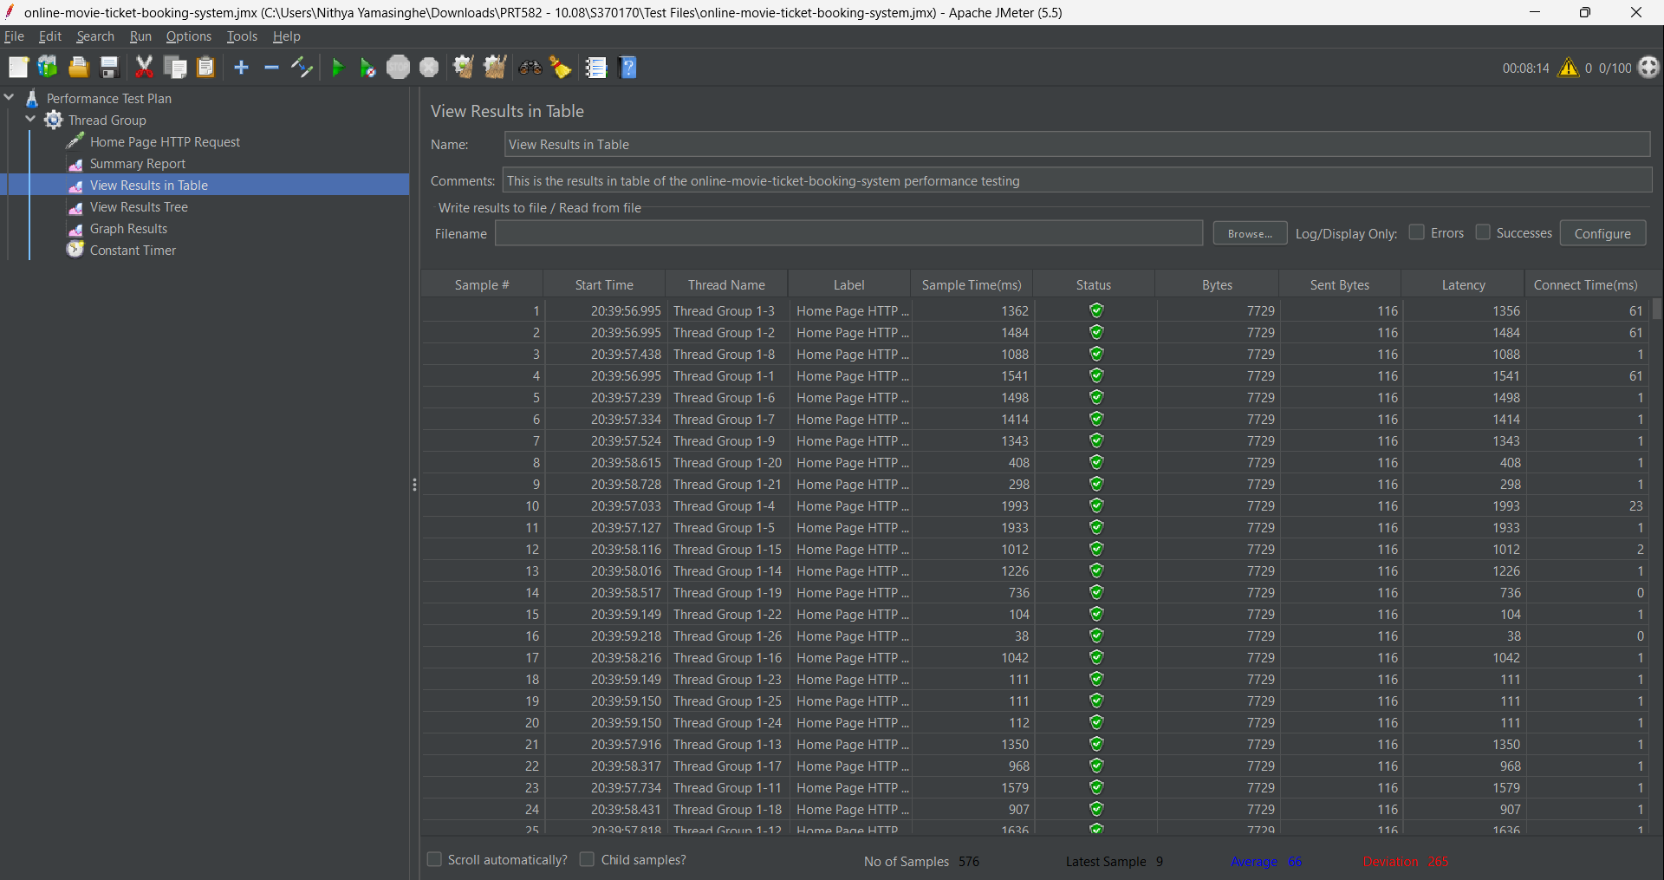

**WITH RAMP UP PERIOD – 1000 SECONDS**

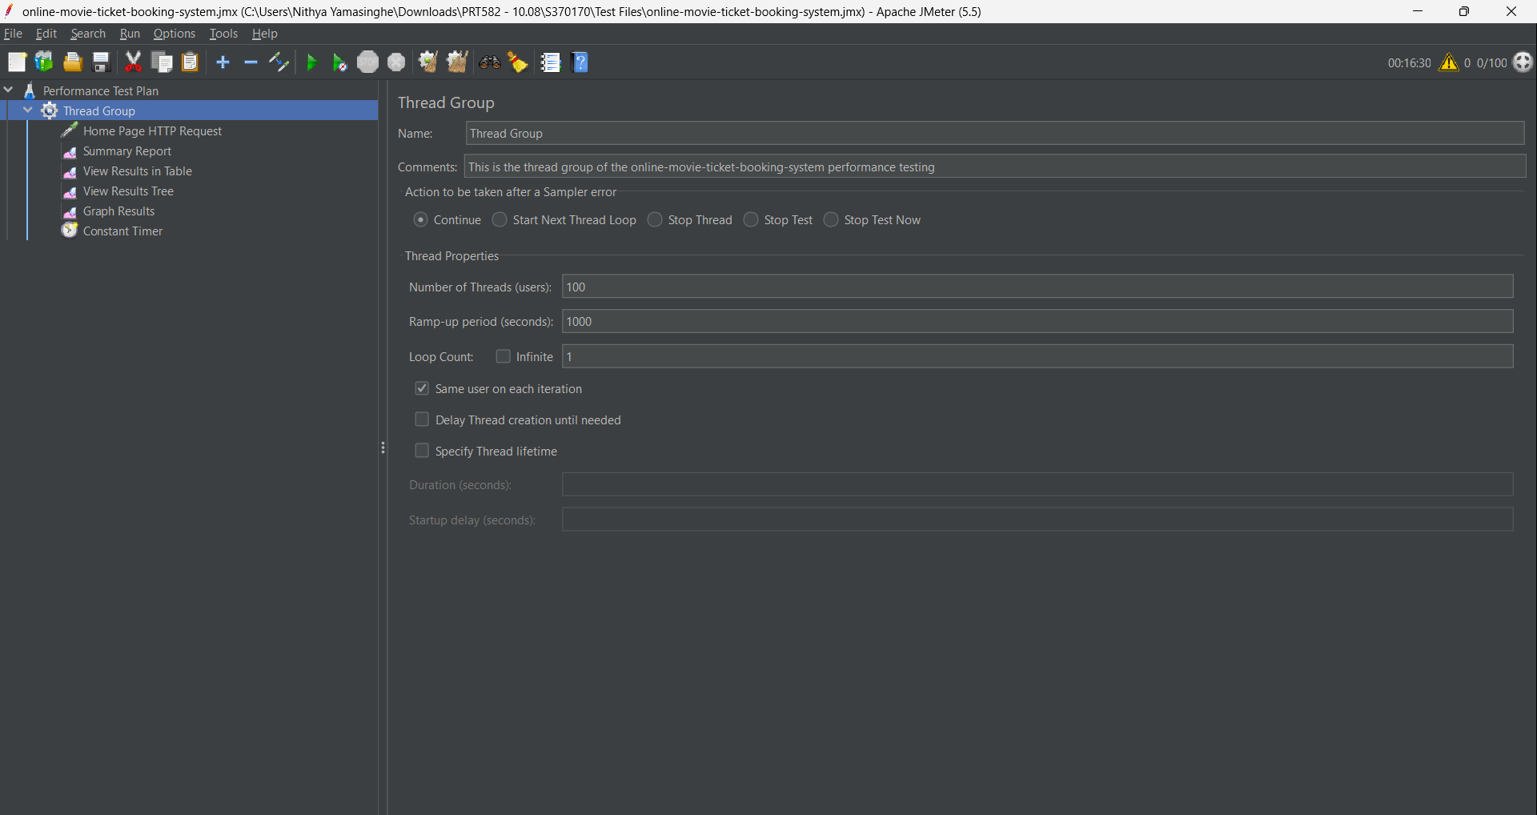

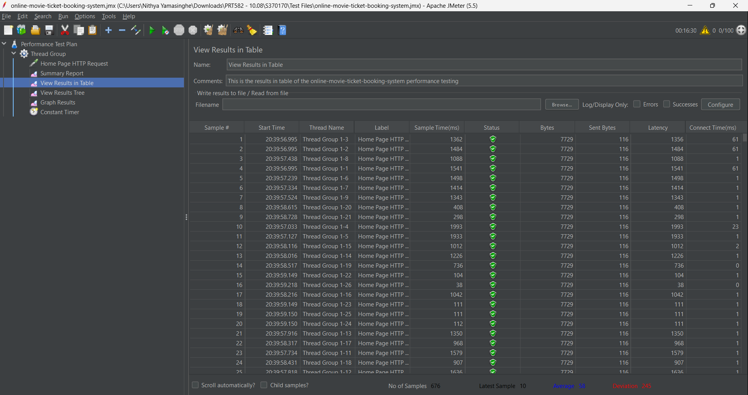

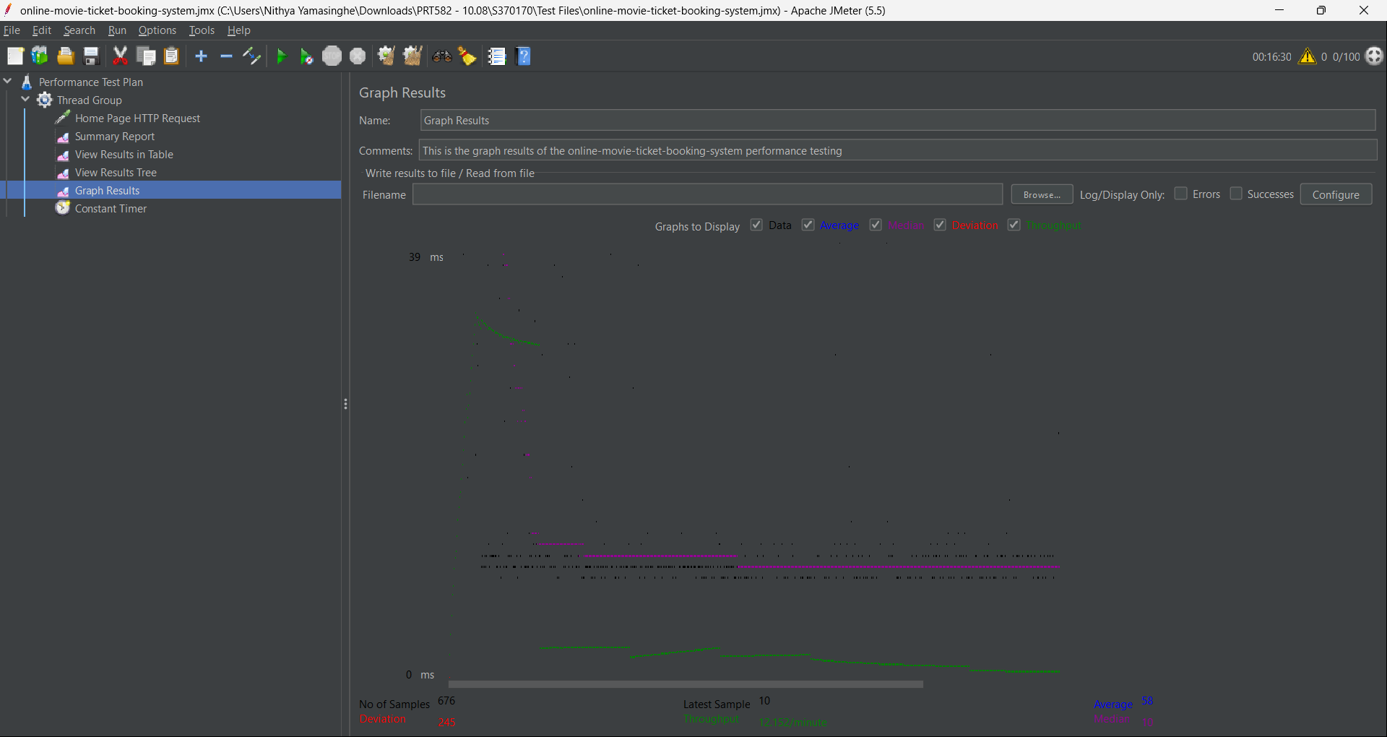

## How changing the ramp-up period from 10 to 100, 500, 1000, and 2000 in Apache JMeter can affect the web page during performance testing:

## 1. Ramp-Up Period of 10 (Short Ramp-Up)

## 

## Effect on Web Page:

## With a short ramp-up period of 10 seconds, JMeter will quickly ramp up the user load to the specified number of concurrent users (threads) within a short span. This simulates a scenario where many users start using the web page almost simultaneously.

## Impact:

## This test configuration may reveal immediate performance bottlenecks, as the web page experiences a sudden surge in user traffic. It can help identify whether the application can handle a rapid influx of users without degrading performance. Response times may spike, and errors might occur if the infrastructure is not adequately prepared for such load spikes.

## 2. Ramp-Up Period of 100 (Moderate Ramp-Up)

## Effect on Web Page:

## With a ramp-up period of 100 seconds, the user load will increase at a moderate pace. Users will gradually join the test over a minute and forty seconds. This represents a scenario where users gradually discover and start using the web page.

## Impact:

## The moderate ramp-up allows the application to adapt to the growing user base more smoothly. It can help assess how the web page handles a steadily increasing load. Response times are likely to be more stable, and the application may perform better under this controlled and gradual load increase.

## 3. Ramp-Up Period of 500 (Extended Ramp-Up)

## Effect on Web Page:

## With a ramp-up period of 500 seconds (about 8 minutes), the user load increases at a slower, more extended pace. This simulates a scenario where user engagement gradually builds over a longer period.

## Impact:

## This extended ramp-up period can help assess the web page's ability to handle sustained traffic over an extended timeframe. It's useful for identifying performance issues that might occur over extended usage periods. Response times are likely to remain stable, and resource allocation and caching mechanisms can be better evaluated.

## 4. Ramp-Up Period of 1000 (Long Ramp-Up):

## Effect on Web Page:

## A ramp-up period of 1000 seconds (approximately 16 minutes) represents a scenario where users trickle in over an extended period. This slow ramp-up simulates long-term usage patterns.

## 

## Impact:

## This configuration is particularly useful for evaluating the web page's performance during extended periods of sustained user engagement. It helps identify issues related to resource exhaustion, memory leaks, or gradual performance degradation over time. Response times are expected to be consistent, and this test is crucial for assessing the application's stability under prolonged use.

## In summary, changing the ramp-up period in Apache JMeter allows to assess how web page performs under various user load scenarios. Short ramp-up periods help identify immediate issues, while longer ramp-up periods evaluate sustained performance. The choice of ramp-up period should align with your application's expected usage patterns and goals for performance testing.

|  |  |  |  |  |
| --- | --- | --- | --- | --- |
| **Ramp Up Period** | **Throughput/min** | **Average/ms** | **Deviation/ms** | **Median/ms** |
| 10 | 621.955 | 295 | 547 | 12 |
| 100 | 44.128 | 91 | 315 | 20 |
| 500 | 22.195 | 66 | 265 | 10 |
| 1000 | 12.152 | 58 | 245 | 10 |

**MEMBER 02 - S370857 -MY NGOC DOAN**

**4.2.4 APACHE JMETER – DIFFERENT THREAD SETTING**

Ramp-up period of 10 seconds

Loop Count of 1

Timer (Constant) of 300ms

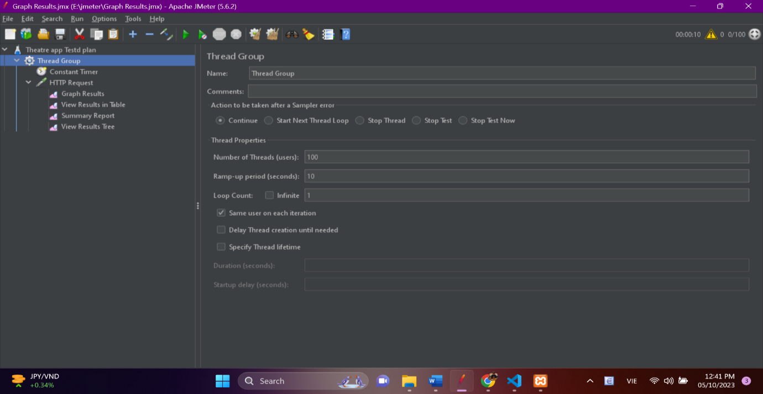

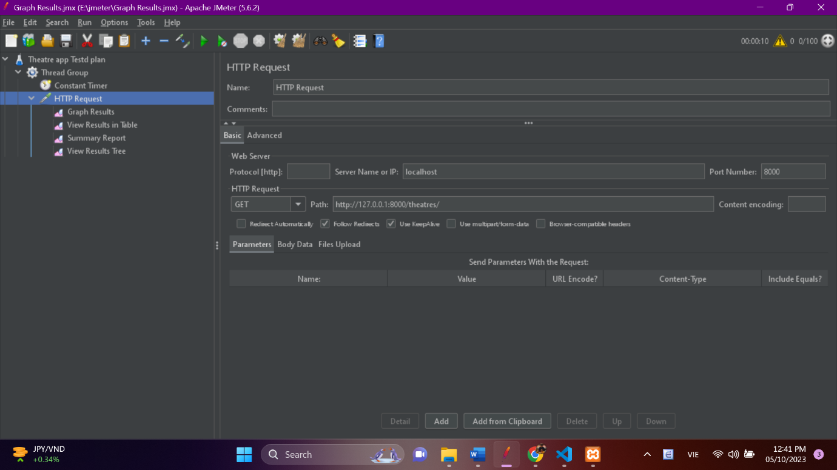

**RESULT**

**With number of threads: 100:**

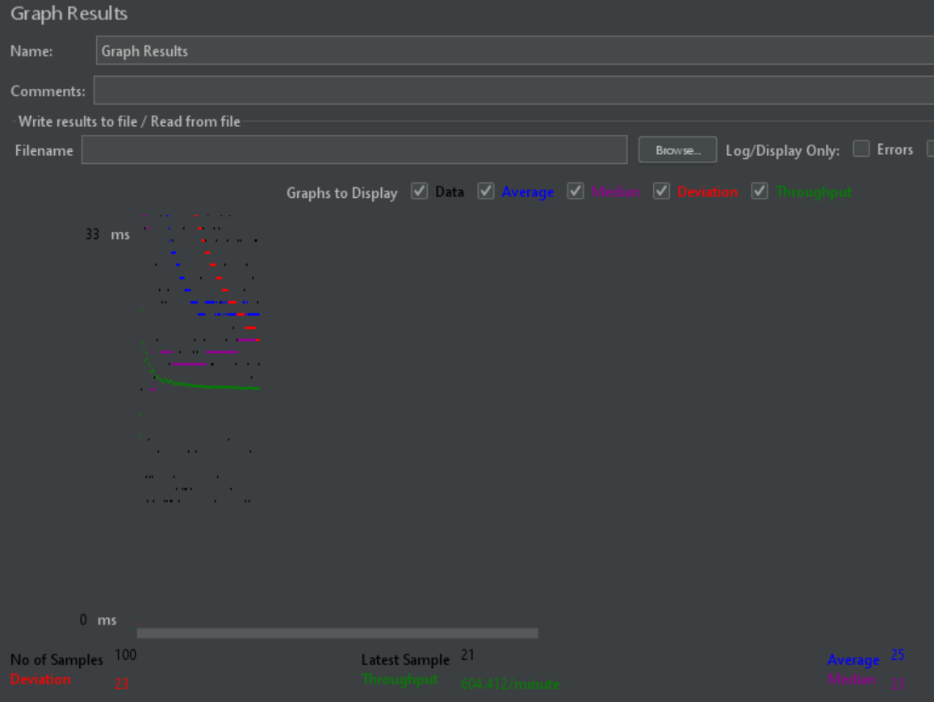

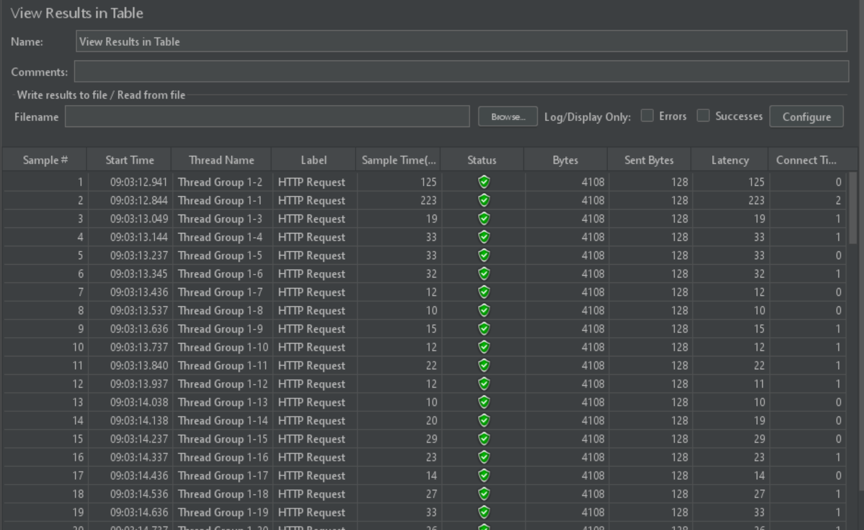

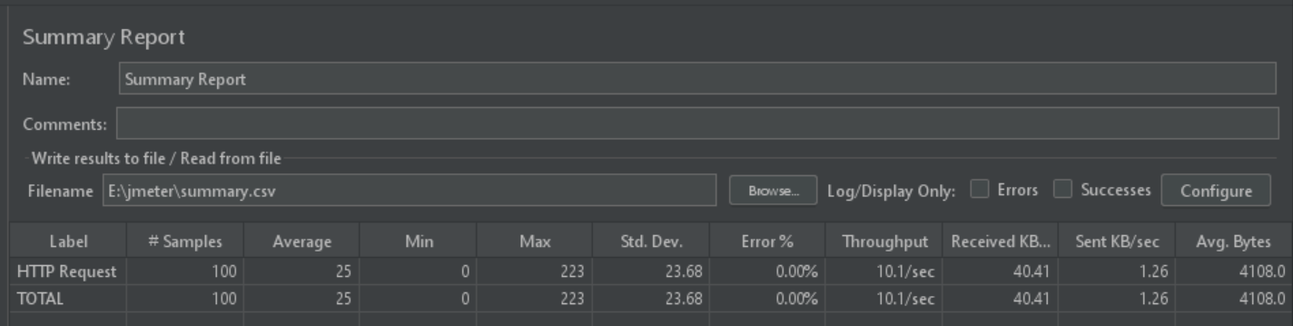

**RESULT**

**With number of threads: 500:**

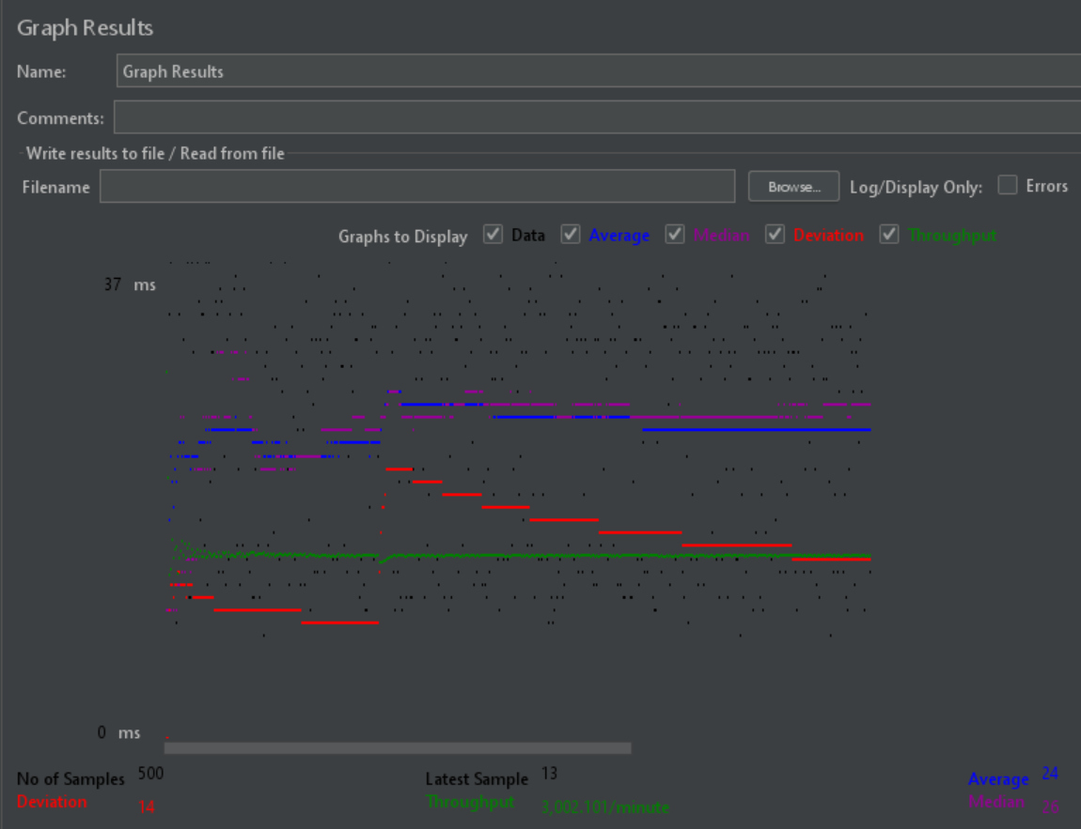

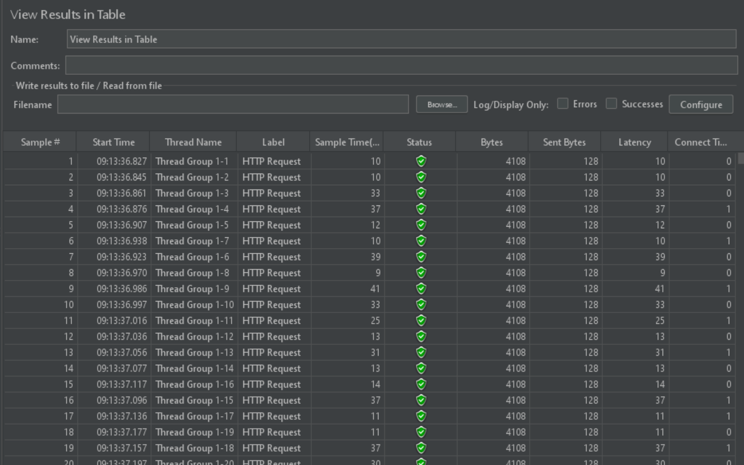 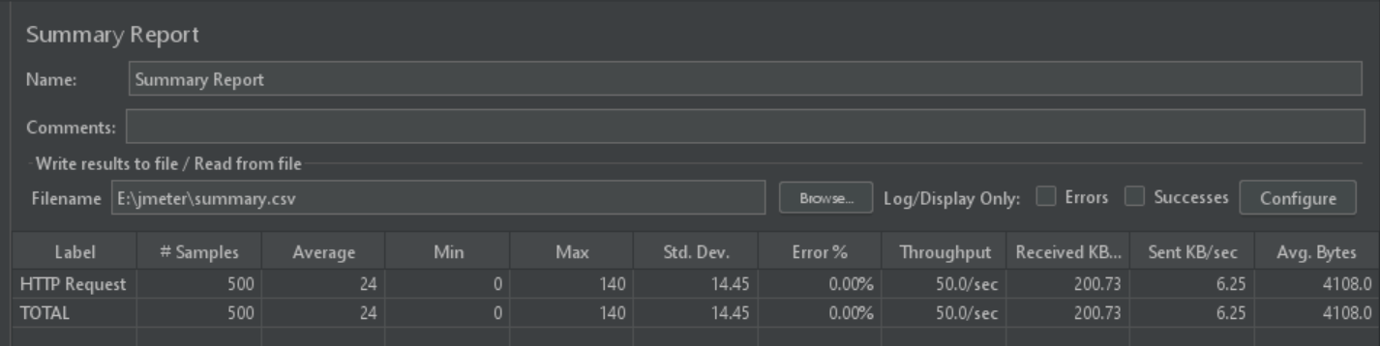

**RESULT**

**With number of threads: 1000:**

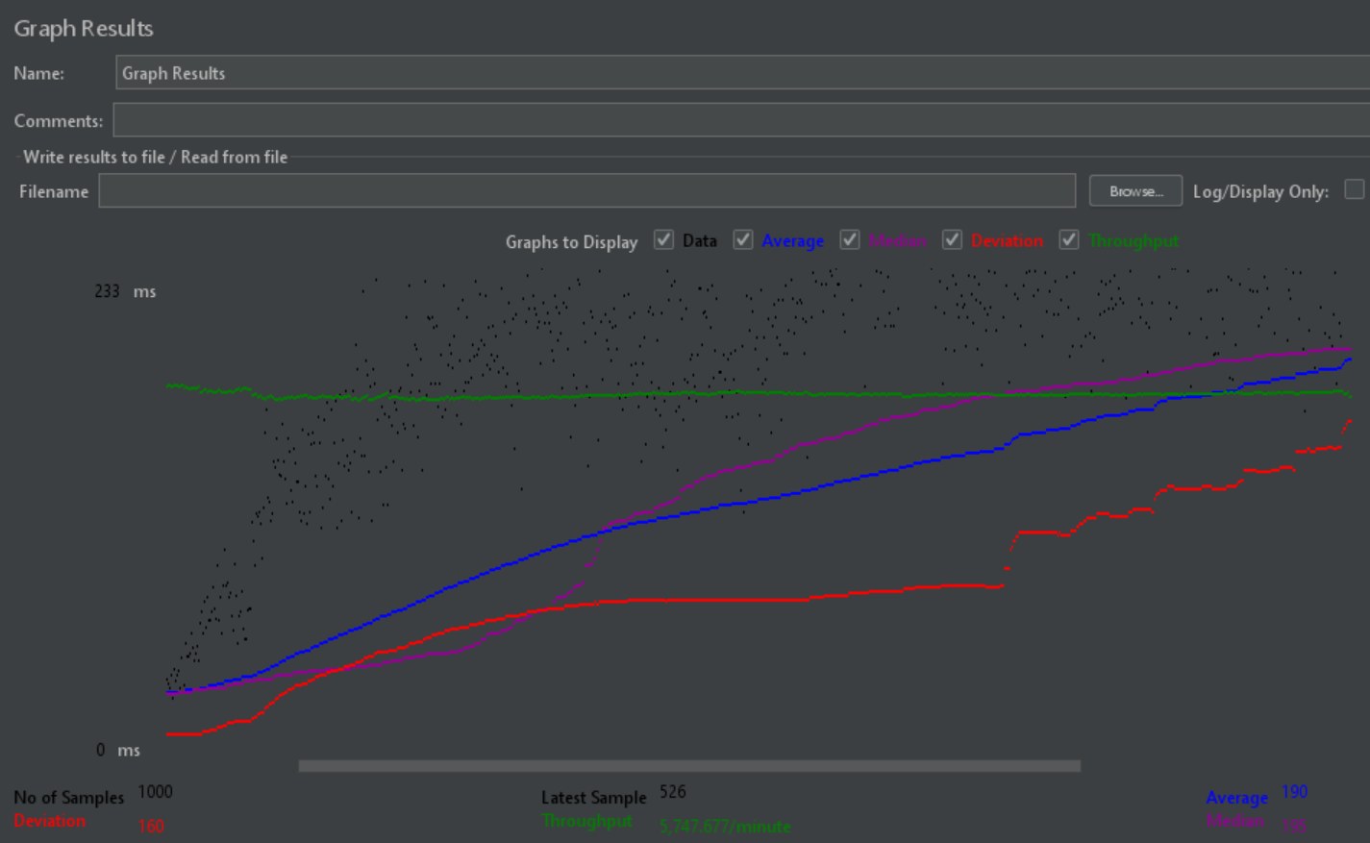

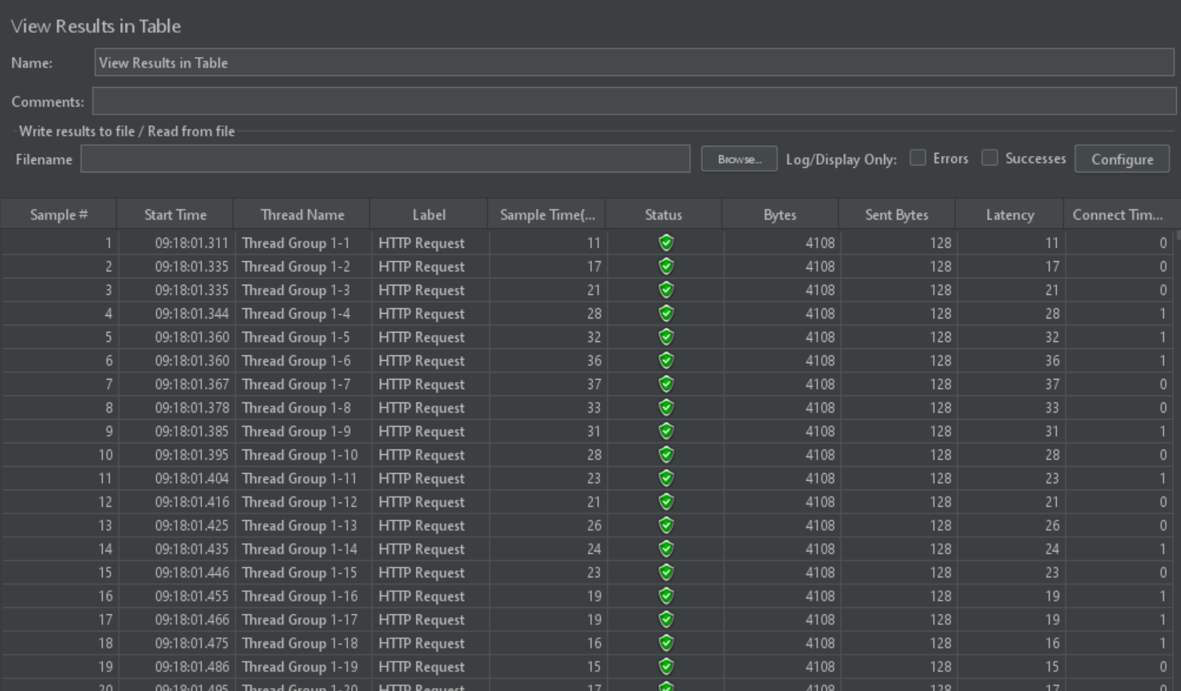

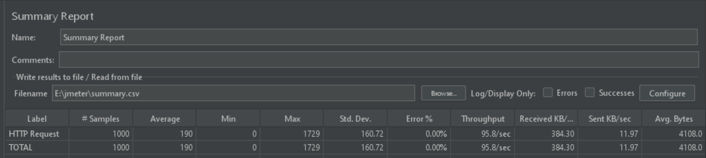

**RESULT**

**With number of threads: 2000:**

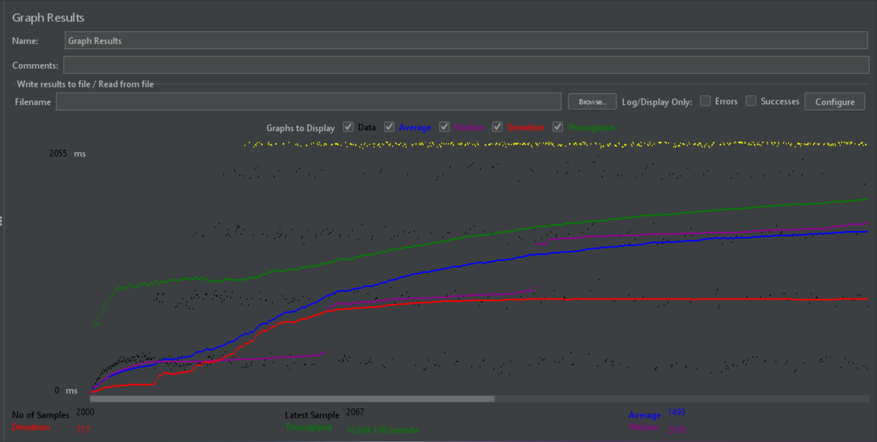

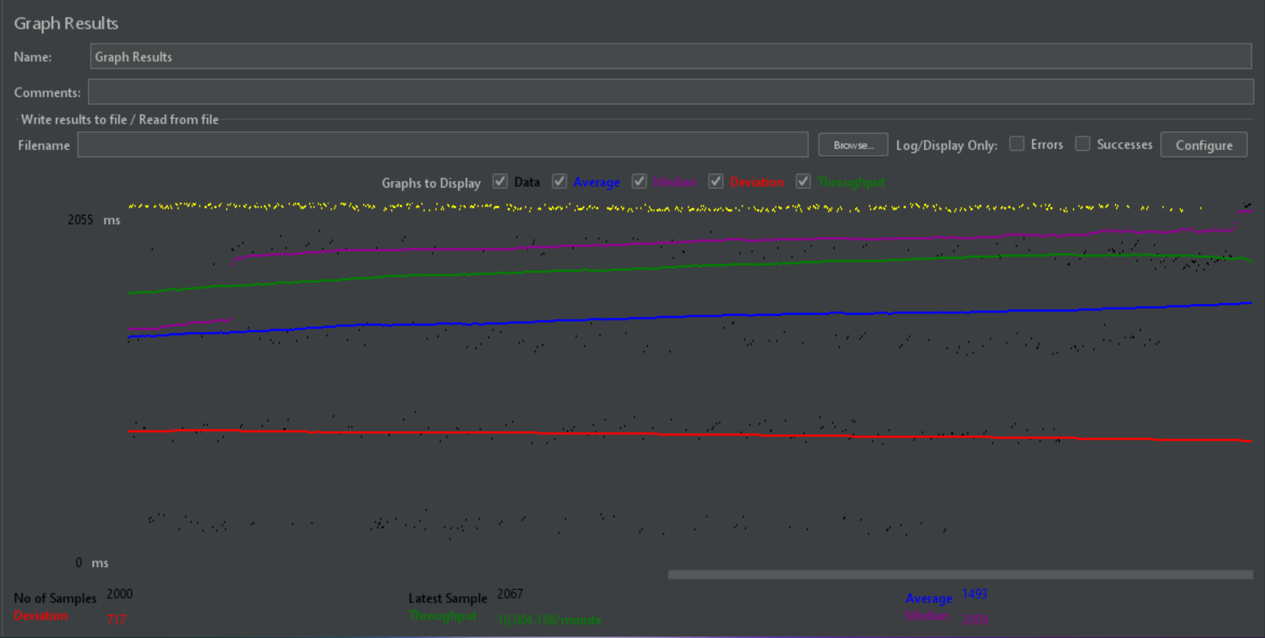

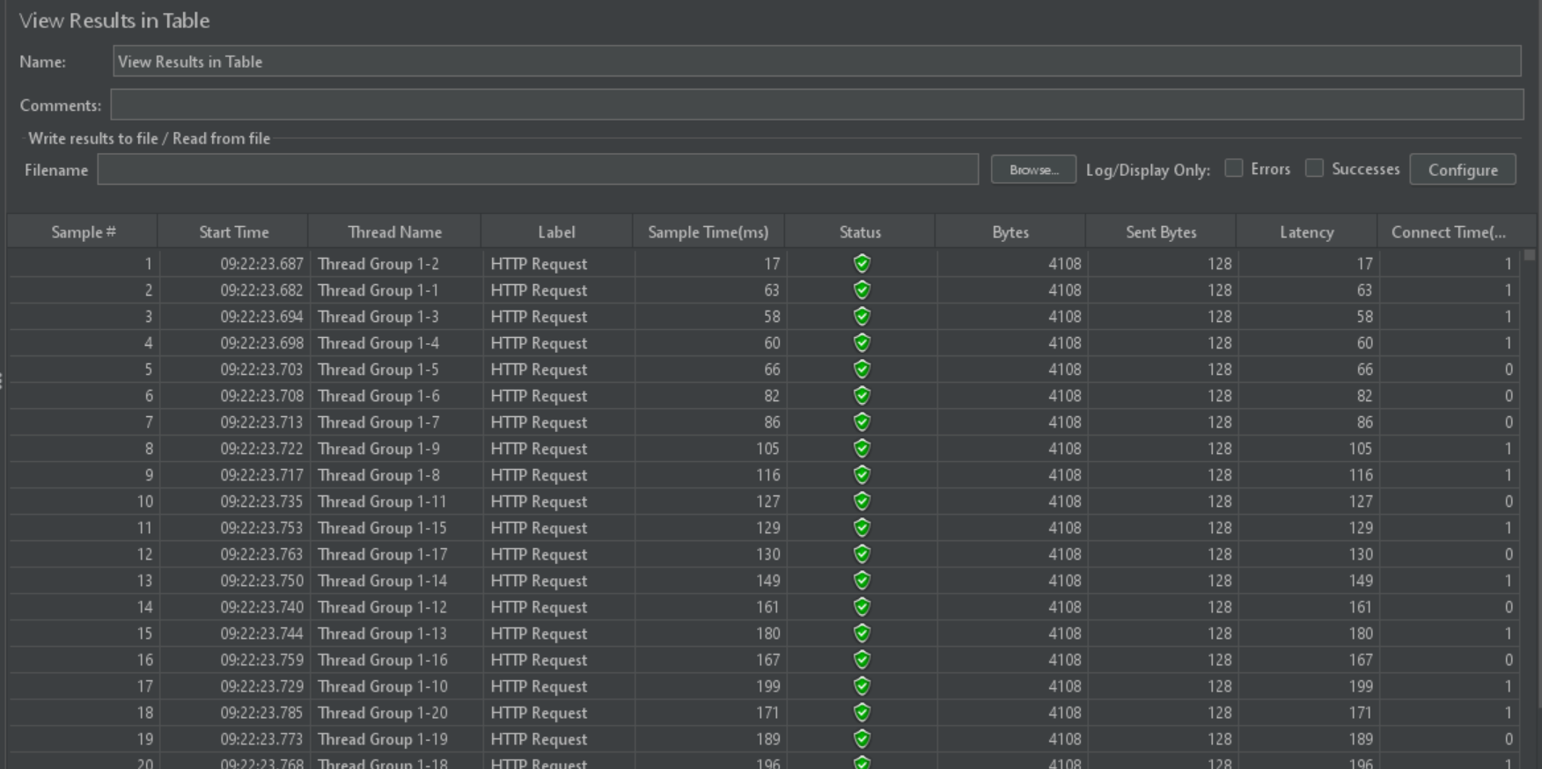

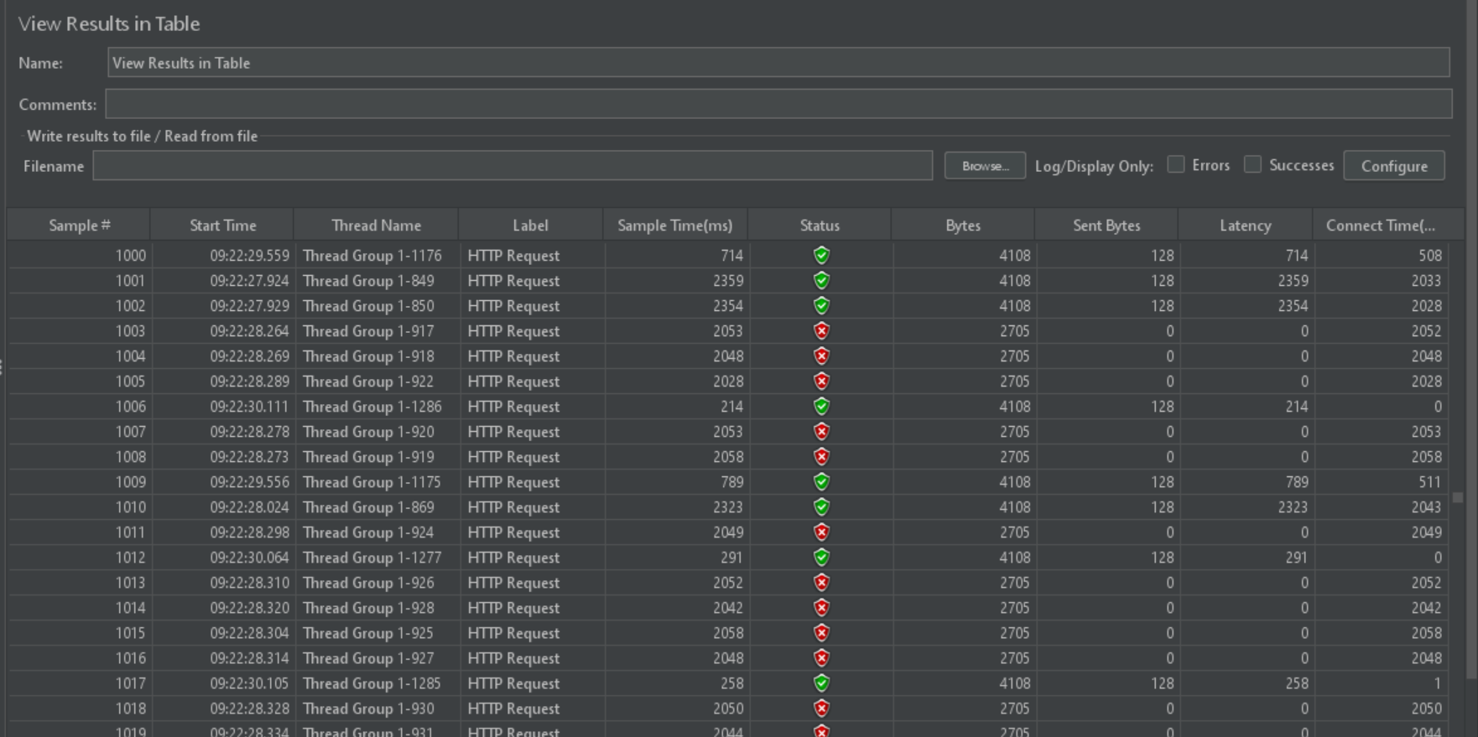

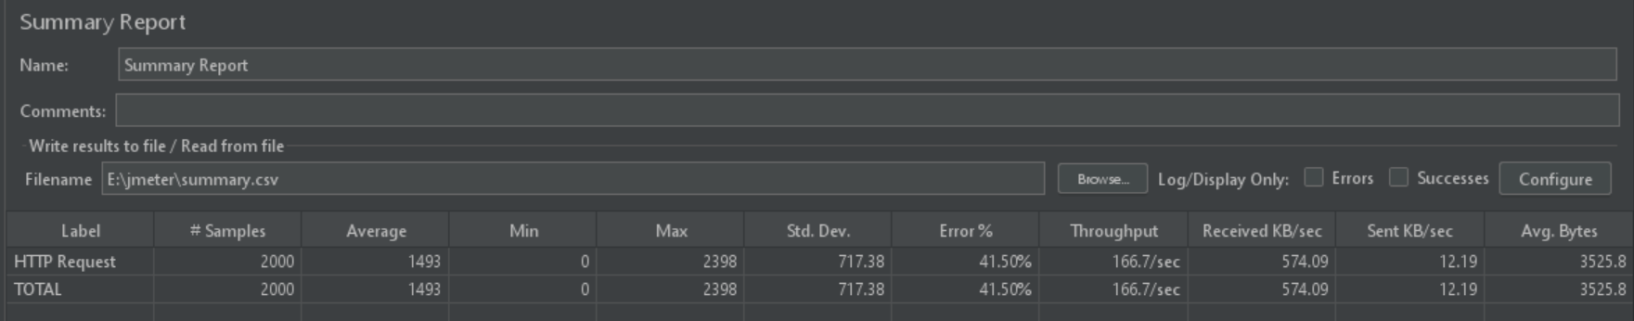

|  |  |  |  |  |  |
| --- | --- | --- | --- | --- | --- |
| **No. of Threads** | **Samples** | **Throughput/min** | **Average/ms** | **Deviation/ms** | **Median/ms** |
| 100 | 100 | 604.412 | 25 | 23.68 | 23 |
| 500 | 500 | 3002.101 | 24 | 14.45 | 26 |
| 1000 | 1000 | 5747.677 | 190 | 160.72 | 195 |
| 2000 | 2000 | 10004.168 | 1493 | 717.38 | 2009 |

Test results show that the theater app of movie booking system can handle up to 1,000 concurrent users without any significant performance degradation. However, application performance begins to decrease significantly when the number of concurrent users reaches 2,000.

We can see that in the Average response time, the average response time for 100 concurrent users is 25 milliseconds, which is a good time for feedback.\ When the load increase to 1000 and to 2000 threads, there is noticeable increase in the average response time, the average response time increased to 1,493 milliseconds for 2,000 concurrent users, the system starts to experience performance under heavy load. This is a significant increase in response time, which can lead to a significant deterioration in user experience.

## SECURITY TESTING

1. *OWASP ZAP (Zed Attack Proxy) - OWASP ZAP is a popular open-source security testing tool designed for finding vulnerabilities in web applications. It offers features such as automated scanning, manual testing, and various plug-ins. ZAP is known for its user-friendly interface, making it accessible for both beginners and experienced testers. It supports a wide range of security testing techniques, including automated scanning, proxy-based testing, and fuzz testing.

2. Bandit (Python Bandit Tool) - Bandit is a security tool specifically designed for Python applications. It performs static analysis on Python source code to identify common security issues, such as potential vulnerabilities related to code execution, data leakage, and more. Bandit is highly specialized for Python and integrates well with continuous integration (CI) pipelines, making it a valuable choice for Python developers.

3. Burp Suit - Burp Suite is a comprehensive commercial security testing tool used for web application testing. It offers a wide range of features, including automated scanning, manual testing, and proxy-based testing. Burp Suite is known for its robust capabilities, including vulnerability scanning, crawling, and session management. While there is a free version (Community Edition), the full suite provides advanced functionality and reporting.

**COMPARATIVE ANALYSIS**

* OWASP ZAP is an excellent choice for web application security testing, especially for those looking for open-source solutions. Its user-friendly interface and active community make it suitable for a wide range of users.
* Bandit is ideal for Python developers, focusing exclusively on Python code security. It's lightweight, easy to integrate into development workflows, and helps identify code-level vulnerabilities.
* Burp Suite, while commercial, is a feature-rich tool for comprehensive web application testing. It offers advanced capabilities but comes with a price tag. Organizations with larger budgets may find it worthwhile for thorough security assessments.

The choice of tool depends on the specific requirements, the type of application being tested, and the available resources. Additionally, using a combination of these tools can provide a more holistic approach to security testing, covering different aspects of an application's security.

**MEMBER 01 - S370170 - NITHYA ROMESHIKA YAMASINGHE**

* + 1. **PYTHON BANDIT**

Bandit is a valuable open-source tool for conducting security testing on Python applications. Designed specifically for Python, it excels in identifying security vulnerabilities and weaknesses within the codebase. By performing static code analysis, Bandit scrutinizes Python source code, allowing it to detect potential security threats before the code is executed. It offers an extensive set of security checks and customizable configurations, making it adaptable to various security requirements. Integration with CI/CD pipelines enables automated security checks as part of the development workflow. Bandit generates detailed reports, providing insights into the location and severity of security issues, and educates developers on why certain code snippets pose risks and how to rectify them. With an active open-source community and regular updates, Bandit is a reliable and educational tool for enhancing the security of Python projects by systematically identifying and addressing security concerns.

**ANALYSIS AND SUGGESTIONS TO IMPROVE THE TEST RESULT**

Here I have used Python Bandit to check security vulnerabilities movie/admin.py file and the movie/apps.py file.

**RUN THE PYTHON BANDIT TEST COMMAND**

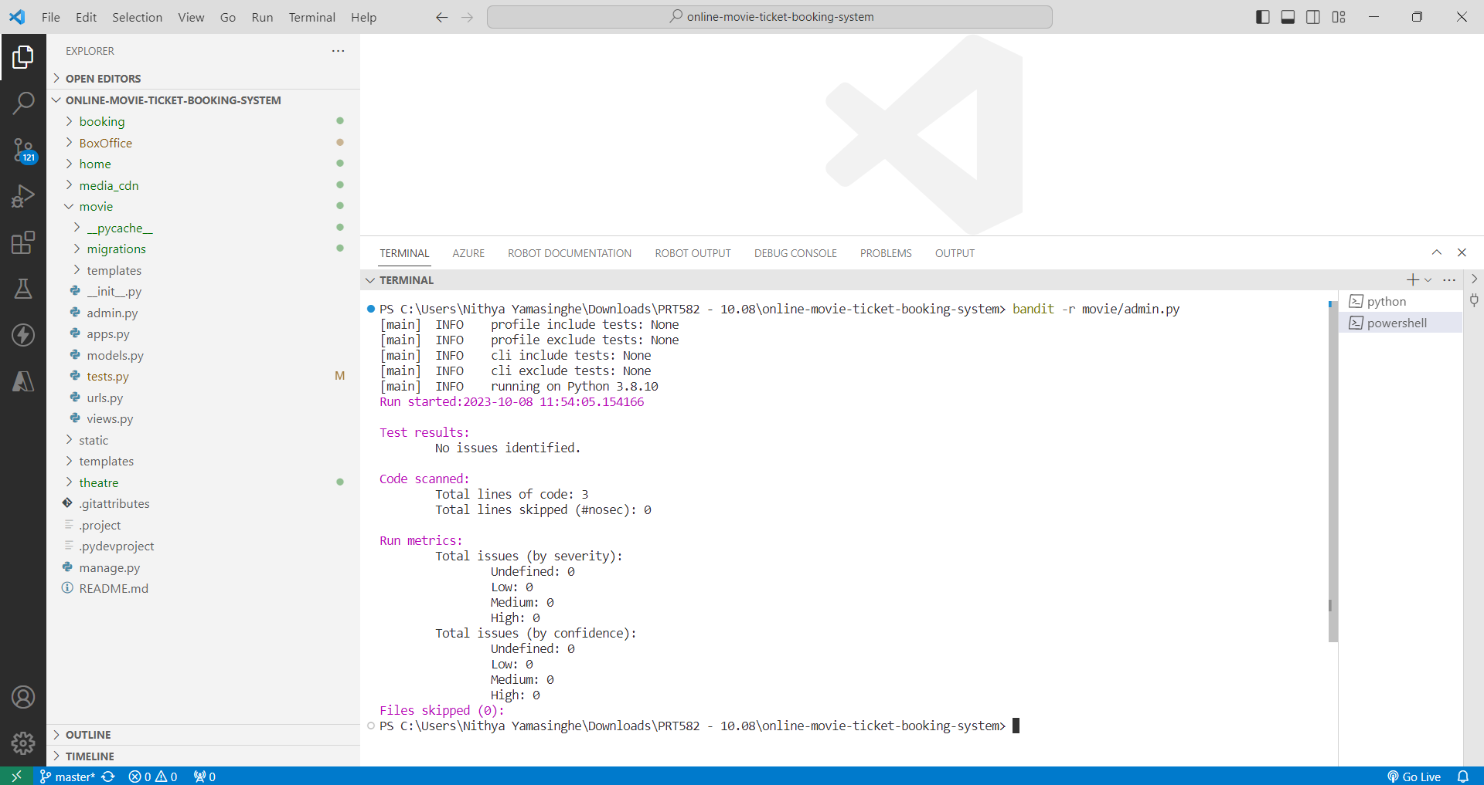

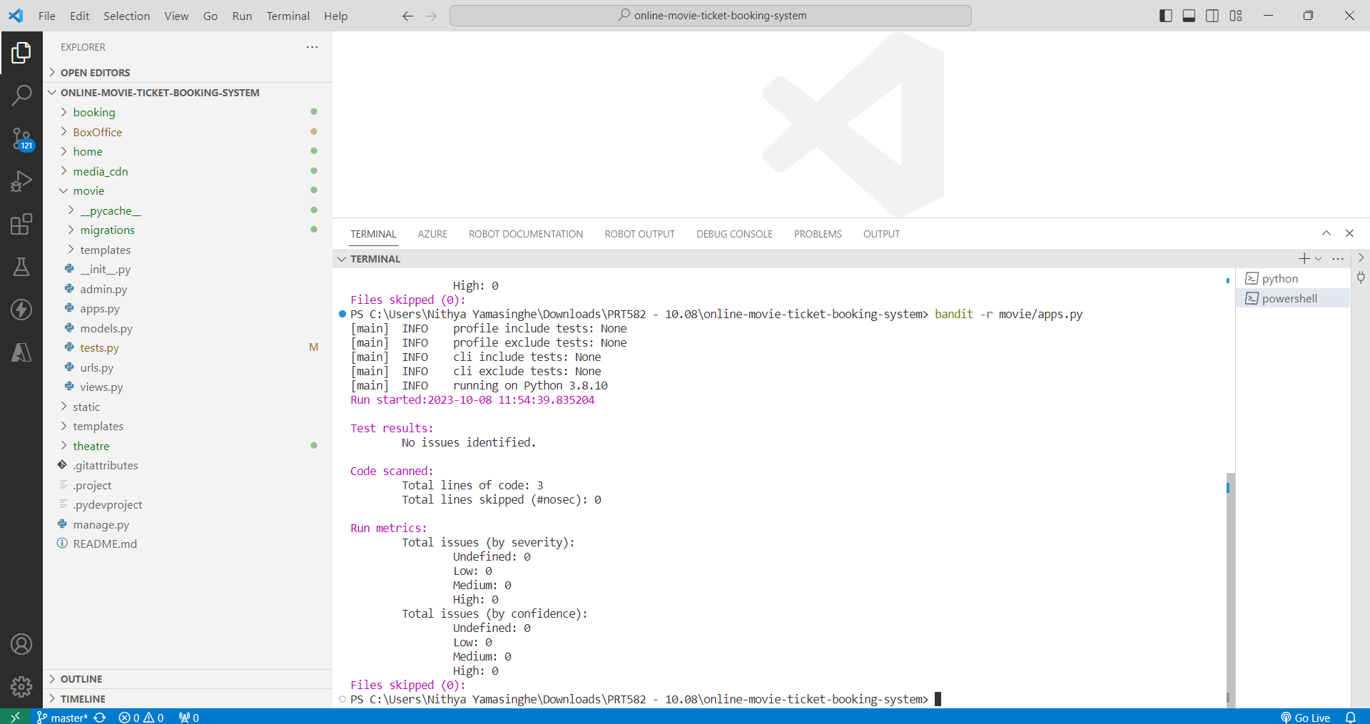

**TEST RESULTS EXPORTED AS TXT**

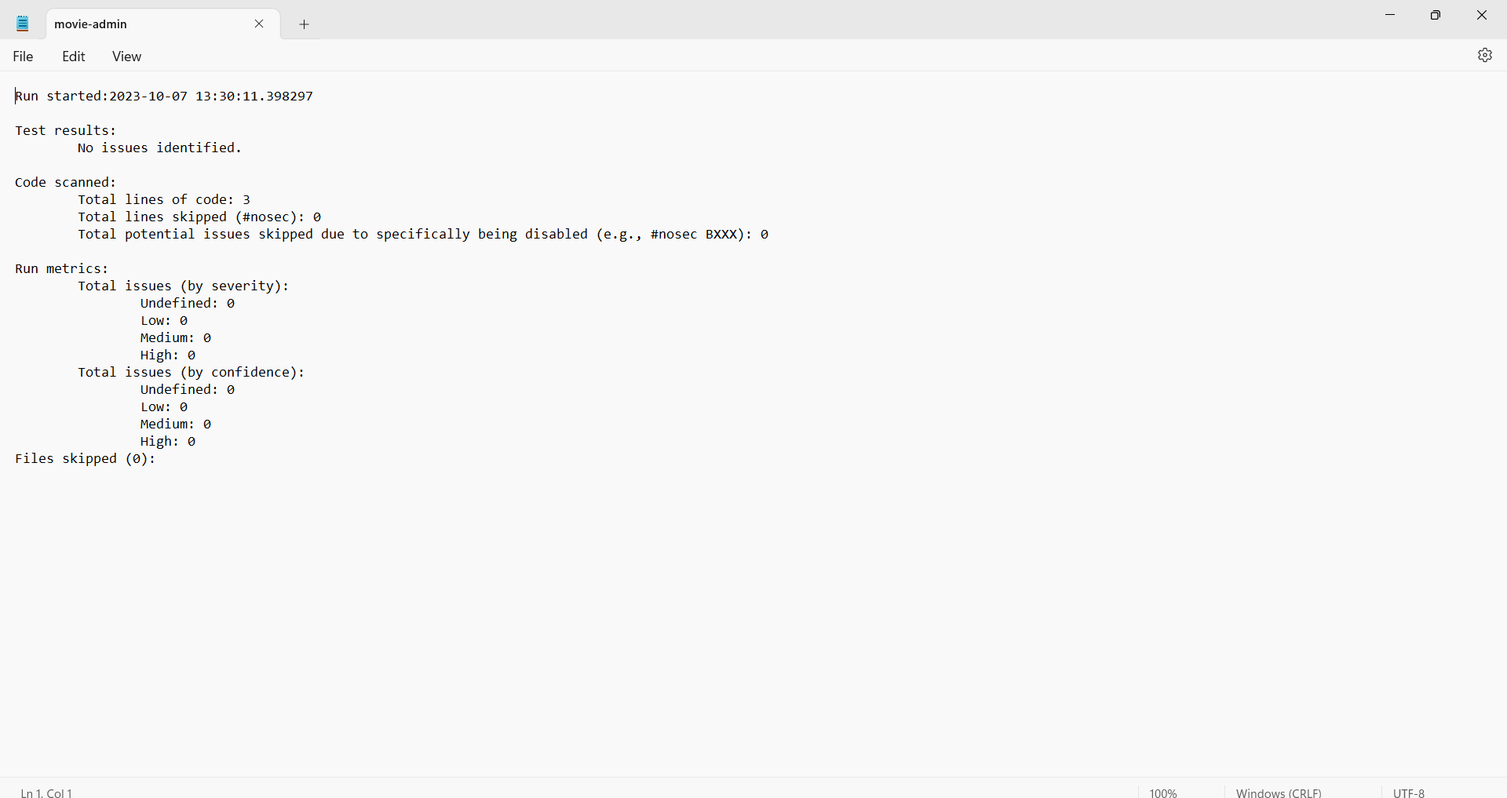

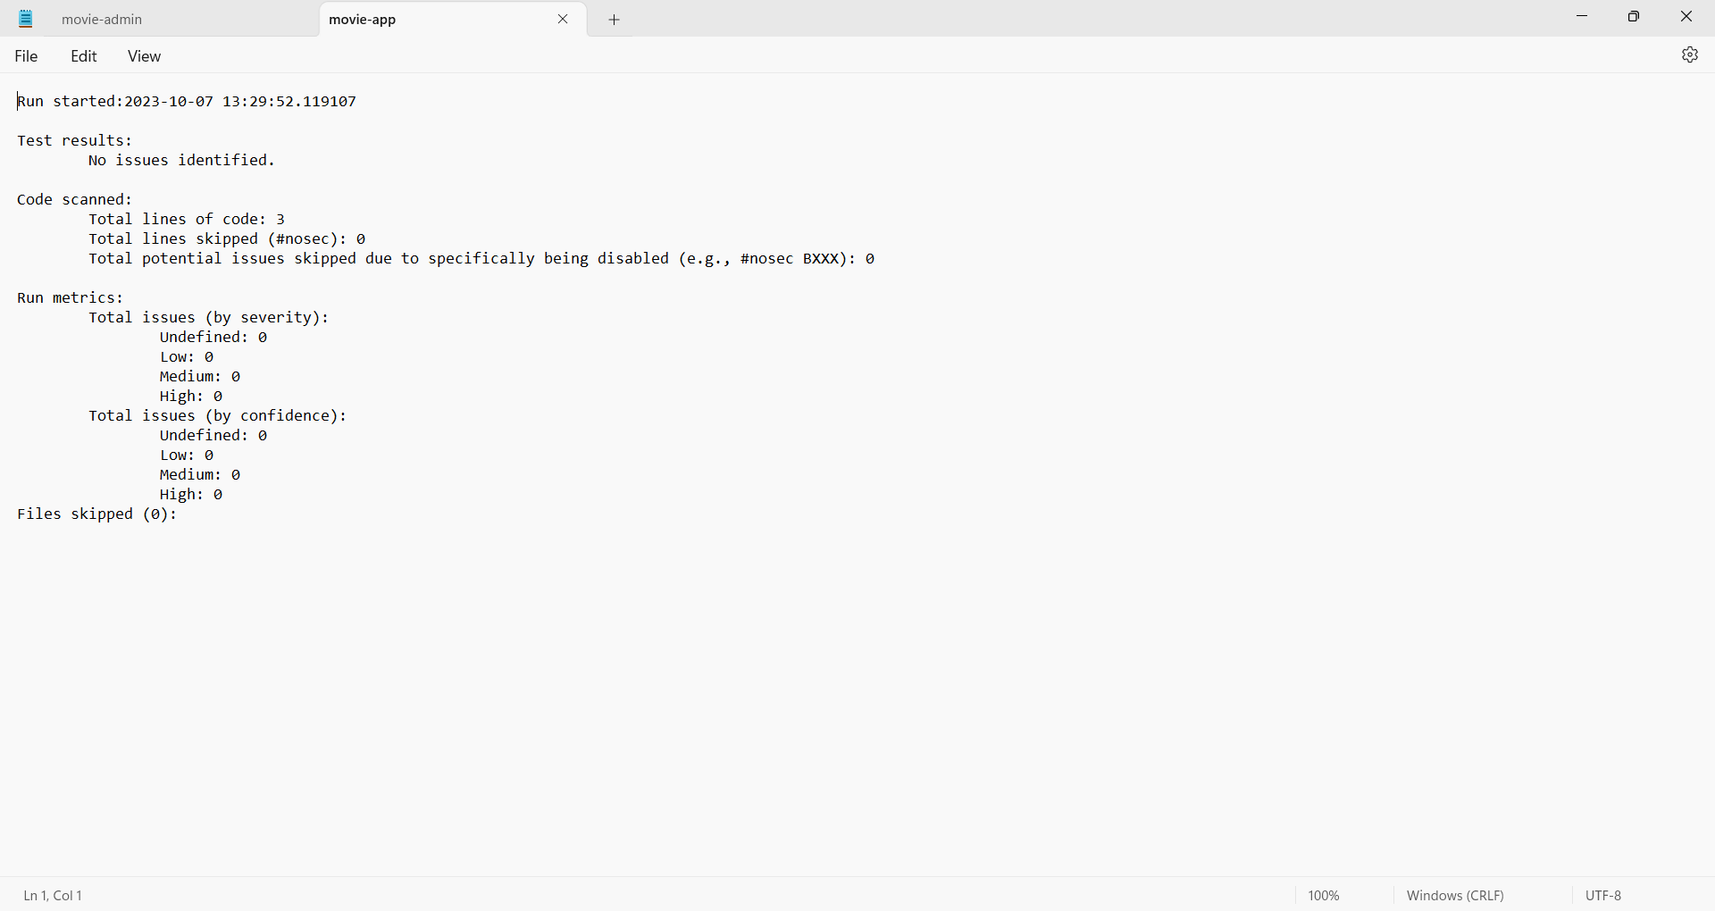

* + 1. **OWASP ZAP – FOR MOVIES APP**

I've opted to employ OWASP ZAP for conducting a security assessment of the Movie Booking System web application for several compelling reasons. Firstly, OWASP ZAP is a freely accessible and open-source tool, ensuring that it's available to a wide range of users without cost constraints. Secondly, its specialization in web application security testing makes it perfectly suited for our needs, with features and functions tailored specifically for this purpose. Moreover, OWASP ZAP offers comprehensive testing capabilities, capable of uncovering a multitude of security vulnerabilities, including SQL injection, cross-site scripting (XSS), and more. What's more, I've configured an automated scanning process utilizing ZAP, which includes traditional Spider and Ajax Spider components, and leverages Chrome headless for simulation, streamlining our testing efforts. Finally, ZAP's capability to generate detailed reports will facilitate effective communication of our findings and enable us to monitor the progress of remediation efforts. In essence, OWASP ZAP is an ideal choice for this security assessment, combining accessibility, web application focus, thorough testing, automation, and robust reporting to enhance the security of the Movie Booking System.

Here I have set up an automated Scan using OWASP ZAP for the Movie app of the Movie booking system. After configuring the Browser Proxy and Configuring ZAP for Local Testing, my website will automatically scan using traditional Spider and Ajax Spider with Chrome headless.

**ANALYSIS AND SUGGESTIONS TO IMPROVE THE TEST RESULT**

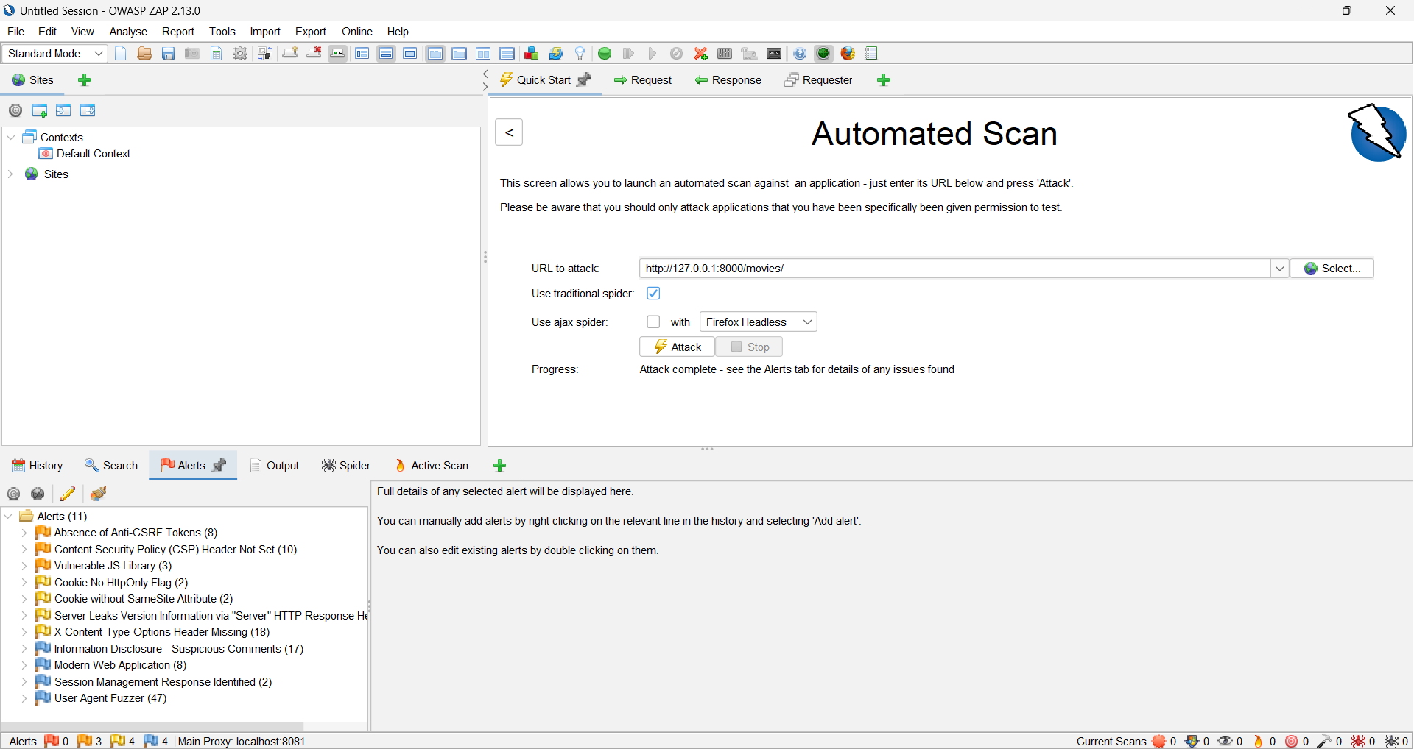

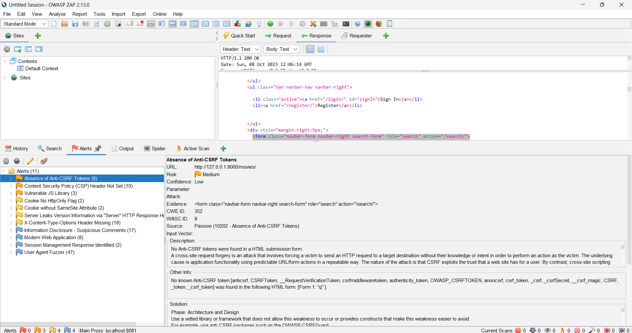

**TEST REPORT GENERATED**

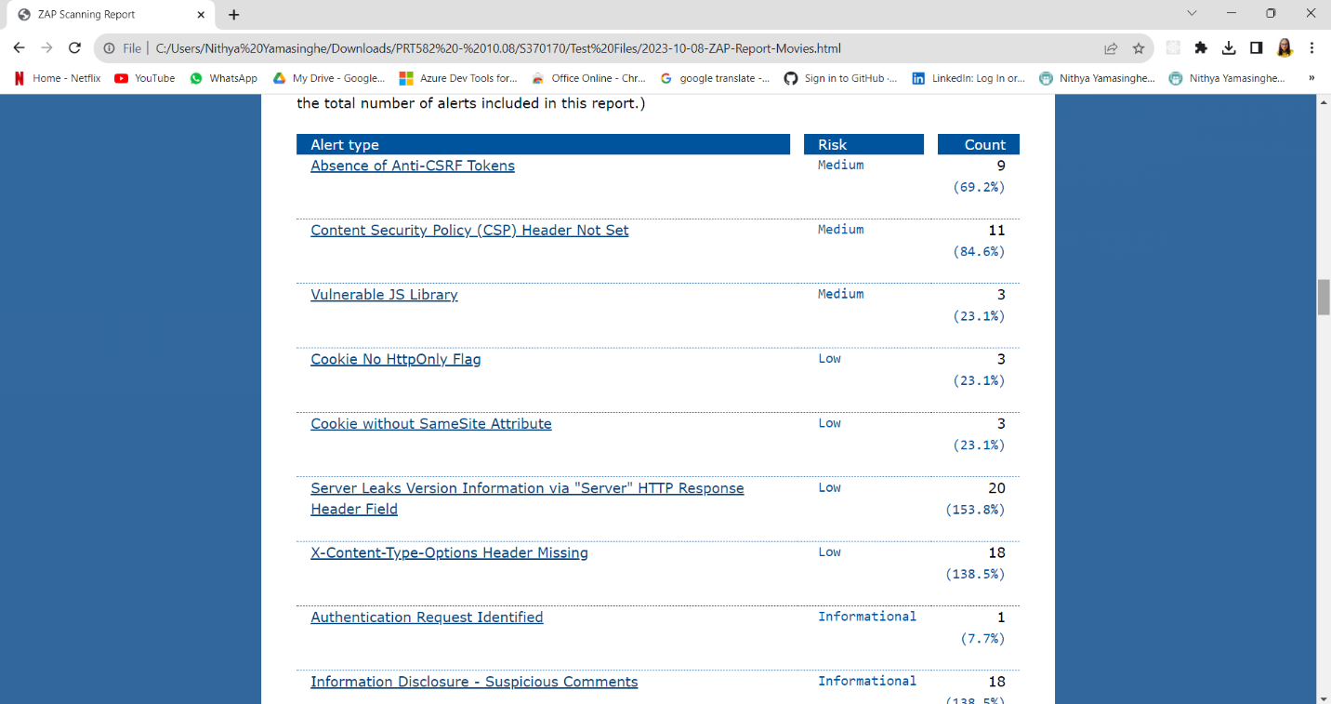

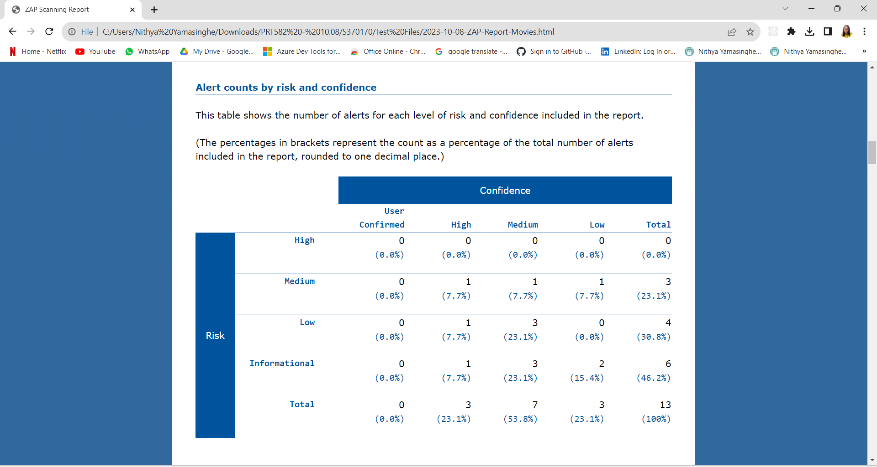

The report categorizes alerts into different risk levels (High, Medium, Low, Informational) and confidence levels (User Confirmed, High, Medium, Low). There are a total of 13 alerts in the report.

The report identifies various security issues, including the absence of Anti-CSRF Tokens, missing Content Security Policy (CSP) headers, vulnerabilities in JavaScript libraries, and issues related to cookies (e.g., missing HttpOnly flag and SameSite attribute). Additionally, it highlights concerns like the disclosure of server version information in HTTP response headers and missing X-Content-Type-Options headers.

Furthermore, the report mentions the detection of authentication requests, suspicious comments indicating potential information disclosure, the application being categorized as a "Modern Web Application," and the use of a User Agent Fuzzer for testing. It's important to note that the report also includes some false positives, which should be reviewed for accuracy.

In summary, the report offers a detailed breakdown of security vulnerabilities and issues found during the scanning process, along with their associated risk and confidence levels, helping developers and security teams prioritize and address these issues to improve the application's security posture.

In the provided ZAP scanning report, several security threats and vulnerabilities have been identified during the assessment of the web application hosted at http://127.0.0.1:8000. These identified threats are categorized based on their risk levels (High, Medium, Low, Informational) and confidence levels (User Confirmed, High, Medium, Low). Here's an explanation of the identified threats:

1. High-Risk Threats (None Detected)

The report indicates that there are no high-risk threats with user-confirmed or high confidence levels. This suggests that there are no critical security vulnerabilities or issues with strong evidence in the application.

2. Medium-Risk Threats

Content Security Policy (CSP) Header Not Set (1):

This alert suggests that the web application lacks a proper CSP header, which can help mitigate the risk of certain types of attacks, such as cross-site scripting (XSS) and data injection.

3. Low-Risk Threats

Server Leaks Version Information via "Server" HTTP Response Header Field (1):

This indicates that the application's HTTP response headers may be leaking server version information, which can potentially assist attackers in identifying vulnerabilities.

Cookie No HttpOnly Flag (1):

This alert points out that there is a cookie without the HttpOnly flag, which can make cookies susceptible to theft via client-side scripts.

Cookie without SameSite Attribute (1):

This alert signifies that certain cookies do not have the SameSite attribute set, potentially making them more vulnerable to cross-site request forgery (CSRF) attacks.

X-Content-Type-Options Header Missing (1):

The absence of the X-Content-Type-Options header may expose the application to MIME-sniffing attacks.

4. Informational Threats

Vulnerable JS Library (1):

This alert suggests that a JavaScript library used in the application may have known vulnerabilities.

Modern Web Application (1):

This informational alert highlights that the application exhibits characteristics of a modern web application, which is valuable information for system administrators.

Session Management Response Identified (1):

Indicates the detection of a session management response, which is informative for security analysis.

User Agent Fuzzer (1):

This alert suggests the use of a User Agent Fuzzer for testing, which can help identify potential security issues.

Information Disclosure - Suspicious Comments (1):

This alert indicates the presence of suspicious comments in the application, which may warrant further investigation.

User Controllable HTML Element Attribute (Potential XSS) (1):

This alert points to a potential cross-site scripting (XSS) vulnerability related to user-controllable HTML attributes.

It's important to note that while these threats have been identified, their actual impact and severity may vary, and some may be false positives or require further investigation. Web application developers and security teams should review these findings and take appropriate actions to address and mitigate the identified security issues to enhance the overall security of the application.

**MEMBER 02 - S370857 -MY NGOC DOAN**

* + 1. **OWASP ZAP – FOR THEATRE APP**

For the security test, I decided to use OWASP ZAP to do this test for some reasons. Firstly, it is a free and open-source tool, so everyone can access it. Secondly, ZAP is specifically designed for web application security testing. It provides a wide range of features and functionalities tailored to assess the security of web applications effectively. Moreover, ZAP is a comprehensive tool. It can test for various security vulnerabilities, including SQL injection, cross-site scripting (XSS), insecure direct object references, and more. Lastly, it can generate detailed reports documenting identified vulnerabilities, making communicating findings easier and tracking remediation efforts.

I set up an automated Scan using OWASP ZAP for the Theatre app of the Movie booking system. After configuring the Browser Proxy and Configuring ZAP for Local Testing, my website will automatically scan using traditional Spider and Ajax Spider with Chrome headless.

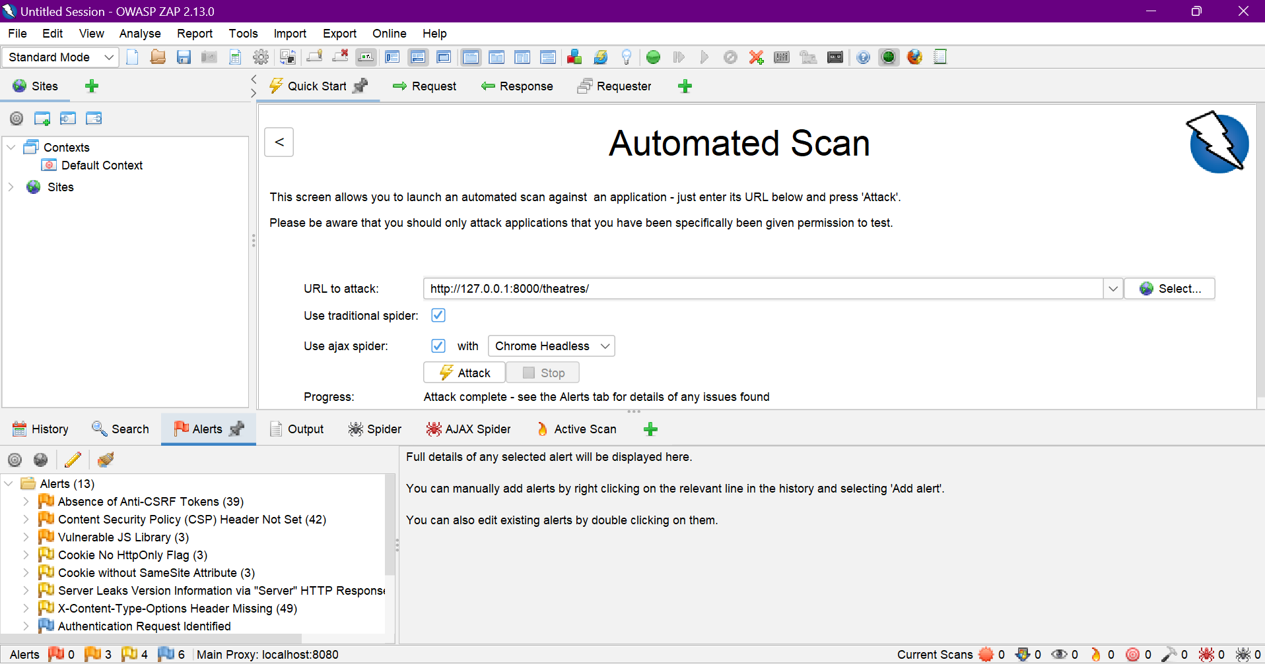

**RESULTS**

This results from a security testing assessment conducted on the theatre app of a movie booking system using OWASP ZAP (Zed Attack Proxy).

The assessment aimed to identify potential security vulnerabilities and provide recommendations for improvement.

The testing revealed a total of 13 alerts, categorised as follows:

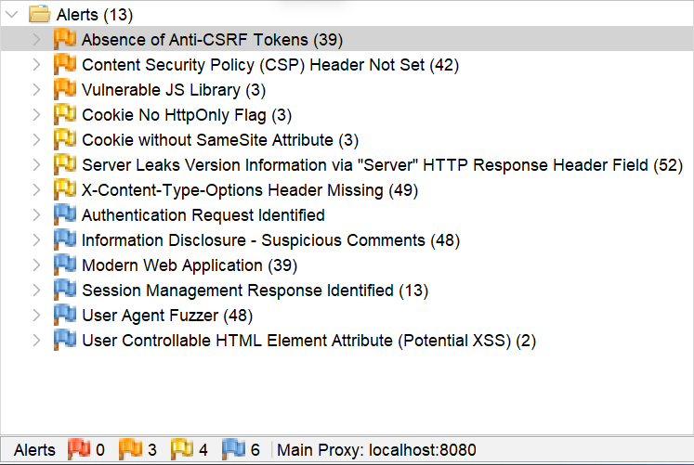

Here are some suggestions for improvement based on the ZAP alerts:

* Medium Priority: 3 alerts
  + Absence of Anti-CSRF Tokens: Use anti-CSRF tokens to prevent CSRF attacks, especially for sensitive operations.
  + Content Security Policy (CSP) Header Not Set: Use a CSP header to restrict the sources from which content can be loaded, enhancing security.
  + Vulnerable JS Library: Update the JavaScript library to the latest secure version and regularly monitor for updates.
* Low Priority: 4 alerts
  + Cookie No HttpOnly Flag: Ensure that the HttpOnly flag is set on any cookies that contain sensitive information.
  + Cookie without SameSite Attribute: Use the SameSite attribute for cookies to limit cookies' activity across sites.
  + Server Leaks Version Information via "Server" HTTP Response Header Field: Set the response header's version information to be obscured or removed by the server.
  + X-Content-Type-Options Header Missing: Use the X-Content-Type-Options header to stop MIME-sniffing attacks.
* Informational Priority: 6 alerts
  + Authentication Request Identified: Use a multi-factor authentication (MFA) solution to add an extra layer of security.
  + Information Disclosure - Suspicious Comments: Use a comment moderation system to remove or flag suspicious comments for review
  + Modern Web Application: Should be aware of the latest security vulnerabilities in modern web technologies.
  + Session Management Response Identified: Need to make sure the session management is secure.
  + User Agent Fuzzer
  + User Controllable HTML Element Attribute (Potential XSS): Use a content security policy (CSP).

Below is some more information that was written in the Report:

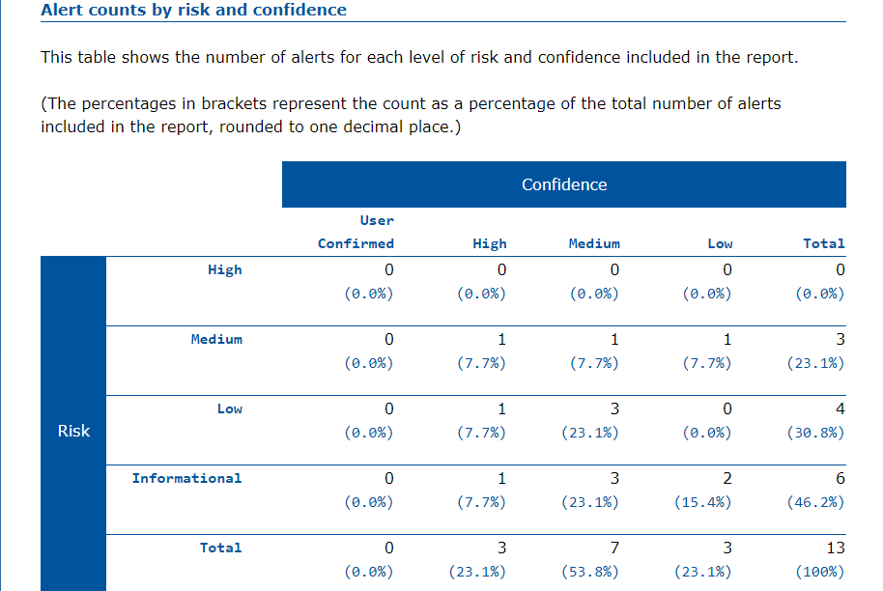

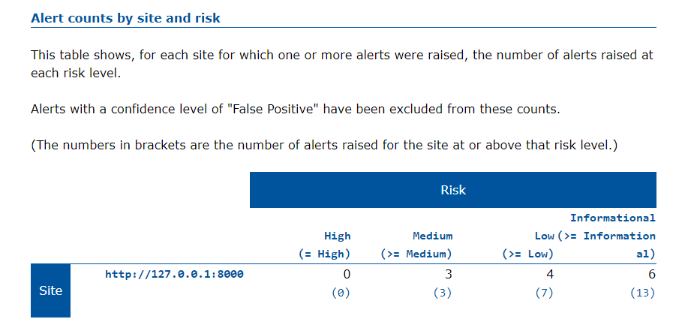

# FUNCTIONAL TESTING

## MANUAL TESTING AND RESULTS

Manual functional testing is a crucial aspect of software testing where skilled testers interact directly with a software application to assess its functionality. In this process, testers meticulously execute test cases based on predetermined requirements and specifications, focusing on the software's intended functionality. They validate whether the application performs its expected tasks correctly and consistently. Manual functional testing includes activities such as inputting data, navigating through the user interface, and verifying that the software responds appropriately to user interactions. Testers meticulously document their findings, reporting any defects or issues they encounter. This type of testing helps identify discrepancies between expected and actual behavior, ensuring that the software functions as intended and meets user requirements. Manual functional testing is a fundamental quality assurance technique that plays a vital role in delivering reliable and user-friendly software products.

**MEMBER 01 - S370170 - NITHYA ROMESHIKA YAMASINGHE**

## MANUAL TEST CASES

## 

Project Name: Online Movie Booking System Module Name: Add Movies Functionality/ Login Functionality

Created By: Power Puffs Created Date: 03-08-2023

Executed by: Power Puffs Executed Date: 03-08-2023

|  |  |  |  |  |  |  |  |
| --- | --- | --- | --- | --- | --- | --- | --- |
| **Test Case ID** | **Description** | **Test Step** | **Preconditions** | **Test Data** | **Expected Result** | **Actual Result** | **Status** |
| TC_ADD_MOVIES_01 | Verify add movies functionality with valid data set | Navigate to add movies page |  |  | Able to see add movies page | As expected | Pass |
|  |  | Enter valid movie name | Valid movie name | Name - Barbie | Movie name can be entered | As Expected | Pass |
|  |  | Enter valid movie cast | Valid movie cast | Cast - Margret Robbie | Movie cast can be entered | As Expected | Pass |
|  |  | Enter valid movie director name | Valid movie director name | Director – Greta Grewig | Movie director name can be entered | As Expected | Pass |
|  |  | Select valid movie language | Valid movie language | Language - English | Movie language can be selected | As Expected | Pass |
|  |  | Enter valid movie run length | Valid movie run length | Run Length – 90 minutes | Movies run length can be entered | As Expected | Pass |
|  |  | Select valid movie certificate | Valid movie certificate | Certificate - RA | Movie certificate can be selected | As Expected | Pass |
|  |  | Enter movie popularity index | Valid popularity index | Popularity Index - 8.6 | Movie popularity index can be entered | As Expected | Pass |
|  |  | Enter movie trailer link | Valid trailer link | Trailer Link - <https://www.youtube.com/watch?v=pBk4NYhWNMM> | Trailer can be entered | As Expected | Pass |
|  |  | Upload movie poster | Valid movie poster | Image – barbie.jpg | Image can be upload | As Expected | Pass |
|  |  | Click on save button |  |  | Movie added | Movie added successfully | Pass |
| TC_ADD_MOVIES_02 | Verify add movies functionality without selecting movie language | Navigate to add movies page |  |  | Able to see add movies page | As expected | Pass |
|  |  | Enter valid movie name | Valid movie name | Name - Barbie | Movie name can be entered | As Expected | Pass |
|  |  | Enter valid movie cast | Valid movie cast | Cast - Margret Robbie | Movie cast can be entered | As Expected | Pass |
|  |  | Enter valid movie director name | Valid movie director name | Director – Greta Grewig | Movie director name can be entered | As Expected | Pass |
|  |  | Select valid movie language | Movie language not selected | Language – Empty/ Null | Movie language can be selected | As Expected | Pass |
|  |  | Enter valid movie run length | Valid movie run length | Run Length – 90 minutes | Movies run length can be entered | As Expected | Pass |
|  |  | Select valid movie certificate | Valid movie certificate | Certificate - RA | Movie certificate can be selected | As Expected | Pass |
|  |  | Enter movie popularity index | Valid popularity index | Popularity Index - 8.6 | Movie popularity index can be entered | As Expected | Pass |
|  |  | Enter movie trailer link | Valid trailer link | Trailer Link - <https://www.youtube.com/watch?v=pBk4NYhWNMM> | Trailer can be entered | As Expected | Pass |
|  |  | Upload movie poster | Valid movie poster | Image – barbie.jpg | Image can be upload | As Expected | Pass |
|  |  | Click on save button |  |  | Movie added | Movie adding unsuccessful | Fail |
| TC_ADD_MOVIES_03 | Verify add movies functionality without selecting movie poster | Navigate to add movies page |  |  | Able to see add movies page | As expected | Pass |
|  |  | Enter valid movie name | Valid movie name | Name - Barbie | Movie name can be entered | As Expected | Pass |
|  |  | Enter valid movie cast | Valid movie cast | Cast - Margret Robbie | Movie cast can be entered | As Expected | Pass |
|  |  | Enter valid movie director name | Valid movie director name | Director – Greta Grewig | Movie director name can be entered | As Expected | Pass |
|  |  | Select valid movie language | Valid movie language | Language - English | Movie language can be selected | As Expected | Pass |
|  |  | Enter valid movie run length | Valid movie run length | Run Length – 90 minutes | Movies run length can be entered | As Expected | Pass |
|  |  | Select valid movie certificate | Valid movie certificate | Certificate - RA | Movie certificate can be selected | As Expected | Pass |
|  |  | Enter movie popularity index | Valid popularity index | Popularity Index - 8.6 | Movie popularity index can be entered | As Expected | Pass |
|  |  | Enter movie trailer link | Valid trailer link | Trailer Link - <https://www.youtube.com/watch?v=pBk4NYhWNMM> | Trailer can be entered | As Expected | Pass |
|  |  | Upload movie poster | Movie poster not uploaded | Image – Null | Image can be upload | As Expected | Pass |
|  |  | Click on save button |  |  | Movie added | Movie adding unsuccessful | Fail |
| TC_ADD_MOVIES_04 | Verify add movies functionality without selecting movie certificate | Navigate to add movies page |  |  | Able to see add movies page | As expected | Pass |
|  |  | Enter valid movie name | Valid movie name | Name - Barbie | Movie name can be entered | As Expected | Pass |
|  |  | Enter valid movie cast | Valid movie cast | Cast - Margret Robbie | Movie cast can be entered | As Expected | Pass |
|  |  | Enter valid movie director name | Valid movie director name | Director – Greta Grewig | Movie director name can be entered | As Expected | Pass |
|  |  | Select valid movie language | Valid movie language | Language - English | Movie language can be selected | As Expected | Pass |
|  |  | Enter valid movie run length | Valid movie run length | Run Length – 90 minutes | Movies run length can be entered | As Expected | Pass |
|  |  | Select valid movie certificate | Movie certificate not selected | Certificate – Empty/ Null | Movie certificate can be selected | As Expected | Pass |
|  |  | Enter movie popularity index | Valid popularity index | Popularity Index - 8.6 | Movie popularity index can be entered | As Expected | Pass |
|  |  | Enter movie trailer link | Valid trailer link | Trailer Link - <https://www.youtube.com/watch?v=pBk4NYhWNMM> | Trailer can be entered | As Expected | Pass |
|  |  | Upload movie poster | Valid movie poster | Image – barbie.jpg | Image can be upload | As Expected | Pass |
|  |  | Click on save button |  |  | Movie added | Movie adding unsuccessful | Fail |
| TC_ADD_MOVIES_05 | Verify add movies functionality without adding invalid trailer link. | Navigate to add movies page |  |  | Able to see add movies page | As expected | Pass |
|  |  | Enter valid movie name | Valid movie name | Name - Barbie | Movie name can be entered | As Expected | Pass |
|  |  | Enter valid movie cast | Valid movie cast | Cast - Margret Robbie | Movie cast can be entered | As Expected | Pass |
|  |  | Enter valid movie director name | Valid movie director name | Director – Greta Grewig | Movie director name can be entered | As Expected | Pass |
|  |  | Select valid movie language | Valid movie language | Language - English | Movie language can be selected | As Expected | Pass |
|  |  | Enter valid movie run length | Valid movie run length | Run Length – 90 minutes | Movies run length can be entered | As Expected | Pass |
|  |  | Select valid movie certificate | Valid movie certificate | Certificate - RA | Movie certificate can be selected | As Expected | Pass |
|  |  | Enter movie popularity index | Valid popularity index | Popularity Index - 8.6 | Movie popularity index can be entered | As Expected | Pass |
|  |  | Enter movie trailer link | Invalid trailer link | Trailer Link - [watch?v=pBk4NYhWNMM](https://www.youtube.com/watch?v=pBk4NYhWNMM) | Trailer can be entered | As Expected | Pass |
|  |  | Upload movie poster | Valid movie poster | Image – barbie.jpg | Image can be upload | As Expected | Pass |
|  |  | Click on save button |  |  | Movie added | Movie adding unsuccessful | Fail |
| TC_UPDATE_MOVIES_01 | Verify updating movie name. | Navigate to update movies page. |  |  | Able to see view movies page. | As Expected | Pass |
|  |  | Select a movie to update. | Valid movie selected. | Selected movie - Barbie | Movie selected | As Expected | Pass |
|  |  | Modify the movie name. | Valid movie name | Name – Barbie and Ken | Movie name entered | As Expected | Pass |
|  |  | Click on the update button. |  |  | Movie name updated successfully. | Movie name updated successfully | Pass |
| TC_UPDATE_MOVIES_02 | Verify updating movie cast | Navigate to update movies page. |  |  | Able to see view movies page. | As Expected | Pass |
|  |  | Select a movie to update. | Valid movie selected. | Selected movie - Barbie | Movie selected | As Expected | Pass |
|  |  | Modify the movie cast. | Valid movie cast | Cast – Margert Robbie, Ryan Gosling | Movie cast entered | As Expected | Pass |
|  |  | Click on the update button. |  |  | Movie cast updated successfully. | As Expected | Pass |
| TC_UPDATE_MOVIES_04 | Verify updating movie language | Navigate to update movies page. |  |  | Able to see view movies page. | As Expected | Pass |
|  |  | Select a movie to update. | Valid movie selected. | Selected movie - Barbie | Movie selected | As Expected | Pass |
|  |  | Change the movie language. | Valid movie language | Language – French | Movie language entered | As Expected | Pass |
|  |  | Click on the update button. |  |  | Movie language updated successfully. | As Expected | Pass |
| TC_UPDATE_MOVIES_05 | Verify updating movie director name | Navigate to update movies page. |  |  | Able to see view movies page. | As Expected | Pass |
|  |  | Select a movie to update. | Valid movie selected. | Selected movie - Barbie | Movie selected | As Expected | Pass |
|  |  | Change the movie director. | Valid movie director | Director – john Art | Movie director entered | As Expected | Pass |
|  |  | Click on the update button. |  |  | Movie language updated successfully. | As Expected | Pass |
| TC_UPDATE_MOVIES_06 | Verify updating movie run length | Navigate to update movies page. |  |  | Able to see view movies page. | As Expected | Pass |
|  |  | Select a movie to update. | Valid movie selected. | Selected movie - Barbie | Movie selected | As Expected | Pass |
|  |  | Modify the run length. | Valid movie run length | Run Length – 120 minutes | Movie run length entered | As Expected | Pass |
|  |  | Click on the update button. |  |  | Movie language updated successfully. | As Expected | Pass |
| TC_LOGIN_01 | Verify login functionality with valid username and password | Navigate to login page |  |  | Able to see login page | As Expected | Pass |
|  |  | Enter valid username | Valid username | Username: [abc@gmail.com](mailto:abc@gmail.com) | Credentials can be entered | As Expected | Pass |
|  |  | Enter valid password | Valid password | Password: 123ABC!@# | Credentials can be entered | As Expected | Pass |
|  |  | Click on login button |  |  | User logged | User logged successfully | Pass |
| TC_LOGIN_02 | Verify login functionality with valid username and invalid password | Navigate to login page |  |  | Able to see login page | As Expected | Pass |
|  |  | Enter valid username | Valid username | Username: [abc@gmail.com](mailto:abc@gmail.com) | Credentials can be entered | As Expected | Pass |
|  |  | Enter valid password | Invalid password | Password: ABC!@# | Credentials can be entered | As Expected | Pass |
|  |  | Click on login button |  |  | User logged | Unsuccessful login | Fail |
| TC_LOGIN_03 | Verify login functionality with invalid username and valid password | Navigate to login page |  |  | Able to see login page |  |  |
|  |  | Enter valid username | Invalid username | Username: [abc1@gmail.com](mailto:abc1@gmail.com) | Credentials can be entered | As Expected | Pass |
|  |  | Enter valid password | Valid password | Password: 123ABC!@# | Credentials can be entered | As Expected | Pass |
|  |  | Click on login button |  |  | User logged | Unsuccessful login | Fail |
| TC_LOGIN_04 | Verify login functionality with invalid username and invalid password | Navigate to login page |  |  | Able to see login page |  |  |
|  |  | Enter valid username | Invalid username | Username: [abc3@gmail.com](mailto:abc3@gmail.com) | Credentials can be entered | As Expected | Pass |
|  |  | Enter valid password | Invalid Password | Password: 4556A | Credentials can be entered | As Expected | Pass |
|  |  | Click on login button |  |  | User logged | Unsuccessful login | Fail |

**MEMBER 02 - S370857 -MY NGOC DOAN**

Project Name: Online Movie Booking System Module Name: Theatre app Functionality

Created By: Power Puffs Created Date: 03-08-2023

Executed by: Power Puffs Executed Date: 03-08-2023

|  |  |  |  |  |  |  |  |
| --- | --- | --- | --- | --- | --- | --- | --- |
| **Test Case ID** | **Description** | **Test Step** | **Preconditions** | **Test Data** | **Expected Result** | **Actual Result** | **Status** |
| TC_ADD_THEATRE_01 | Verify add theatre functionality with valid data set | Navigate to add theatre page |  |  | Able to see add theatre page | As expected | Pass |
|  |  | Enter valid theatre name | Valid theatre name | Name: Theatre Dh1 | Theatre name can be entered | As Expected | Pass |
|  |  | Select valid City | Valid theatre city | City: Delhi | Theatre city can be selected | As Expected | Pass |
|  |  | Enter valid theatre address | Valid theatre address | Address: 123 Abcd Street | Theatre address can be entered | As Expected | Pass |
|  |  | Enter number of screen | Valid number of screen | Number of screen: 5 | Number of screen can be entered | As Expected | Pass |
|  |  | Select Admin id | Valid admin id | Admin id: Admin1 | Admin id can be selected | As Expected | Pass |
|  |  | Click on save button |  |  | Theater added | Theater added successfully | Pass |
| TC_ADD_THEATRE_02 | Verify add theatre functionality with invalid theatre name | Navigate to add theatre page |  |  | Able to see add theatre page | As expected | Pass |
|  |  | Enter valid theatre name | Not enter theater name | Name: Empty/ Null | Theatre name can be entered | Unexpected | Fail |
|  |  | Select valid City | Valid theatre city | City: Delhi | Theatre city can be selected | As Expected | Pass |
|  |  | Enter valid theatre address | Valid theatre address | Address: 123 Abcd Street | Theatre address can be entered | As Expected | Pass |
|  |  | Enter number of screen | Valid number of screen | Number of screen: 5 | Number of screen can be entered | As Expected | Pass |
|  |  | Select Admin id | Valid admin id | Admin id: Admin1 | Admin id can be selected | As Expected | Pass |
|  |  | Click on save button |  |  | Theatre cannot added | Theatre adding unsuccessfully | Fail |
| TC_ADD_THEATRE_03 | Verify add theatre functionality without selecting theatre city | Navigate to add theatre page |  |  | Able to see add theatre page | As expected | Pass |
|  |  | Enter valid theatre name | Valid theatre name | Name: Theatre Dh1 | Theatre name can be entered | As Expected | Pass |
|  |  | Select valid City | Not select theatre city | City: Empty/ Null | Theatre city can be selected | Unexpected | Fail |
|  |  | Enter valid theatre address | Valid theatre address | Address: 123 Abcd Street | Theatre address can be entered | As Expected | Pass |
|  |  | Enter number of screen | Valid number of screen | Number of screen: 5 | Number of screen can be entered | As Expected | Pass |
|  |  | Select Admin id | Valid admin id | Admin id: Admin1 | Admin id can be selected | As Expected | Pass |
|  |  | Click on save button |  |  | Theatre cannot added | Theatre adding unsuccessfully | Fail |
| TC_ADD_THEATRE_04 | Verify add theatre functionality with invalid theatre address | Navigate to add theatre page |  |  | Able to see add theatre page | As expected | Pass |
|  |  | Enter valid theatre name | Valid theatre name | Name: Theatre Dh1 | Theatre name can be entered | As Expected | Pass |
|  |  | Select valid City | Valid theatre city | City: Delhi | Theatre city can be selected | As Expected | Pass |
|  |  | Enter valid theatre address | Not enter theatre address | Address: Empty/Null | Theatre address can be entered | Unexpected | Fail |
|  |  | Enter number of screen | Valid number of screen | Number of screen: 5 | Number of screen can be entered | As Expected | Pass |
|  |  | Select Admin id | Valid admin id | Admin id: Admin1 | Admin id can be selected | As Expected | Pass |
|  |  | Click on save button |  |  | Theater cannot added | Theatre adding unsuccessfully | Fail |
| TC_ADD_THEATRE_05 | Verify add theatre functionality with invalid number of screen | Navigate to add theatre page |  |  | Able to see add theatre page | As expected | Pass |
|  |  | Enter valid theatre name | Valid theatre name | Name: Theatre Dh1 | Theatre name can be entered | As Expected | Pass |
|  |  | Select valid City | Valid theatre city | City: Delhi | Theatre city can be selected | As Expected | Pass |
|  |  | Enter valid theatre address | Valid theatre address | Address: 123 Abcd Street | Theatre address can be entered | As Expected | Pass |
|  |  | Enter number of screen | Invalid number of screen | Number of screen: -1 | Number of screen can be entered | As Expected | Pass |
|  |  | Select Admin id | Valid admin id | Admin id: Admin1 | Admin id can be selected | As Expected | Pass |
|  |  | Click on save button |  |  | Theater cannot added | Theatre adding unsuccessfully | Fail |
| TC_ADD_THEATRE_06 | Verify add theatre functionality without selecting admin id | Navigate to add theatre page |  |  | Able to see add theatre page | As expected | Pass |
|  |  | Enter valid theatre name | Valid theatre name | Name: Theatre Dh1 | Theatre name can be entered | As Expected | Pass |
|  |  | Select valid City | Valid theatre city | City: Delhi | Theatre city can be selected | As Expected | Pass |
|  |  | Enter valid theatre address | Valid theatre address | Address: 123 Abcd Street | Theatre address can be entered | As Expected | Pass |
|  |  | Enter number of screen | Valid number of screen | Number of screen: 5 | Number of screen can be entered | As Expected | Pass |
|  |  | Select Admin id | Not select admin id | Admin id: Empty/null | Admin id can be selected | Unexpected | Pass |
|  |  | Click on save button |  |  | Theater cannot added | Theatre adding unsuccessfully | Fail |
| TC_ADD_SHOW_01 | Verify add show functionality with valid data set | Navigate to add show page |  |  | Able to see add show page | As expected | Pass |
|  |  | Select valid movie name | Valid movie name | Name: Barbie | Movie name can be selected | As Expected | Pass |
|  |  | Select valid theatre | Valid theatre name | Name: Theatre Dh1 | Theatre name can be selected | As Expected | Pass |
|  |  | Enter screen | Valid theatre’s screen | Screen: 2 | Screen can be entered | As Expected | Pass |
|  |  | Enter valid date | Valid show’s date | Date: 05/11/2024 | Show date can be entered | As Expected | Pass |
|  |  | Enter valid time | Valid show’s time | Time: 12:00 | Show time can be entered | As Expected | Pass |
|  |  | Click on save button |  |  | Show added | Show added successfully | Pass |
| TC_ADD_SHOW_02 | Verify add show functionality with invalid movie name | Navigate to add show page |  |  | Able to see add show page | As expected | Pass |
|  |  | Select valid movie name | Not select movie name | Name: Empty/Null | Movie name can be selected | Unexptected | Fail |
|  |  | Select valid theatre | Valid theatre name | Name: Theatre Dh1 | Theatre name can be selected | As Expected | Pass |
|  |  | Enter screen | Valid theatre’s screen | Screen: 2 | Screen can be entered | As Expected | Pass |
|  |  | Enter valid date | Valid show’s date | Date: 05/11/2024 | Show date can be entered | As Expected | Pass |
|  |  | Enter valid time | Valid show’s time | Time: 12:00 | Show time can be entered | As Expected | Pass |
|  |  | Click on save button |  |  | Show cannot added | Show adding unsuccessfully | Fail |
| TC_ADD_SHOW_03 | Verify add show functionality with invalid theatre | Navigate to add show page |  |  | Able to see add show page | As expected | Pass |
|  |  | Select valid movie name | Valid movie name | Name: Barbie | Movie name can be selected | As Expected | Pass |
|  |  | Select valid theatre | Not select theatre | Theatre: Empty/Null | Theatre name can be selected | Unexpected | Fail |
|  |  | Enter screen | Valid theatre’s screen | Screen: 2 | Screen can be entered | As Expected | Pass |
|  |  | Enter valid date | Valid show’s date | Date: 05/11/2024 | Show date can be entered | As Expected | Pass |
|  |  | Enter valid time | Valid show’s time | Time: 12:00 | Show time can be entered | As Expected | Pass |
|  |  | Click on save button |  |  | Show connot added | Show adding unsuccessfully | Fail |
| TC_ADD_SHOW_04 | Verify add show functionality with invalid screen | Navigate to add show page |  |  | Able to see add show page | As expected | Pass |
|  |  | Select valid movie name | Valid movie name | Name: Barbie | Movie name can be selected | As Expected | Pass |
|  |  | Select valid theatre | Valid theatre name | Name: Theatre Dh1 | Theatre name can be selected | As Expected | Pass |
|  |  | Enter screen | Enter invalid screen | Screen: -1 | Screen can be entered | As Expected | Pass |
|  |  | Enter valid date | Valid show’s date | Date: 05/11/2024 | Show date can be entered | As Expected | Pass |
|  |  | Enter valid time | Valid show’s time | Time: 12:00 | Show time can be entered | As Expected | Pass |
|  |  | Click on save button |  |  | Show cannot added | Show adding unsuccessfully | Fail |
| TC_ADD_SHOW_05 | Verify add show functionality with invalid date | Navigate to add show page |  |  | Able to see add show page | As expected | Pass |
|  |  | Select valid movie name | Valid movie name | Name: Barbie | Movie name can be selected | As Expected | Pass |
|  |  | Select valid theatre | Valid theatre name | Name: Theatre Dh1 | Theatre name can be selected | As Expected | Pass |
|  |  | Enter screen | Valid theatre’s screen | Screen: 2 | Screen can be entered | As Expected | Pass |
|  |  | Enter valid date | Enter invalid show’s date | Date: 34/11/2024 | Show date can be entered | As Expected | Pass |
|  |  | Enter valid time | Valid show’s time | Time: 12:00 | Show time can be entered | As Expected | Pass |
|  |  | Click on save button |  |  | Show cannot added | Show adding unsuccessfully | Fail |
| TC_ADD_SHOW_06 | Verify add show functionality with invalid time | Navigate to add show page |  |  | Able to see add show page | As expected | Pass |
|  |  | Select valid movie name | Valid movie name | Name: Barbie | Movie name can be selected | As Expected | Pass |
|  |  | Select valid theatre | Valid theatre name | Name: Theatre Dh1 | Theatre name can be selected | As Expected | Pass |
|  |  | Enter screen | Valid theatre’s screen | Screen: 2 | Screen can be entered | As Expected | Pass |
|  |  | Enter valid date | Valid show’s date | Date: 05/11/2024 | Show date can be entered | As Expected | Pass |
|  |  | Enter valid time | Enter invalid show’s time | Time: 26:00 | Show time can be entered | As Expected | Pass |
|  |  | Click on save button |  |  | Show cannot added | Show adding unsuccessfully | Fail |
| TC_EDIT_THEATRE_01 | Verify edit theatre functionality with valid data set | Navigate to edit theatre page |  |  | Able to see edit theatre page | As expected | Pass |
|  |  | Enter valid theatre name | Valid theatre name | Name: Theatre SuperStar | Theatre name can be entered | As Expected | Pass |
|  |  | Select valid City | Valid theatre city | City: Delhi | Theatre city can be selected | As Expected | Pass |
|  |  | Enter valid theatre address | Valid theatre address | Address: 123 Abcd Street | Theatre address can be entered | As Expected | Pass |
|  |  | Enter number of screen | Valid number of screen | Number of screen: 5 | Number of screen can be entered | As Expected | Pass |
|  |  | Select Admin id | Valid admin id | Admin id: Admin1 | Admin id can be selected | As Expected | Pass |
|  |  | Click on save button |  |  | Theater edited | Theater edited successfully | Pass |
| TC_EDIT_THEATRE_02 | Verify edit theatre functionality with invalid theatre name | Navigate to edit theatre page |  |  | Able to see edit theatre page | As expected | Pass |
|  |  | Enter valid theatre name | Not enter theater name | Name: Empty/ Null | Theatre name can be entered | Unexpected | Fail |
|  |  | Select valid City | Valid theatre city | City: Delhi | Theatre city can be selected | As Expected | Pass |
|  |  | Enter valid theatre address | Valid theatre address | Address: 123 Abcd Street | Theatre address can be entered | As Expected | Pass |
|  |  | Enter number of screen | Valid number of screen | Number of screen: 5 | Number of screen can be entered | As Expected | Pass |
|  |  | Select Admin id | Valid admin id | Admin id: Admin1 | Admin id can be selected | As Expected | Pass |
|  |  | Click on save button |  |  | Theatre cannot edited | Theatre editing unsuccessfully | Fail |
| TC_EDIT_THEATRE_03 | Verify edit theatre functionality without selecting theatre city | Navigate to edit theatre page |  |  | Able to see edit theatre page | As expected | Pass |
|  |  | Enter valid theatre name | Valid theatre name | Name: Theatre Dh1 | Theatre name can be entered | As Expected | Pass |
|  |  | Select valid City | Not select theatre city | City: Empty/ Null | Theatre city can be selected | Unexpected | Fail |
|  |  | Enter valid theatre address | Valid theatre address | Address: 123 Abcd Street | Theatre address can be entered | As Expected | Pass |
|  |  | Enter number of screen | Valid number of screen | Number of screen: 5 | Number of screen can be entered | As Expected | Pass |
|  |  | Select Admin id | Valid admin id | Admin id: Admin1 | Admin id can be selected | As Expected | Pass |
|  |  | Click on save button |  |  | Theatre cannot edited | Theatre editing unsuccessfully | Fail |
| TC_EDIT_THEATRE_04 | Verify edit theatre functionality with invalid theatre address | Navigate to edit theatre page |  |  | Able to see edit theatre page | As expected | Pass |
|  |  | Enter valid theatre name | Valid theatre name | Name: Theatre Dh1 | Theatre name can be entered | As Expected | Pass |
|  |  | Select valid City | Valid theatre city | City: Delhi | Theatre city can be selected | As Expected | Pass |
|  |  | Enter valid theatre address | Not enter theatre address | Address: Empty/Null | Theatre address can be entered | Unexpected | Fail |
|  |  | Enter number of screen | Valid number of screen | Number of screen: 5 | Number of screen can be entered | As Expected | Pass |
|  |  | Select Admin id | Valid admin id | Admin id: Admin1 | Admin id can be selected | As Expected | Pass |
|  |  | Click on save button |  |  | Theater cannot edited | Theatre editing unsuccessfully | Fail |
| TC_EDIT_THEATRE_05 | Verify edit theatre functionality with invalid number of screen | Navigate to edit theatre page |  |  | Able to see edit theatre page | As expected | Pass |
|  |  | Enter valid theatre name | Valid theatre name | Name: Theatre Dh1 | Theatre name can be entered | As Expected | Pass |
|  |  | Select valid City | Valid theatre city | City: Delhi | Theatre city can be selected | As Expected | Pass |
|  |  | Enter valid theatre address | Valid theatre address | Address: 123 Abcd Street | Theatre address can be entered | As Expected | Pass |
|  |  | Enter number of screen | Invalid number of screen | Number of screen: -1 | Number of screen can be entered | As Expected | Pass |
|  |  | Select Admin id | Valid admin id | Admin id: Admin1 | Admin id can be selected | As Expected | Pass |
|  |  | Click on save button |  |  | Theater cannot edited | Theatre editing unsuccessfully | Fail |
| TC_EDIT_THEATRE_06 | Verify edit theatre functionality without selecting admin id | Navigate to edit theatre page |  |  | Able to see edit theatre page | As expected | Pass |
|  |  | Enter valid theatre name | Valid theatre name | Name: Theatre Dh1 | Theatre name can be entered | As Expected | Pass |
|  |  | Select valid City | Valid theatre city | City: Delhi | Theatre city can be selected | As Expected | Pass |
|  |  | Enter valid theatre address | Valid theatre address | Address: 123 Abcd Street | Theatre address can be entered | As Expected | Pass |
|  |  | Enter number of screen | Valid number of screen | Number of screen: 5 | Number of screen can be entered | As Expected | Pass |
|  |  | Select Admin id | Not select admin id | Admin id: Empty/null | Admin id can be selected | Unexpected | Pass |
|  |  | Click on save button |  |  | Theater cannot edit | Theatre edit unsuccessfully | Fail |
| TC_EDIT_SHOW_01 | Verify edit show functionality with valid data set | Navigate to edit show page |  |  | Able to see edit show page | As expected | Pass |
|  |  | Select valid movie name | Valid movie name | Name: Barbie | Movie name can be selected | As Expected | Pass |
|  |  | Select valid theatre | Valid theatre name | Name: Theatre Dh1 | Theatre name can be selected | As Expected | Pass |
|  |  | Enter screen | Valid theatre’s screen | Screen: 3 | Screen can be entered | As Expected | Pass |
|  |  | Enter valid date | Valid show’s date | Date: 12/11/2024 | Show date can be entered | As Expected | Pass |
|  |  | Enter valid time | Valid show’s time | Time: 16:00 | Show time can be entered | As Expected | Pass |
|  |  | Click on save button |  |  | Show edited | Show edited successfully | Pass |
| TC_EDIT_SHOW_02 | Verify edit show functionality with invalid movie name | Navigate to edit show page |  |  | Able to see edit show page | As expected | Pass |
|  |  | Select valid movie name | Not select movie name | Name: Empty/Null | Movie name can be selected | Unexptected | Fail |
|  |  | Select valid theatre | Valid theatre name | Name: Theatre Dh1 | Theatre name can be selected | As Expected | Pass |
|  |  | Enter screen | Valid theatre’s screen | Screen: 2 | Screen can be entered | As Expected | Pass |
|  |  | Enter valid date | Valid show’s date | Date: 05/11/2024 | Show date can be entered | As Expected | Pass |
|  |  | Enter valid time | Valid show’s time | Time: 12:00 | Show time can be entered | As Expected | Pass |
|  |  | Click on save button |  |  | Show cannot edited | Show editing unsuccessfully | Fail |
| TC_EDIT_SHOW_03 | Verify edit show functionality with invalid theatre | Navigate to edit show page |  |  | Able to see edit show page | As expected | Pass |
|  |  | Select valid movie name | Valid movie name | Name: Barbie | Movie name can be selected | As Expected | Pass |
|  |  | Select valid theatre | Not select theatre | Theatre: Empty/Null | Theatre name can be selected | Unexpected | Fail |
|  |  | Enter screen | Valid theatre’s screen | Screen: 2 | Screen can be entered | As Expected | Pass |
|  |  | Enter valid date | Valid show’s date | Date: 05/11/2024 | Show date can be entered | As Expected | Pass |
|  |  | Enter valid time | Valid show’s time | Time: 12:00 | Show time can be entered | As Expected | Pass |
|  |  | Click on save button |  |  | Show connot edited | Show editing unsuccessfully | Fail |
| TC_EDIT_SHOW_04 | Verify edit show functionality with invalid screen | Navigate to edit show page |  |  | Able to see edit show page | As expected | Pass |
|  |  | Select valid movie name | Valid movie name | Name: Barbie | Movie name can be selected | As Expected | Pass |
|  |  | Select valid theatre | Valid theatre name | Name: Theatre Dh1 | Theatre name can be selected | As Expected | Pass |
|  |  | Enter screen | Enter invalid screen | Screen: -1 | Screen can be entered | As Expected | Pass |
|  |  | Enter valid date | Valid show’s date | Date: 05/11/2024 | Show date can be entered | As Expected | Pass |
|  |  | Enter valid time | Valid show’s time | Time: 12:00 | Show time can be entered | As Expected | Pass |
|  |  | Click on save button |  |  | Show cannot edited | Show editing unsuccessfully | Fail |
| TC_EDIT_SHOW_05 | Verify edit show functionality with invalid date | Navigate to edit show page |  |  | Able to see edit show page | As expected | Pass |
|  |  | Select valid movie name | Valid movie name | Name: Barbie | Movie name can be selected | As Expected | Pass |
|  |  | Select valid theatre | Valid theatre name | Name: Theatre Dh1 | Theatre name can be selected | As Expected | Pass |
|  |  | Enter screen | Valid theatre’s screen | Screen: 2 | Screen can be entered | As Expected | Pass |
|  |  | Enter valid date | Enter invalid show’s date | Date: 34/11/2024 | Show date can be entered | As Expected | Pass |
|  |  | Enter valid time | Valid show’s time | Time: 12:00 | Show time can be entered | As Expected | Pass |
|  |  | Click on save button |  |  | Show cannot edited | Show editing unsuccessfully | Fail |
| TC_EDIT_SHOW_06 | Verify edit show functionality with invalid time | Navigate to edit show page |  |  | Able to see edit show page | As expected | Pass |
|  |  | Select valid movie name | Valid movie name | Name: Barbie | Movie name can be selected | As Expected | Pass |
|  |  | Select valid theatre | Valid theatre name | Name: Theatre Dh1 | Theatre name can be selected | As Expected | Pass |
|  |  | Enter screen | Valid theatre’s screen | Screen: 2 | Screen can be entered | As Expected | Pass |
|  |  | Enter valid date | Valid show’s date | Date: 05/11/2024 | Show date can be entered | As Expected | Pass |
|  |  | Enter valid time | Enter invalid show’s time | Time: 26:00 | Show time can be entered | As Expected | Pass |
|  |  | Click on save button |  |  | Show cannot edited | Show editing unsuccessfully | Fail |
| TC_INFO_THEATRE_01 | Verify showing theatre’s information functionality with valid data set | Navigate to theatre’s information page when click on theatre’s name |  |  | Able to see theather’s information page when click on theatre’s name | As expected | Pass |
|  |  | This page show:  -Name  -City  -Address  -Number of screen  -Contact number  -Show’s information with movie name and time | -Valid Theatre name  -Valid City  -Valid Address  -Valid Number of screen  -Valid Admin ID  -Valid Movie  -Valid Show time | Click on theatre name “Theatre Dh1” | This page show:  -Correct name  -Correct city  -Correct address  -Correct number of screen  -Correct contact number  -Correct show’s information with movie name and time | As expected | Pass |
| TC_INFO_THEATRE_02 | Verify showing theatre’s information functionality with invalid data set | Navigate to theatre’s information page when click on theatre’s name |  |  | Able to see theatre’s information page when click on theatre’s name | As expected | Pass |
|  |  | This page show:  -Name  -City  -Address  -Number of screen  -Contact number  -Show’s information with movie name and time | At least one element is invalid:  -Theatre name  -City  -Address  -Number of screen  -Admin ID  -Movie  -Show time | Click on theatre name “Theater Dh1” | This page show:  -Correct name  -Correct city  -Correct address  -Correct number of screen  -Correct contact number  -Correct show’s information with movie name and time | Unexpected | Fail |
| TC_INFO_SHOW_01 | Verify showing the show information functionality with valid data set | Navigate to selecting seat page when click on show’s time |  |  | Able to see selecting seat page when click on show’s time | As expected | Pass |
|  |  | This page show:  - Movie name  -Theatre  -Address  -City  -Date  -Time  -Screen map | -Valid Movie  -Valid Theatre  -Valid Screen  -Valid Date  -Valid Time | Click on the show’s time “12:00” of Barbie movie | This page show:  -Correct movie name  -Correct theatre  -Correct address  -Correct city  -Correct date  -Correct time  -Correct Screen map | As expected | Pass |
| TC_INFO_SHOW_02 | Verify showing the show information functionality with invalid data set | Navigate to selecting seat page when click on show’s time |  |  | Able to see selecting seat page when click on show’s time | As expected | Pass |
|  |  | This page show:  - Movie name  -Theatre  -Address  -City  -Date  -Time  -Screen map | At least one element is invalid:  -Movie  -Theatre  -Screen  -Date  -Time | Click on the show’s time “12:00” of Barbie movie | This page show:  -Correct movie name  -Correct theatre  -Correct address  -Correct city  -Correct date  -Correct time  -Correct Screen map | Unexpected | Fail |

## AUTOMATED TESTING AND RESULTS

Automated testing using Robot Framework, often referred to as "Robot," is a popular open-source test automation framework used for automating test cases across a wide range of applications, including web, mobile, and desktop. Robot Framework uses a highly readable and keyword-driven syntax, making it accessible to both testers and non-technical team members.

**MEMBER 01 - S370170 - NITHYA ROMESHIKA YAMASINGHE**

Test 1: Go to Website

In this test, we simulate the action of opening the movie ticket booking system's website. This test ensures that the website is accessible, and the initial page loads correctly.

Test 2: Admin Sign In

This test involves entering the admin username and password, followed by clicking the "Admin Sign In" button. Its purpose is to verify the admin login functionality. A successful login grants access to the admin panel.

Test 3: View Movies List

Once logged in, we navigate to the movies list section. This test checks if the list of movies is displayed properly, ensuring that movie data is being fetched and presented correctly.

Test 4: Add New Movie

Here, we test the functionality to add a new movie to the system. We provide details about the movie and click the "Save" button to confirm the addition. This verifies that the system can accept new movie entries.

Test 5: Update Existing Movie

In this test, we modify the information of an existing movie and save the changes. The system should confirm these changes with a message like "Select movie to change," indicating that the update was successful.

Test 6: Delete Existing Movie

To validate the movie removal feature, we select an existing movie and remove it from the system. Successful removal should result in the movie no longer appearing in the list.

Test 7: Add New Movie Again

This is a repetition of Test 4, adding a new movie. It can help confirm that the system can handle multiple movie additions.

Test 8: Go to Home

After managing movies, we return to the home page. This test ensures that the navigation between different sections of the application works correctly.

Test 9: View Users List

We move to the section displaying a list of users in this test. It validates that user data is being retrieved and presented as expected.

Test 10: Add New User

As an admin, we add a new user by providing their information and saving it. This test checks the functionality for adding new users.

Test 11: Update Existing User

Similar to updating an existing movie, this test involves modifying the information of an existing user (e.g., changing their email or password) and saving the changes. The system should confirm these changes with a success message.

Test 12: Delete Existing User

This test verifies the user removal feature. It involves selecting an existing user and removing them from the system, with the expected result being the user's absence from the user list.

Test 13: Admin Logout

Admin logs out.

Test 14: User Sign In

This test involves entering the admin username and password, followed by clicking the "Sign In" button. Its purpose is to verify the admin login functionality. A successful login grants access to the user panel.

Test 15: Search Movies

Movies search in the search bar.

Test 16: User Logout

User logout from the system.

|  |  |  |  |
| --- | --- | --- | --- |
| **Test Description** | **Expected Result** | **Actual Result** | **Pass/Fail** |
| Go to Website | Website loads | Website loaded | Pass |
| Admin Sign In | Successful login | Successful login | Pass |
| View Movies List | Movie list displayed | Movie list displayed | Pass |
| Add New Movie | Movie added | Movie added | Pass |
| Update Existing Movie | Movie updated | Movie updated | Pass |
| Delete Existing Movie | Movie deleted | Movie deleted | Pass |
| Add New Movie Again | Movie added | Movie added | Pass |
| Go to Home | Home page displayed | Home page displayed | Pass |
| View Users List | User list displayed | User list displayed | Pass |
| Add New User | User added | User added | Pass |
| Update Existing User | User updated | User updated | Pass |
| Delete Existing User | User deleted | User deleted | Pass |

In the table above, I documented each test's description, the expected result, the actual result observed during testing, and whether the test passed or failed based on the comparison between expected and actual results. All tests appear to have passed, indicating that the movie ticket booking system's admin functionality is working as expected.

**PYTHON ROBOT CODE**

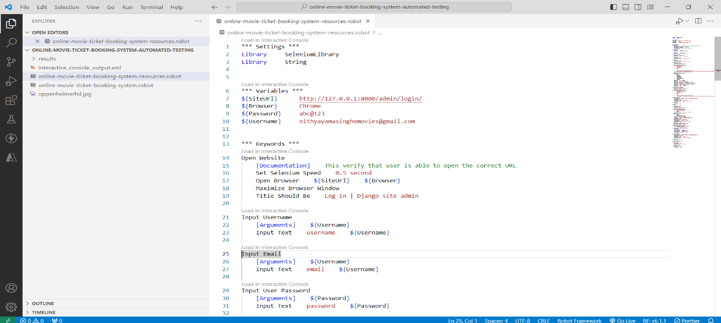

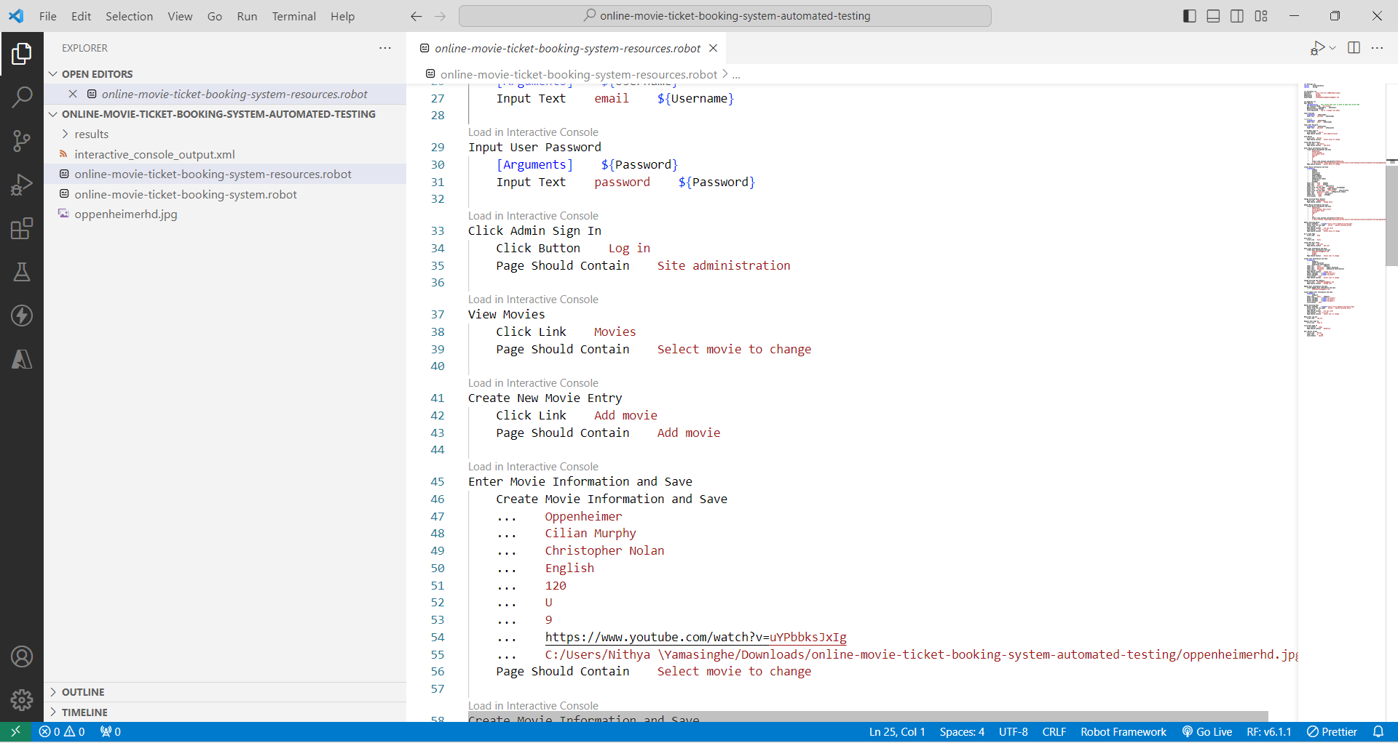

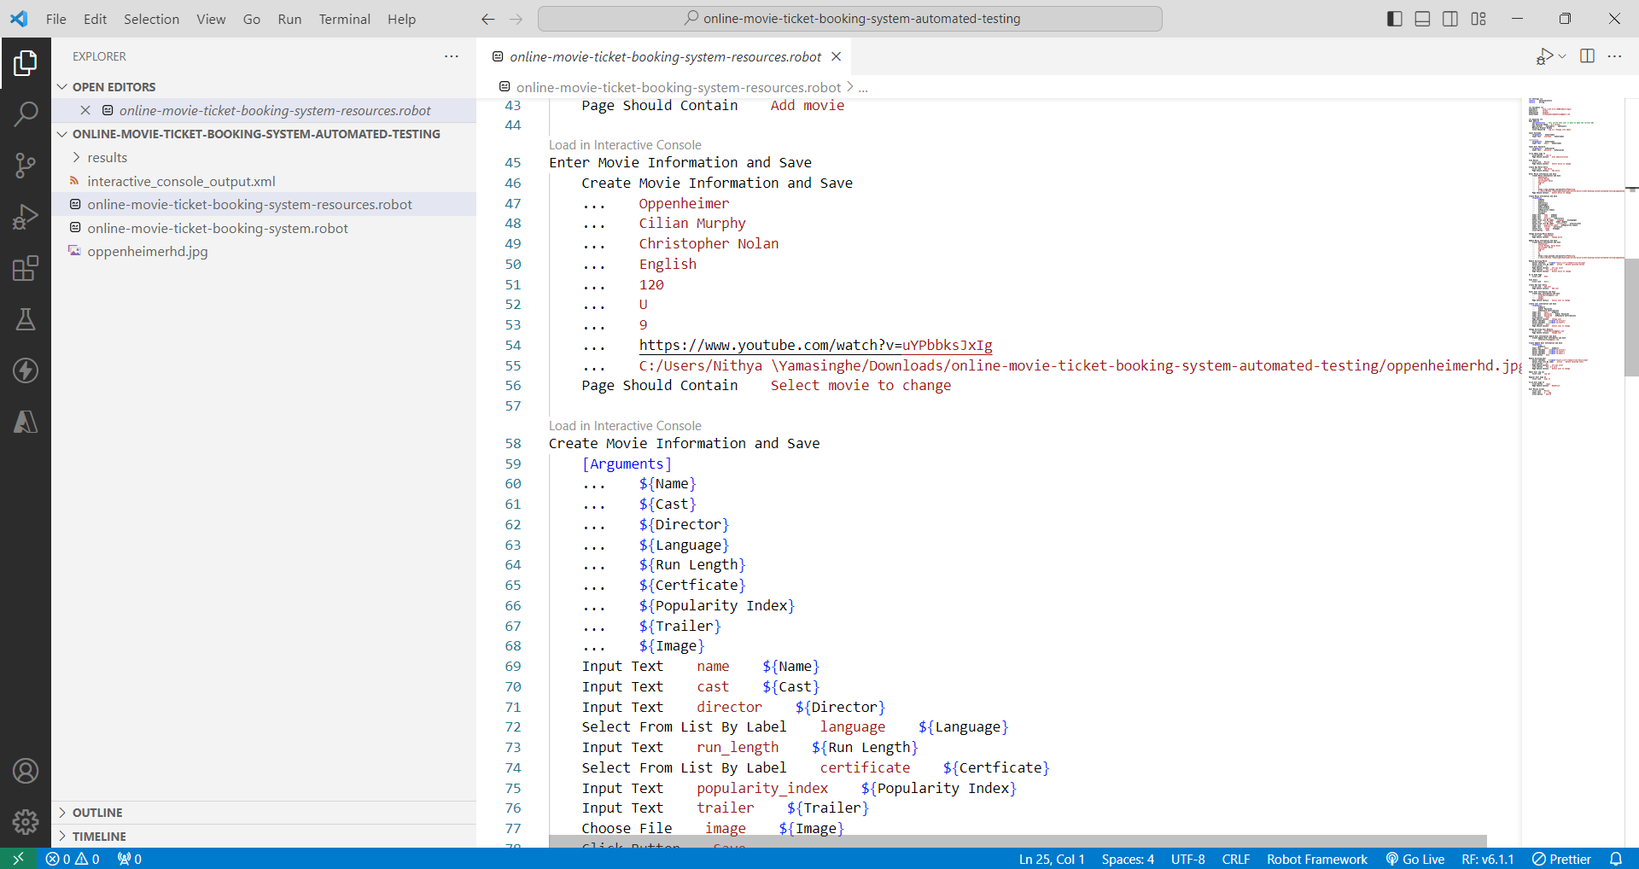

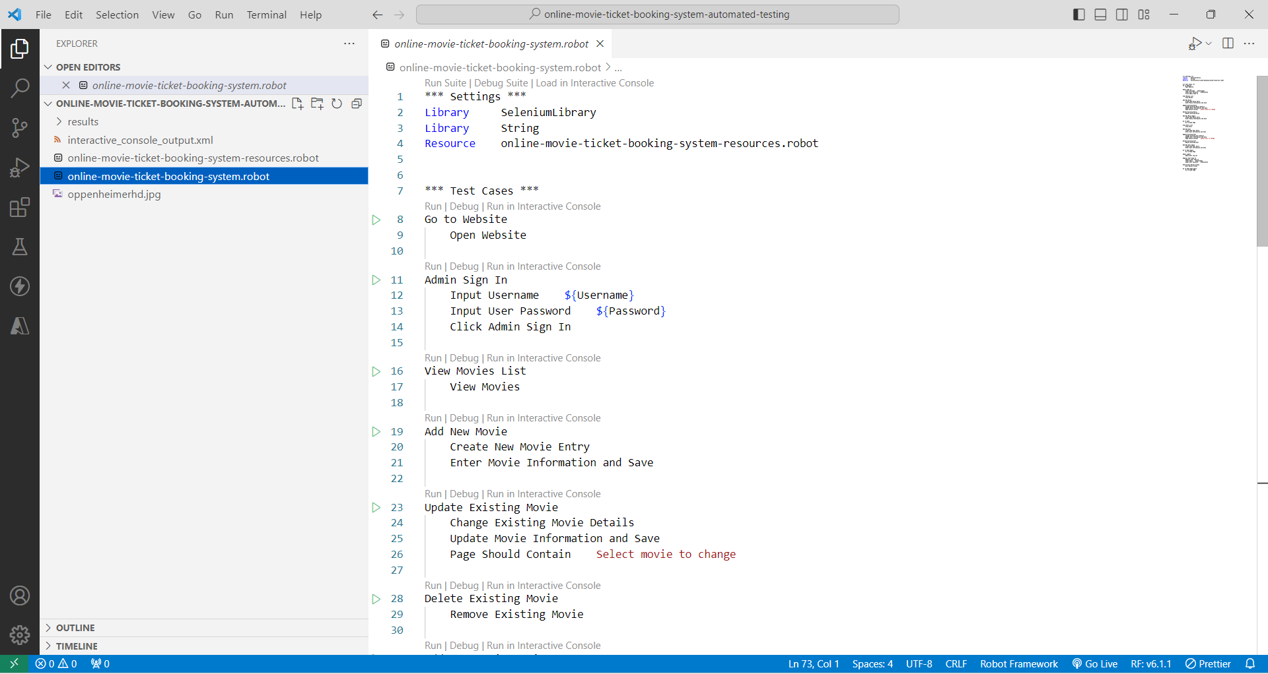

**PYTHON ROBOT AUTOMATION TEST RESULTS**

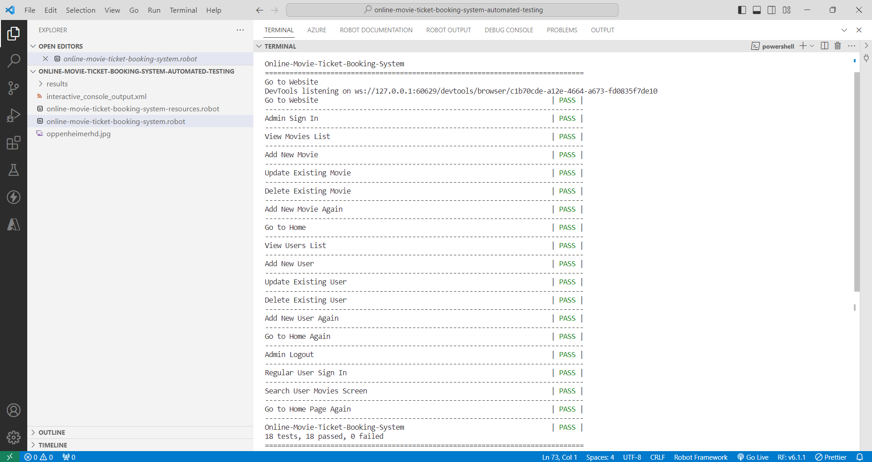



**MEMBER 02 - S370857 -MY NGOC DOAN**

**FOR ADMIN USER**

Checking login admin page

**ROBOT**

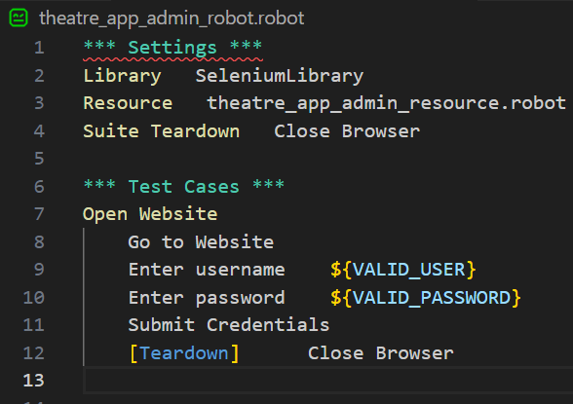

**ROBOT RESOURE**

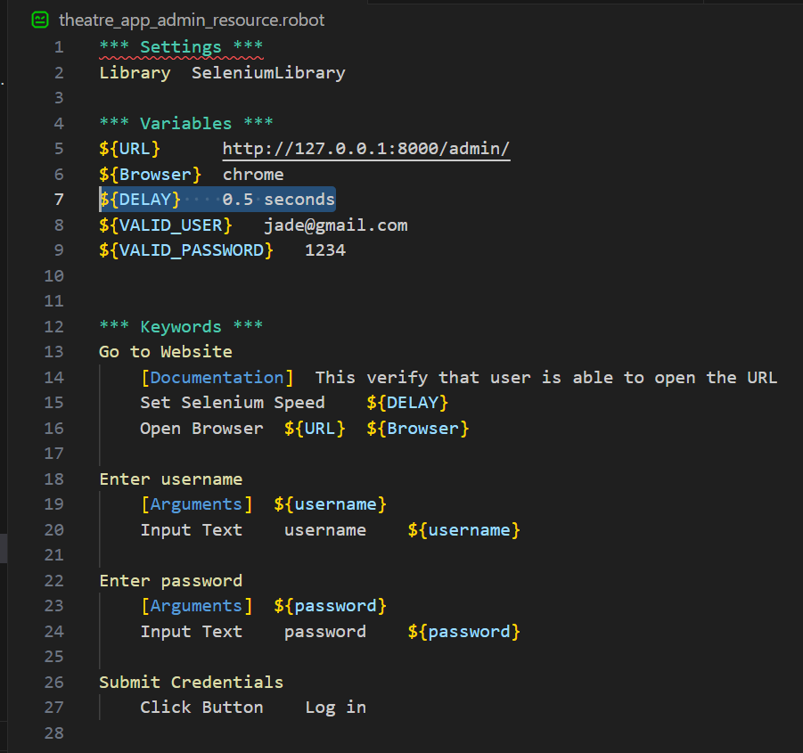

**RESULT**

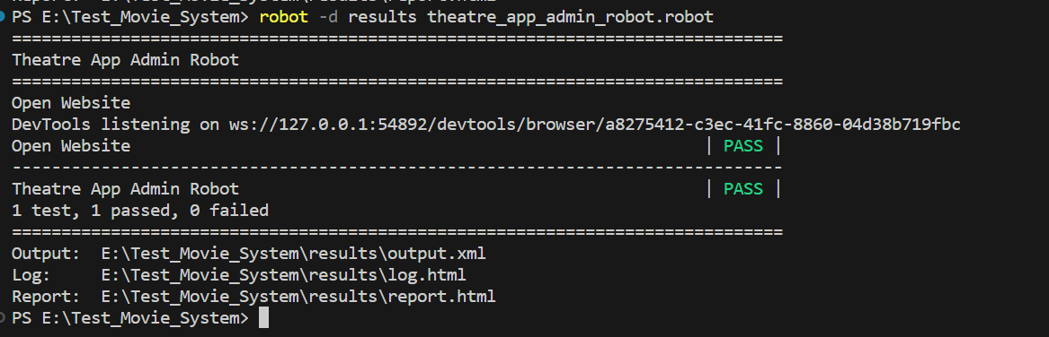

**FOR GENERAL USER**

* Checking open website
* Checking Choose the Theater
* Checking Choose the Movie

**ROBOT**

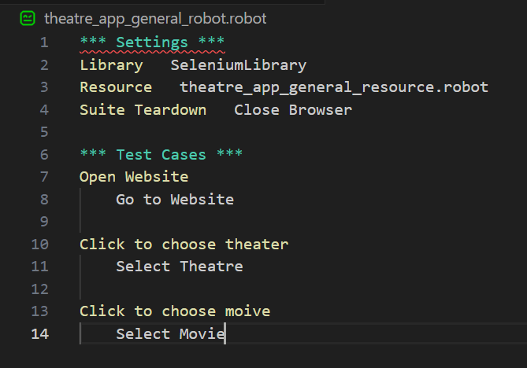

**ROBOT RESOURCE**

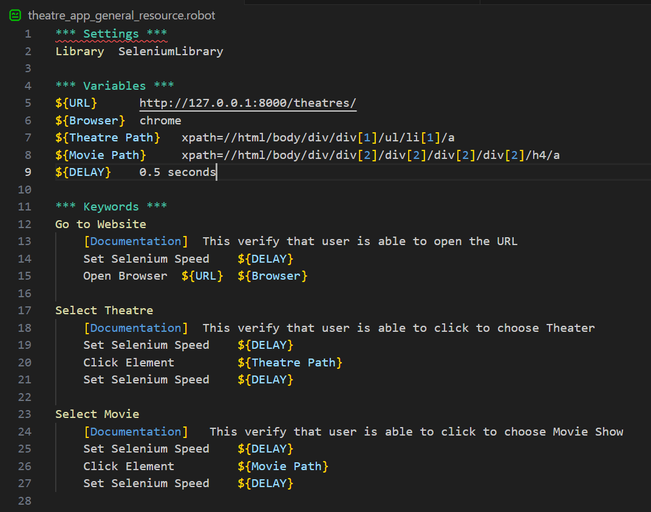

**RESULT**

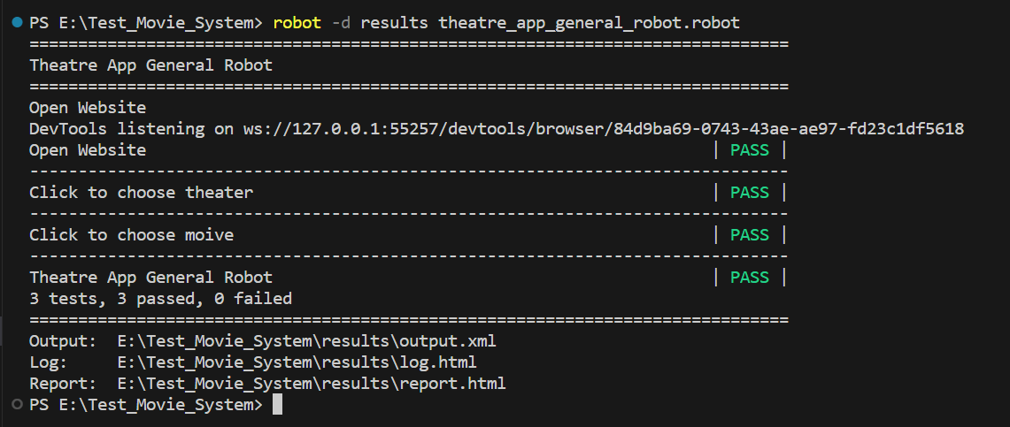

# CONCLUSION

The online movie ticket booking system is a system that can automate most of the manual processing and time-consuming tasks that happen in a real-world scenario. The system can be personalized based on the requirements of any vendor and can be hosted for access by any user. The system can be further improved by introducing an e-ticketing system based on QR codes and improving the user interfaces to be more user-friendly. Some system limitations have been identified and can be removed by implementing them in the project's next phase. The testing plan introduced is to identify any issues or bugs in the current stage of the system and resolve them before the commercial hosting of the application. Even though many other tests can be performed to ensure the system is fit to purpose; however, here we have outlined the most necessary testing areas that can be used to verify the system is bug-free. The report has highlighted important information about the system and its background based on that reasonable time estimation has been added to the testing plan.

* 1. **ETHICAL CONSIDERATION**

In the development of our online movie ticket booking system, our team has remained steadfast in upholding ethical principles that align with the expectations of IT professionals and adhere to the ethical considerations set forth by relevant professional bodies. We have placed a strong emphasis on ensuring the security and privacy of user data, implementing robust encryption protocols to protect sensitive information and adhering to best practices in cybersecurity. Moreover, we have strived to maintain transparency and fairness in our pricing strategies, avoiding hidden fees or discriminatory practices. Our system is designed to provide equal access and opportunities for all users, promoting inclusivity and avoiding any form of bias. Additionally, we have implemented stringent measures to prevent fraudulent activities and safeguard the integrity of the booking process. Throughout the project, we have constantly referenced and followed the ethical guidelines and codes of conduct established by respected IT professional bodies to ensure that our online movie ticket booking system not only meets industry standards but also stands as an exemplar of ethical IT development.

* 1. **FURTHUR WORK**

In considering potential avenues for further work, there are several promising directions to explore in the context of our online movie ticket booking system. First and foremost, enhancing the user experience remains a priority. This could involve the development of a mobile application for convenient ticket booking on smartphones, offering personalized recommendations based on user preferences, or implementing intuitive features like seat selection with visual representations of the cinema layout.

Moreover, we should focus on strengthening our system's cybersecurity further, staying ahead of emerging threats and ensuring the continuous protection of user data. Collaborating with cybersecurity experts and conducting regular security audits can be instrumental in achieving this goal.

Additionally, expanding our system to support a wider range of payment methods and integrating with loyalty programs or partnerships with cinemas could enhance user engagement and satisfaction. Furthermore, exploring sustainability initiatives such as digital ticketing to reduce paper waste and carbon footprint could align with ethical and environmental considerations.

Lastly, we should consider investing in data analytics and machine learning algorithms to gain insights from user behavior, optimize pricing strategies, and enhance operational efficiency. This data-driven approach can lead to better decision-making and a more tailored user experience.

In conclusion, there are numerous exciting opportunities for further work to enhance our online movie ticket booking system, ranging from user experience improvements to cybersecurity enhancements and sustainability initiatives, all of which can contribute to the system's long-term success and ethical operation.

* 1. **LESSONS LEARNT**

Throughout the development of our online movie ticket booking system, we have gained valuable insights and lessons that have shaped our approach and improved our project management and execution. One of the most significant lessons learned is the paramount importance of user feedback and usability testing. We discovered that involving users early in the design process and actively seeking their input helped us identify and rectify usability issues and design flaws, ultimately leading to a more user-friendly and effective system.

Another crucial lesson was the need for robust cybersecurity measures. As cyber threats continue to evolve, we realized the importance of staying proactive in our security efforts. Regular vulnerability assessments, penetration testing, and timely updates were essential in safeguarding user data and maintaining the trust of our customers.

Project management also played a significant role in our lessons learned. We recognized the value of setting clear objectives, milestones, and timelines while maintaining flexibility to adapt to changing requirements. Effective communication and collaboration among team members were vital for ensuring the project's success.

Ethical considerations were a constant focus throughout the project. We learned that ethics should not be an afterthought but an integral part of every decision-making process. This approach ensured that our system adhered to the ethical standards expected of IT professionals and aligned with the guidelines set forth by professional bodies.

Lastly, continuous improvement and adaptability were key takeaways. The tech industry is ever-evolving, and our system needed to adapt to new technologies and user expectations. Embracing a culture of continuous learning and improvement allowed us to stay competitive and deliver a system that met the dynamic needs of our users.

In conclusion, the development of our online movie ticket booking system taught us valuable lessons in user-centric design, cybersecurity, project management, ethics, and adaptability. These lessons have not only shaped the success of our project but also contributed to our growth as responsible IT professionals.

# APPENDIX

## YOUTUBE LINK TO THE VIDEO PRESENTATION

## VIDEO LINK - <https://youtu.be/Ox0rfMivE_E>

## RESULTS FROM THE NON-FUNCTIONAL TESTS

USABILITY TEST PROJECT LINK - <https://app.usabilityhub.com/projects/online-movie-ticket-booking-system-79d71ef66a5547159a91cdb652c3830c?ap3c=IGTh-Wp-Ar6FEzIDAGTh-WrAQbSjfvsdWrGYqMpquPKGpl7E2w>

